FACULTY OF COMPUTING STAFF PUBLICATION DASHBOARD

Adib Bin Morshed

UNIVERSITI TEKNOLOGI MALAYSIA

PSZ 19:16 (Pind. 1/13)

UNIVERSITI TEKNOLOGI MALAYSIA

DECLARATION OF THESIS / UNDERGRADUATE PROJECT REPORT AND COPYRIGHT

Author’s full name : Adib Bin Morshed

Date of Birth : 19/09/2001

Title : FACULTY OF COMPUTING STAFF PUBLICATION DASHBOARD

Academic Session : 2022/23

I declare that this thesis is classified as:

|  |  |  |
| --- | --- | --- |
|  | CONFIDENTIAL | (Contains confidential information under the Official Secret Act 1972)* |
|  |  |  |
|  | RESTRICTED | (Contains restricted information as specified by the organization where research was done)* |
|  |  |  |
| ✓ | OPEN ACCESS | I agree that my thesis to be published as online open access (full text) |

1. I acknowledged that Universiti Teknologi Malaysia reserves the right as follows:
2. The thesis is the property of Universiti Teknologi Malaysia
3. The Library of Universiti Teknologi Malaysia has the right to make copies for the purpose of research only.
4. The Library has the right to make copies of the thesis for academic exchange.

|  |  |  |  |  |
| --- | --- | --- | --- | --- |
|  |  |  | Certified by: |  |
|  |  |  |  |  |
|  |  |  |  |  |
|  |  |  |  |  |
|  | SIGNATURE OF STUDENT |  | SIGNATURE OF SUPERVISOR |  |
|  |  |  |  |  |
|  | A20EC4008 |  | Prof. Madya. Ts. Dr. Mohd Shahizan bin Othman |  |
|  | **MATRIX NUMBER** |  | **NAME OF SUPERVISOR** |  |
|  |  |  |  |  |
|  | Date: 9 MAY 2019 |  | Date: 9 MAY 2019 |  |

NOTES : If the thesis is CONFIDENTIAL or RESTRICTED, please attach with the letter from the organization with period and reasons for confidentiality or restriction

“I hereby declare that we have read this thesis and in my

opinion this thesis is suffcient in term of scope and quality for the

award of the degree of Bachelor of Computer Science (Computer Networks & Security)”

|  |  |  |
| --- | --- | --- |
| Signature | : | ________________________________ |
| Name of Supervisor | : | **Prof. Madya. Ts. Dr. Mohd Shahizan bin Othman** |
| Date | : | 25 June 2023 |
|  |  |  |
|  |  |  |
|  |  |  |
|  |  |  |
|  |  |  |
|  |  |  |
|  |  |  |
|  |  |  |
|  |  |  |
|  |  |  |

ON-LINE RECOGNITION OF DEVELOPING CONTROL CHART PATTERNS

Adib Bin Morshed

A thesis submitted in fulfilment of the

requirements for the award of the degree of

Bachelor of Computer Science (Software Engineering)

School of Computing

Faculty of Engineering

Universiti Teknologi Malaysia

June 25

DECLARATION

I declare that this thesis entitled *“On-Line Recognition of Developing Control Chart Patterns”* is the result of my own research except as cited in the references. The thesis has not been accepted for any degree and is not concurrently submitted in candidature of any other degree.

|  |  |  |
| --- | --- | --- |
| Signature | : | .............. ...................................... |
| Name | : | Adib Bin Morshed |
| Date | : | 25 June 2023 |
|  |  |  |
|  |  |  |

DEDICATION

This thesis is dedicated to my father, who taught me that hard-working is the key to success. This thesis is also dedicated to my friends and family, who has always supported me in every situation. I would like to mention my fellow teacher and supervisors for teaching and guiding me well.

ACKNOWLEDGEMENT

I would like to thank my parents and my LORD for guiding me and helping me in need. I would like to thank my lecturers for teaching me so well in my previous years.   
I would like to thank my supervisor for supporting me and helping me with whatever I need during this project.

Lastly, this project is far from being perfect and it has lot to achieved before it is usable. Therefore, suggestions are most welcomed for perfecting this thesis.

ABSTRACT

The Faculty of Computing Staff Publication Dashboard is a comprehensive web-based platform designed to track and analyse publication metrics for the faculty members and research staff. The dashboard provides a centralized repository for storing, managing, and visualizing various publication-related data, including indexed and non-indexed publications, H-index, citation counts, grant information, income generation, commercialization activities, and networking collaborations. The project aims to streamline the process of monitoring and evaluating the faculty's publication performance, enabling better insights into research productivity and impact. By aggregating and presenting the publication metrics in the form of graphs and charts, the dashboard offers an intuitive and interactive interface for users to explore and understand the faculty's scholarly output. The system utilizes a database to store the publication data, which is scraped and processed through various data preprocessing methods. The data is then organized and displayed on the dashboard in real-time, ensuring up-to-date information for faculty members, research staff, and other stakeholders.

ABSTRAK

Papan Pemuka Penerbitan Staf Fakulti Pengkomputeran ialah platform berasaskan web komprehensif yang direka untuk menjejak dan menganalisis metrik penerbitan untuk ahli fakulti dan kakitangan penyelidikan. Papan pemuka menyediakan repositori berpusat untuk menyimpan, mengurus dan menggambarkan pelbagai data berkaitan penerbitan, termasuk penerbitan berindeks dan tidak diindeks, indeks H, kiraan petikan, maklumat geran, penjanaan pendapatan, aktiviti pengkomersialan dan kerjasama rangkaian. Projek ini bertujuan untuk menyelaraskan proses pemantauan dan penilaian prestasi penerbitan fakulti, membolehkan pandangan yang lebih baik tentang produktiviti dan impak penyelidikan. Dengan mengagregat dan mempersembahkan metrik penerbitan dalam bentuk graf dan carta, papan pemuka menawarkan antara muka yang intuitif dan interaktif untuk pengguna meneroka dan memahami output ilmiah fakulti. Sistem ini menggunakan pangkalan data untuk menyimpan data penerbitan, yang dikikis dan diproses melalui pelbagai kaedah prapemprosesan data. Data tersebut kemudiannya disusun dan dipaparkan pada papan pemuka dalam masa nyata, memastikan maklumat terkini untuk ahli fakulti, kakitangan penyelidikan dan pihak berkepentingan lain.

Table of Contents

DECLARATION ii

DEDICATION iii

ACKNOWLEDGEMENT iv

ABSTRACT v

ABSTRAK vi

LIST OF TABLES viii

LIST OF FIGURES ix

LIST OF ABBREVIATIONS x

LIST OF SYMBOLS xi

LIST OF APPENDICES xii

CHAPTER 1 INTRODUCTION 1

1.1 Introduction 1

1.2 Problem Background 2

1.3 Project Aim 2

1.4 Project Objectives 3

1.5 Project Scope 3

1.6 Project Importance 4

1.7 Report Organization 5

CHAPTER 2 LITERATURE REVIEW 7

2.1 Introduction 7

2.2 Current System Analysis 7

2.2.1 System Pro 8

2.2.2 Scimago Journal & Country Rank 9

2.2.3 Google scholar 11

2.3 Comparison between existing systems 13

2.4 Literature Review of Technology Used 14

2.4.1 IDE 14

2.4.2 Coding language: 15

2.4.3 Technology used 15

2.5 Chapter Summary 15

CHAPTER 3 SYSTEM DEVELOPMENT METHODOLOGY 17

3.1 Introduction 17

3.2 Methodology Choice and Justification 17

3.3 Phases of the Chosen Methodology 19

3.4 Technology Used Description 23

3.5 System Requirement Analysis 24

3.5.1 Hardware Requirements 25

3.5.2 Software Requirements 25

3.6 Chapter Summary 27

CHAPTER 4 REQUIREMENT ANALYSIS AND DESIGN 28

4.1 Introduction 28

4.2 Requirement Analysis 28

4.2.1 Functional requirements 28

4.2.2 Non-Functional Requirements: 36

4.3 Project Design 37

4.4 Database Design 39

4.5 Interface Design 41

4.6 Chapter Summary 43

CHAPTER 5 Conclusion 44

5.1 Introduction 44

5.2 Achievement of Project Objectives 44

5.3 Suggestions for Future Improvement 44

LIST OF TABLES

|  |  |  |
| --- | --- | --- |
| TABLE NO. | TITLE | PAGE |

Table 2 1: Comparison between existing systems and Faculty of Computing publication Dashboard 13

Table 2 2: Technology used 23

Table 2 3:Hardware Requirements 25

Table 2 4: User Description 30

Table 2 5: Use Case Description 30

Table 2 6: Use Case Specifications for Login 36

LIST OF FIGURES

|  |  |  |
| --- | --- | --- |
| FIGURE NO. | TITLE | PAGE |

Figure 2 1: Search Option 9

Figure 2 2: Details about publications 9

Figure 2 3: Homepage for scimagojr website 10

Figure 2 4: Details about the journals 11

Figure 2 5: Home page for Google Scholar 12

Figure 2 6: Display of results in google scholar 12

Figure 3 1: Workflows of Agile Methodology (source: interqualitybg.com) 20

Figure 4 1: Use Case Diagram of Dashboard 29

Figure 4 2: Sequence Diagram for Login 34

Figure 4 3: Activity Diagram for Login 35

Figure 4 4: Architectural Model 39

Figure 4 5. Database Diagram 40

Figure 4 6: Login Page 42

Figure 4 7:Publication Page 42

Figure 4 8: Dashboard for Networking 43

LIST OF ABBREVIATIONS

|  |  |  |
| --- | --- | --- |
| UTM | - | Universiti Teknologi Malaysia |
|  |  |  |
|  |  |  |
|  |  |  |
|  |  |  |
|  |  |  |
|  |  |  |
|  |  |  |
|  |  |  |
|  |  |  |
|  |  |  |
|  |  |  |
|  |  |  |
|  |  |  |
|  |  |  |

LIST OF SYMBOLS

|  |  |
| --- | --- |
|  |  |
|  |  |
|  |  |
|  |  |
|  |  |
|  |  |
|  |  |
|  |  |
|  |  |
|  |  |
|  |  |
|  |  |
|  |  |
|  |  |
|  |  |
|  |  |
|  |  |

LIST OF APPENDICES

|  |  |  |
| --- | --- | --- |
| APPENDIX | TITLE | PAGE |

Appendix A System Requirements Specification 47

Appendix B System Design Documentation 120

Appendix C System Testing Documentation 171

Appendix D Gantt Chart 200

# INTRODUCTION

## Introduction

Over the years, technology has advanced to a stage where we’re able to make everything organized into a single platform with different components that have been able to solve many real-life problems. Data is one of the most important factors in the advancement of technology in the modern world. Modern technology is dependent on the data. It is without a doubt that technology has simplified our lives and has made changes in the way people used to work or think before. Without proper data collection, no system can be developed whether it’s related to technology, science, or any other relevant fields. Data is extracted and refined using certain techniques and methods. Web Scraping is one such technology. Web Scraping is the process involving the extraction of data from a source using automated software and tools. It has grown more popular over the years since its utilization boosts the businesses of different organizations or individuals. In recent years, it has helped different organizations and individuals gain access to useful information that can be used for a wide range of tasks like marketing, research, analysis, etc. For businesses looking to gain a competitive edge in the industry, web scraping has become an essential tool for them.

Web scraping-related technology has advanced significantly over time. Web scraping was a labour-intensive manual procedure in the early days of the internet that entailed manually copying and pasting data from webpages into spreadsheets. The technology evolved in tandem with the growth and complexity of the internet. Various organizations and companies use this technology to analyze their data over the years and work on improving their system in the future. For universities like UTM which is a research-intensive institute, it is very important to keep track of the publications made by the staff of different faculties. One of the main faculties of UTM is the faculty of computing. Web Scraping is one of the very good approaches to keeping track of the publications made by the faculty of computing staff. With this approach, we can analyze the research output and evaluate the current state. A dashboard will be more insightful for viewing the outputs of research and publications made by the staff from the faculty of computing,

In a nutshell, web scraping can assist faculty members with keeping track of faculty publications, identifying patterns in research output, and automating the process of updating publication data by giving them a comprehensive and up-to-date perspective of research output.

## Problem Background

One of the cornerstones of UTM is the Faculty of Computing. The staff of the faculty of computing not only excels in academic teaching but also in research. University Teknologi Malaysia (UTM) is a research-intensive university. The Faculty of Computing at the Universiti Teknologi Malaysia (UTM) has many faculty members who publish their research papers, articles, and other academic works. Keeping track of all the publications from each faculty member can be a challenging task, particularly when this information is dispersed over numerous websites and databases. It is important to keep track of the publications to do an analysis of the results from the staff of faculty of computing staff. Through this approach, the faculty members can keep track of their latest research updates and can analyze them accordingly to make better progress in the future. It can be challenging to obtain an accurate picture of the faculty's research output because of discrepancies in data and inaccuracies caused by manual reliance on individual faculty members. Through this, faculty members may risk missing out on funding or partnership opportunities as well as possible avenues for research advancement without a thorough and current perspective of research output.

## Project Aim

The purpose of this project is to develop a web-based dashboard system that’ll highlight publications, indexed publications, non-indexed publications, and citations to improve the decision-making process and can assist faculty members with keeping track of faculty publications, identifying patterns in research output, and automating the process of updating publication data by giving them a thorough and current perspective of research output.

## Project Objectives

The objectives of the project are given below:

1. To gather and analyze data on the publication output of faculty members in the Faculty of Computing at UTM.
2. To provide a centralized and easily accessible platform for faculty members to track their own publication output as well as the output of their colleagues.
3. To enable the faculty to identify research strengths and areas for improvement within the department.
4. To support accreditation and performance evaluations by providing reliable and up-to-date data on faculty publication output.
5. To provide a comprehensive and user-friendly platform for tracking and analyzing publication output within the Faculty of Computing at UTM, with the goal of improving research outcomes and informing decision-making.

## Project Scope

The scope of the web scraping project for the faculty of computing staff journal publication at UTM includes the collection and analysis of publication data from various sources and the creation of a user-friendly dashboard. The project will prioritize data security and privacy while also enabling the faculty to track their own publication output, identify research strengths, and inform decision-making.

1. Web scraping data from various sources including the UTM website, Google Scholar, and other academic databases.
2. Creating a dashboard that allows users to view and analyze publication data based on various criteria such as author, publication year, journal, and citation count.
3. The project will use appropriate web scraping and data visualization tools based on the requirements and constraints of the project.

## Project Importance

The main idea of this project is to provide real-time information on faculty activities using web scraping techniques. The main aim of this project is to give an idea to improve the decision-making process by providing accurate and timely information to the administration and faculty. In today’s world, many organizations use the data acquisition technique to make future decisions on the improvement of the system. The type of data that’ll be collected and included are publications, indexed publications, non-indexed publications, and citations. This sort of data is important for analyzing the effectiveness of the research published by the faculty of computing staff.

With web scraping, the analysis of the information gathered can be used to identify trends, patterns, and insights to make informed decisions. The Dashboard developed during the project can be used for a variety of purposes, including monitoring faculty performance, identifying areas for improvement, tracking research activity, and fostering collaboration among faculty. For example, a dashboard can provide information on the number of papers each faculty authored, the number of indexed and non-indexed publications, and the number of citations received. This data will help to identify highly productive faculty members and will guide the allocation of R&D resources.

Additionally, the Dashboard can also be used to monitor the status of grant applications. This information can facilitate effective communication and collaboration among faculty members, leading to successful research projects. The dashboard will also provide information about other resources such as income generation, training conducted, and conferences organized. This information will help the faculty members to work on their professional development and can increase the visibility of goals set by the faculty. The administration can also allocate resources more effectively. The dashboard will highlight the networking opportunities which will help the faculty members to recognize the collaboration standards and work on them.

In summary, the project is an important attempt to boost decision-making processes, foster collaboration among faculty members, and enable effective resource management. This project uses web scraping techniques to collect real-time information from various sources that can be used to identify trends, patterns, and insights.

## Report Organization

Chapter 1 provides a summary of the project's background, including the introduction, problem statement, project aim, objectives, scopes, project importance, and report structure. Chapter 2 elaborates on the literature review for this project. which will be used to develop a dashboard containing research publications using web scraping. Chapter 3 describes the methodology of the system development process as well as the hardware and software required to develop the project. All of the system's requirement analyses and designs are shown in Chapter 4. The system's implementation (code) and testing are discussed in Chapter 5 to ensure quality. Finally, chapter 6 is the conclusion, which includes a review of the conclusions as well as suggestions for further studies.

# LITERATURE REVIEW

## Introduction

This chapter provides an overview of the literature on existing web-based dashboard systems that are designed to provide information about faculty publications, identify patterns in research output, and automate the process of updating publication data. This literature review will examine the importance of publications and citations in the academic world. The discussion will also cover various web-based dashboard systems that have been developed to solve problems related to the project, including their features and functionalities.

This assessment of the literature is vital to considerably enhance decision-making and help faculty members manage their publication data more effectively by giving a comprehensive and comparative analysis of the existing web-based dashboard system. The study's findings will help in better understanding the project's area and scope as well as the methods, processes, tools, and technologies that are suitable for its design and development.

## Current System Analysis

For better planning for our system, a comparison of similar systems has been done and measured in conjunction with this system development. To ensure that the new system tackles all of the problems while also including all of the potential good elements, the systems have been reviewed from every angle to identify their strengths and weaknesses.

### System Pro

System Pro is a web-based tool that enables users to examine and display publishing success indicators for institutions and academics. Users may view the number of publications and partnerships, as well as other performance indicators like citation counts and journal impact factors. Data is gathered from a variety of sources, including academic databases, social networking sites, and institutional archives, by System Pro using web scraping algorithms. For users to analyze and explain their data, the platform provides a variety of visualization tools like network graphs, and scatter plots. Users may focus their study on certain areas of interest by filtering and searching their data using a range of parameters, including author, publication year, and research field. System Pro users may easily share and interact with peers by creating custom reports and exporting data in a number of formats. The platform provides a selection of subscription packages, including choices for independent researchers, organizations, and funders, as well as specialized business solutions.

In Figure 2.1, we can see that we can search for research articles and publications. It opens to another page which we can see in Figure 2.2, from where we can get an idea about the publications based on our search. From there we can get more detailed information on the publications.

**Shortcomings:**

There are no major flaws in the website. But the user interface is not up to the mark. It can be made better with proper analysis of the design. However, it is a commercial platform for which users must pay a fee to access the features and services which makes it less accessible to researchers who have limited funding or resources.

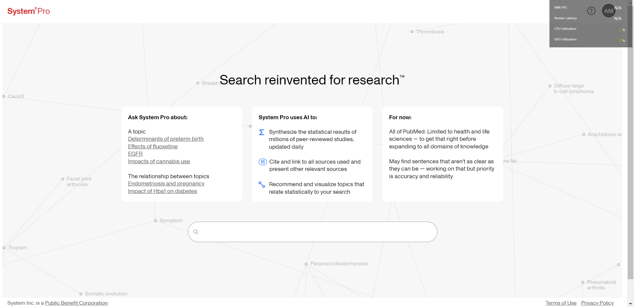

Figure 2 1: Search Option

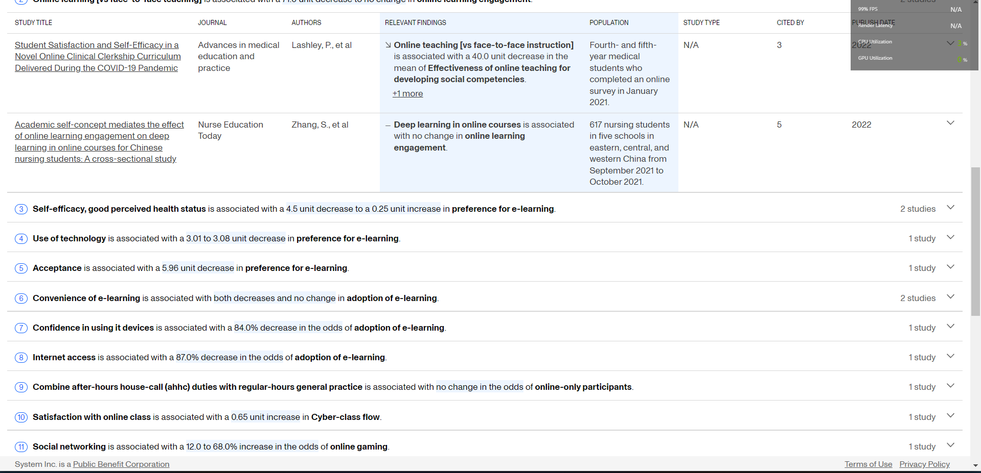

Figure 2 2: Details about publications

### Scimago Journal & Country Rank

The website Scimago Journal & Country Rank have several tools that are available to aid researchers in assessing the scientific output of nations, journals, and individuals. The website Scimago Journal & Country Rank offers a platform for comparing the scientific output of nations, journals, and researchers. Using online scraping techniques, it collects data from a number of sources, such as Scopus, PubMed, and online Science. Scientific journals are ranked according to their impact, influence, and quality by Scimago Journal & Country Rank. Based on information gathered from the Scopus database, which includes publications from many publishers, the rankings are created. Scimago Journal & Country Rank gives ranking to nations according to their contributions to science, citations, and partnerships. The rating is based on information gathered from different sources.

**Shortcomings:**

The interface of the website is user-friendly, but it can be more organized to help the users navigate more easily. The primary focus of Scimago Journal & Country Rank is on the production of scientific research in the engineering and natural sciences. The website may not be as helpful for researchers in other domains when assessing the effectiveness of their work. Overall, the website can be helpful for anyone to go through but there are sides open for development including the setup of a dashboard showing the statistics.

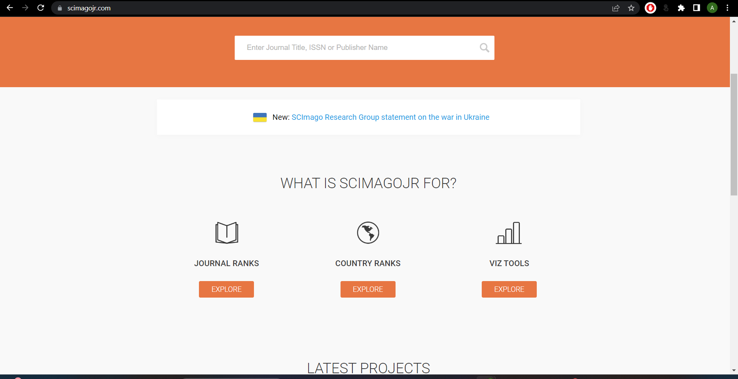

Figure 2 3: Homepage for scimagojr website

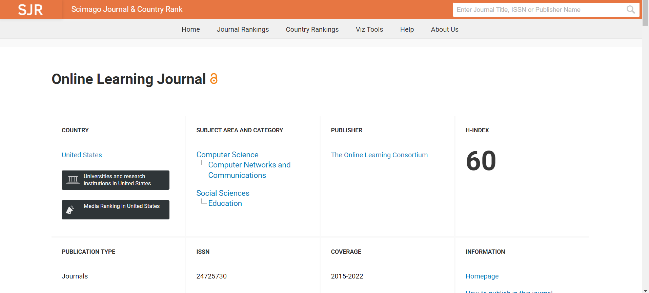

Figure 2 4: Details about the journals

### Google scholar

Google Scholar is a very popular web-based search engine that searches scholarly materials like academic publications and indexes them. The scholarly literature, including articles, theses, conference papers, and other publications, is covered by Google Scholar. It has an advanced search option through which users may search for articles that reference particular authors or papers as well as filter their search results by author, publisher, date, and keyword. The best part of using google scholar is that anyone with an internet connection can use Google Scholar without paying a fee. The search results are displayed in an accessible and organized way, and the interface is intuitive and simple to use. Its integration with a variety of university library management systems has enabled its users to quickly access full-text articles and other resources that may be offered by their institution.

**Shortcomings:**

Although Google Scholar provides a very intuitive interface and has numerous good features, it doesn’t do data analysis based on articles or publications. The coverage provided by Google Scholar is extensive but not exhaustive. The standards by which Google Scholar determines whether a result is "scholarly" are not stated. The researcher must decide whether outcomes are appropriate for their objectives because results are frequently of varying quality. Users of Google Scholar are unable to filter results by discipline, full-text, or peer-reviewed sources. Overall, it doesn’t help any organization/individual by providing them a thorough analysis of their research and doesn’t provide any data analysis dashboard based on them.

The dashboard developed for the faculty of computing staff will do data analysis based on the publications made which makes it unique and different.

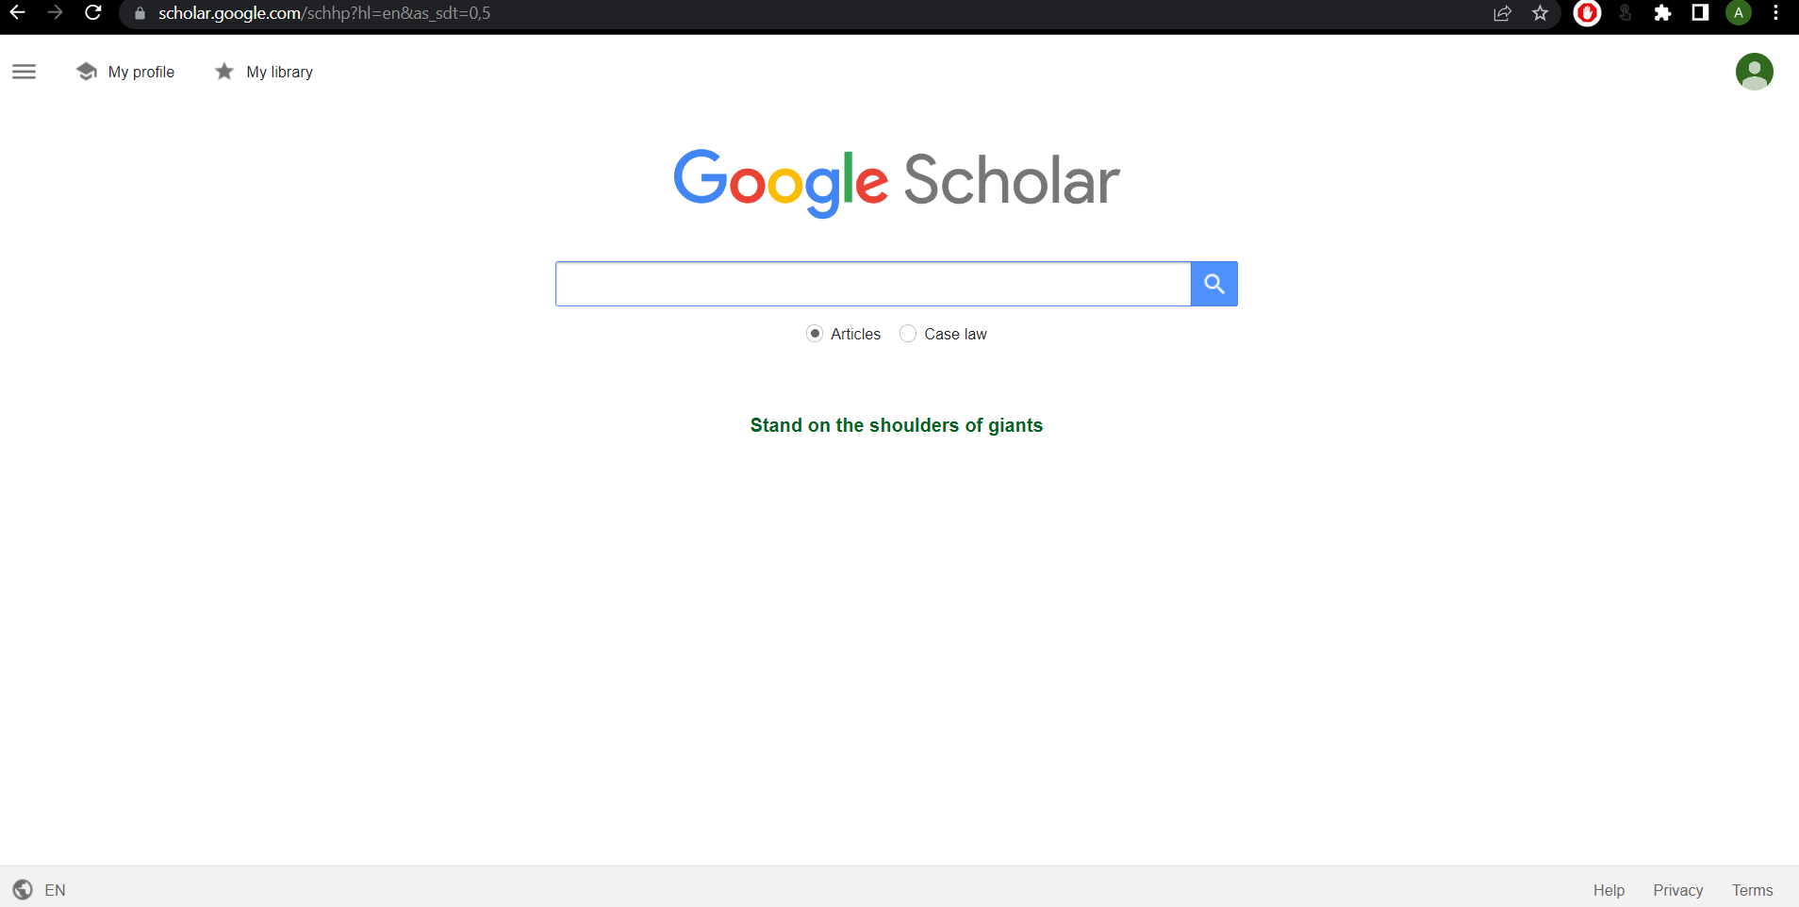

Figure 2 5: Home page for Google Scholar

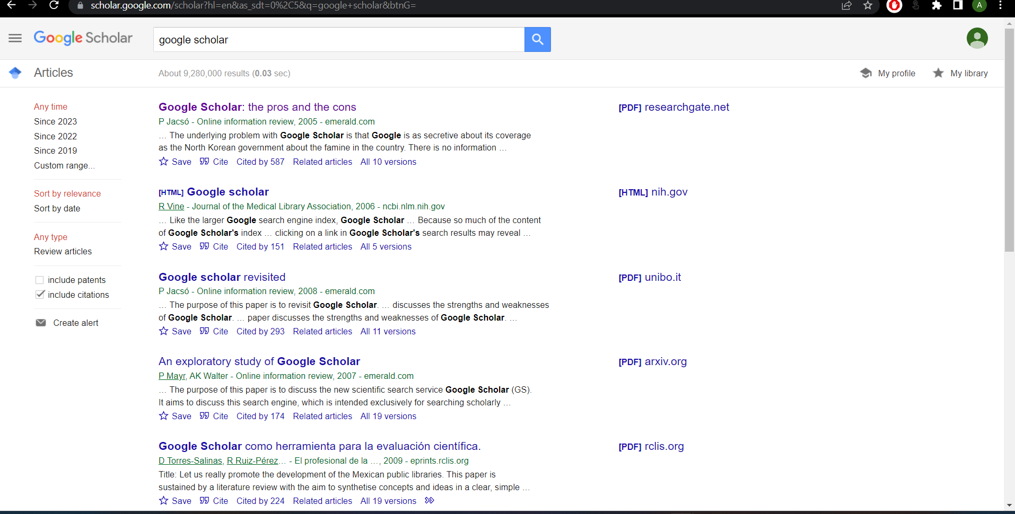

Figure 2 6: Display of results in google scholar

## Comparison between existing systems

Each of System Pro, Scimago Journal & Country Rank, and Google Scholar have benefits and drawbacks of their own. But what sets each of them apart from the others is their area of expertise. Here are some comparisons of the characteristics and functions of the three systems as a consequence.

Table 2 1: Comparison between existing systems and Faculty of Computing publication Dashboard

|  |  |  |  |  |
| --- | --- | --- | --- | --- |
| **Properties** | **System Pro** | **Scimagojr** | **Google Scholar** | **FC Dashboard** |
| **System Type** | Web-based | Web-based | Web-based | Web-based |
| **Interface** | Data visualization is a limited | User-friendly Interface but lacks organization | Very user-friendly interface | User-friendly interface with beautiful themes and organized features |
| **Language** | English | English | English | English |
| **Data Analysis** | Yes | Yes | No | Yes |
| **Reliability** | Fair | Average | Average | Good |
| **Uniqueness** | Examines and displays publishing success for institutions and academics | Assess scientific research of individuals and organizations | Display scholarly materials | Dashboard that’ll provide insight on publication performance among Faculty of Computing researchers |
| **Analytical Dashboard** | No | Yes | No | Yes |

Based on the comparison table 2.1, it can be concluded that the Dashboard developed for the faculty of computing staff to check on their publication performance is an excellent platform when compared to the alternatives. The faculty of computing staff will be benefitted to do a study of their publication works and thus think of further development. This project aims to help the faculty of computing staff to get an insight into their work and assess the current condition of their publication methods. In comparison to similar systems, it can be said that our system will be useful for a certain organization to follow up with their work in their own field.

## Literature Review of Technology Used

Fast advancements in technology are occurring. With the aid of technology, the world is now limitless and everything is possible. Software development has grown to the point that it is the most sophisticated and in demand in the ever-evolving world of technology. In order to stay up with the development of time and technology, a technical study was done to determine the best technologies accessible for this project. In this project, the following technologies will be utilized:

### IDE

#### Visual Studio Code

Microsoft’sVisual Studio Code (VS Code) is a free and open-source code editor and it is a popular choice among developers because of its versatile nature, making it one of the favourite choices for web development, app development, and machine learning projects.

.

### Coding language:

#### Python

We’ll be using Python for our project to carry out web scraping from different sources like Scopus, google scholar, etc. Python is a popular programming language used by developers for web scraping and development. There are many libraries and tools available for scraping data from websites in Python. Some of the notable libraries are BeautifulSoup, Scrapy, Selenium, etc.

### Technology used

#### Web Scraping

Web Scraping is the process involving the extraction of data from a source using automated software and tools. This technology helps in doing data analysis since it collects data from different sources and puts them together in one place. The main purpose of this technique is to have a thorough understanding and analysis of the data collected from different sources.

## Chapter Summary

In conclusion, this chapter described similar systems related to my project that have been studied and researched for strengths and shortcomings that need to be acknowledged. This research will aid in the development of the dashboard that’ll come in handy for the faculty of computing staff and will provide insight into their publications.

# SYSTEM DEVELOPMENT METHODOLOGY

## Introduction

Software development methodology refers to the structured processes involved while working on a project. The methodology's main goal is to provide a systematic approach to software development. Planning is very important when it comes to executing a project. It can save time and money at the same time. Software development is a complex process that involves proper planning, sufficient resources, a budget, and skilled developers to complete the project. It can even lead to software failure if proper planning for software development is chosen. As a result, it is important to have excellent software planning for the project.

To achieve and ensure the development process of the software and its related products, a software development process is described as a collection of processes, actions, activities, and controls Young (2013). There are several software development approaches. Some of them have shown effective results and are used extensively in developing software by developers. Some of the notable approaches are Waterfall method, Incremental method, Prototyping, Agile, and Rational Unified Process (RUP). These approaches consist of seven different phases which is known as the Software Development Life Cycle (SDLC). In this chapter, we’ll be discussing the approach that’ll be taken for implementing the project.

## Methodology Choice and Justification

The system development methodology is a standardized process to perform all the necessary steps to analyze, design, implement, and maintain a system efficiently. There are many system development approaches that can be implemented for the successful planning of the

project. According to the system requirements, Agile methodology seems to be the suitable software development approach that can be used for our project.

In Agile methodology, the project is broken down into small pieces of user functionalities. These functionalities can be organized by prioritizing their importance and setting a delivering time limit to complete them. They can be divided into 2–4-week cycles known as iterations or sprints. Before each cycle, the goal of the sprint needs to be specified. By making an analysis of the requirements, the functionalities will be divided and developed sequentially by giving highest priority to the most important ones. In this way, the development process will be easier and smooth for the developer to develop.

Agile methodology seems to be best suited for our project because of its phases. It is easier to implement the agile methodology as well. The use of sprints to complete tasks in Agile methodology makes it more suitable for the implementation of the project since it’ll help in saving time, money and dividing the tasks according to their priority. It has been seen from previous projects that by embracing the Agile Methodology, organizations can experience numerous benefits. They include more adaptability, a shorter time to market, higher customer satisfaction, better software quality, and lower project risks. Due to its endless benefits, it can be concluded that Agile methodology is the best suited for my project.

## Phases of the Chosen Methodology

Agile methodology follows a cyclical and iterative approach to implement the development of the software. It typically consists of six phases. The phases include the planning, Designing , development, testing, deployment and reviewing. The flow can be viewed from the figure below.

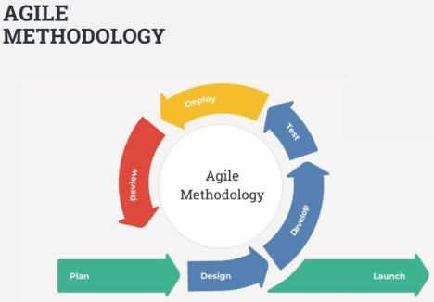

Figure 3 1: Workflows of Agile Methodology (source: interqualitybg.com)

**3.3.1.** **Planning**

Planning is the stage of the system where requirements set by the stakeholder are reviewed by the developers. The developer team reaches a conclusion with the client on how the software/system should look like. After that, the developer divides the various tasks that are needed to develop the system. In this stage, the priority and division of the tasks is done. A detailed planning for the iterations or sprints is made during the planning stage. The items for the development can be updated and viewed in the backlog. The backlog is updated during this phase.

as well. For each sprint and iteration, a goal is set to be completed by the end of that sprint. This includes the timeline for completing the tasks, the percentage of tasks that need to be completed and any other constraints or dependencies. During this phase, communication with the stakeholder is done profusely to meet the goals set for each sprint.

**3.3.2. Design**

Design is the stage where the system blueprint is designed based on the analysis of the requirements and results of the analysis. The prototype of the system is developed in the design stage. A detailed description of different features and operations of the system is carried out in this phase as well. The prototype will demonstrate the basic idea of how the application should look like. Developing the prototype is a key task that is to be completed in the design phase. It is also important to develop the prototype based on the requirements set by the stakeholders but also based on the flexibility of the developer. So, developing the prototype, validating the results of the analysis pinned during the planning stage are to be done during this phase.

**3.3.3.** **Development**

Development is the stage where the software development is carried out according to the plan by the developer. Developers will start developing the system using the programming language that has been chosen for developing the system. Different modules are created for developing the system in this phase. For example, the integration of database with the backend, the front-end of the system to interact with services or logic that has been developed by the back end. The software development process is carried out based on predetermined requirements and procedures during the previous phases.

**3.3.4.** **Testing**

In this stage, the software that has been developed is tested or checked. The testing of the software is very important to avoid software failure. It has been seen in the case of many software companies that due to the lack of proper testing, it has failed during the launch of the software. That is why this phase plays an essential role to avoid software failure and to ensure software success. Software quality is assured and maintained in this phase.

**3.3.5. Deployment**

Deployment is the stage where the software is ready to be placed in the market after getting clearance from the software quality control team. It comes after the testing phase since the quality and percentage of failure/success are determined in the testing phase. If the system developed matches the requirements, the software will be ready for deployment.

**3.3.6.** **Review**

Review is the stage where we get user feedback whether it's about bugs that weren't found during testing or about adding new features if needed. Review plays an essential role in software launching. User feedback is the most important part of the software development cycle since the system is basically built for the user. It is important to ensure a smooth user experience for the user to ensure excellent software review. From this stage, it could be a new software development life cycle to fix bugs, define an iterative development plan, or update features in future releases.

## Technology Used Description

This section will briefly explain the required tools and technology used for the development of the proposed system which is the faculty of computing staff publication dashboard.

Table 2 2: Technology used

|  |  |  |
| --- | --- | --- |
| **Technology** | **Purpose** | **Type** |
|  |  |  |
| Windows | Operating System | Operating System |
|  |  |  |
| Google Drive | Documentation | Storage |
|  |  |  |
| Draw.io |  | UML Diagram Editor |
|  | Design |  |
| Figma | UI and UX Design |
|  |
|  |  |  |
| Visual Studio Code | Software Development | IDE |
|  |  |  |
|  |  |  |

## System Requirement Analysis

This section includes hardware and software, which are essential for designing, developing, and testing the system. The system will work properly and be compatible if the appropriate hardware and software tools are used.

### Hardware Requirements

We will need a computer or laptop for documentation and, most significantly, for the development of the system.

Table 2 3:Hardware Requirements

|  |  |
| --- | --- |
| Component | Requirements |
| Processor | Ryzen 7 |
| RAM | 8GB |
| Operating System | Windows 7 / 8 / 10 / 11 (32-bit or 64-bits) |
| HDD | 20GB |
| Available Disk Space | 100GB |
| Internet connection | Wifi |

### Software Requirements

Software Requirements must be met for developing the system.

**3.5.2.1.** **Vs Code**

Visual Studio Code is a source-code editor that will be used as the main platform for coding the application in this project

**3.5.2.2.** **Microsoft Word**

Microsoft Word is the ideal tool for documentation. It gives users powerful features to help them write more efficiently and effectively. The Microsoft Word software is required to complete the project’s documentation.

## Chapter Summary

This chapter goes through the system methodology used to develop this project, which is the Agile method. This chapter also explores more into the Agile phases and how they work. Following that, this chapter explains the technology utilized in the development of the project, as well as the hardware's minimal requirements and a list of required software.

# REQUIREMENT ANALYSIS AND DESIGN

## Introduction

This chapter describes the requirement analysis and the design of the system. Analysis of essential functional and non-functional requirements gathered during the design process is also discussed in this chapter. Essential Design Elements are discussed in this chapter. For example, a use case diagram is used to understand the requirements of the whole system. Other diagrams like sequence and activity diagrams are used to represent the use case in further detail. The chosen architecture style, database design and the interface designs will also be discussed in this document.

## Requirement Analysis

The functional and non-functional requirements of the system are discussed in this section. These requirements were gathered from the stakeholders of the system.

### Functional requirements

#### Use Case Diagram

The use case diagram represents all the requirements of the system. The system features and functions are shown in the use case diagram as well. The requirements are set after finalizing with the stakeholder. The use case diagram is the primary diagram for depicting all the necessary features and functions of our system.

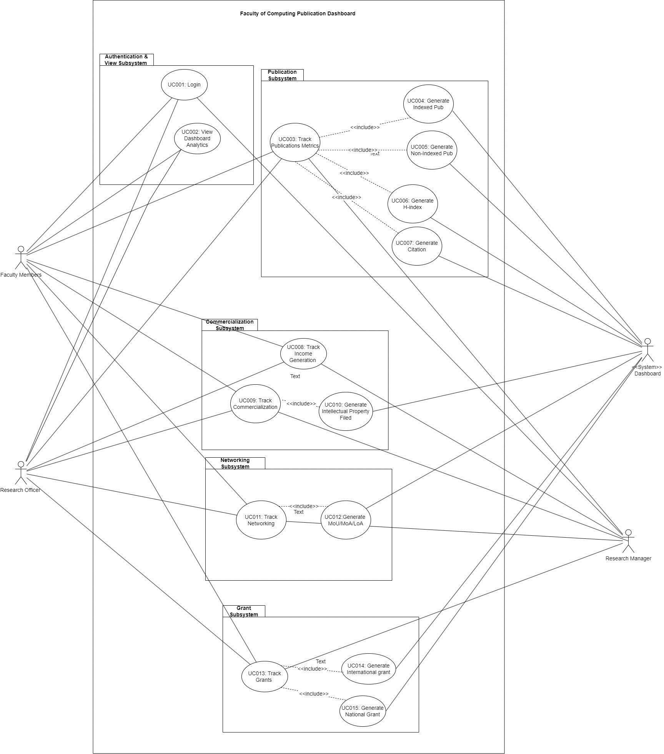

Figure 4 1: Use Case Diagram of Dashboard

#### Actor Description

The description of the actors of the use case given above is given below:

Table 2 4: User Description

|  |  |  |
| --- | --- | --- |
| No. | User | Characteristics |
|  | Faculty Members | This user is the main part of the system. The system is basically built for the usage of the faculty members. The faculty members will be able to get an insight of their research work and what measures can be taken to do improvement on research by the faculty of computing staff. |
|  | Research Officer | Research officer plays a crucial role in our system design. All the data that will be collected will have to go through the research officer for filtering it properly before displaying in the system. This role is one of the major parts of the project. Research officer will help in data filtering before displaying in the form of a dashboard. |
|  | Research Manager | Research manager will help in collecting the data that will be displayed in the dashboard. Research manager is the one who manages the data related to research. So, the role of the research manager is very important for carrying out the development of the system. |

#### Use Case Description

The elements of the use case are described in the table below:

Table 2 5: Use Case Description

|  |  |  |
| --- | --- | --- |
| **Module** | **Product Function** | **Description** |
| Authentication and View | Login | It will allow the user to login to the system. |
| View Dashboard Analytics | It will allow the user to view the dashboard analytics of different research related data. |
| Publication | Track Publication Metrics | This will allow the research staff to track the publication metrics by reviewing the data related to publication. |
| Generate Indexed Publication | This will be generated by the system dashboard by using data science techniques for the users to view their update. |
| Generate Non-Indexed Publication | This will be generated by the system dashboard by using data science techniques for the users to view non-Indexed publications. |
| Generate H-Index | This will be generated by the system dashboard by using data science techniques for the users to view H-Index data generated. |
| Generate Citation | This will be generated by the system dashboard by using data science techniques for the users to view Citations made data. |
| Commercialization | Track Income Generation | This will allow the research staff to track the Income generation by reviewing the data related to income generation. |
| Track Commercialization Data | This will allow the research staff to track and edit the Commercialization data by reviewing the data related to commercialization. |
| Generate Intellectual Property Filed | This will be generated by the system dashboard by using data science techniques for the users to view the number of intellectual property filed for the researchers. |
| Networking | Track Networking | This will allow the research staff to track and edit the Networking data by reviewing the data related to networking. |
| Generate MoU/MoA/LoU data | The system dashboard will generate data related to the agreement/letter of undertaking by using data science techniques for the users to view and evaluate on the current condition. |
| Grant | Track Grant | This will allow the research staff to track and edit the Grant data by reviewing the data related to Grant management. |
|  | Generate International grant Data | The system dashboard will generate data related to the international grant that has been received by using data science techniques for the research staff to view and evaluate on the current condition. |
|  | Generate National grant Data | The system dashboard will generate data related to the national grant that has been received by using data science techniques for the research staff to view and evaluate on the current condition. |

#### Sequence Diagram

Sequence diagrams are detailed design of a use case should work. The sequence of events that’ll be happening while using the system are depicted in sequence diagrams. For each use case, a sequence of events is maintained. The sequence of events for each use case are depicted in sequence diagrams. Detailed sequence diagrams are given in the SRS.

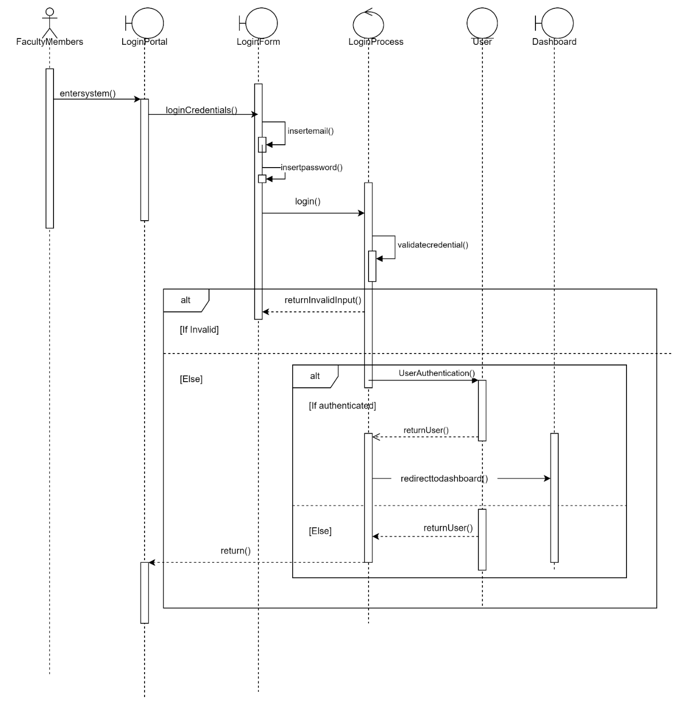

Figure 4 2: Sequence Diagram for Login

#### Activity Diagrams

The activity diagrams are illustrations of the workflow of a use case diagram. The activity diagram depicts the flow of the system while a user is making the system. Below is just one example of the activity diagram for this system.

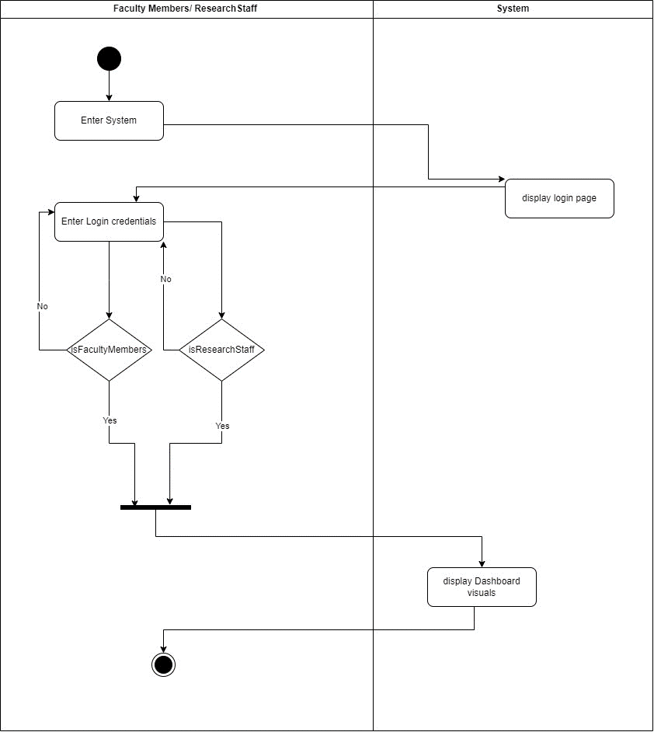

Figure 4 3: Activity Diagram for Login

#### Use Case Specifications

Use case specifications are tabulated form of in-depth analysis of each of the use cases. The Use Case Specifications consist of the normal, alternative and exception flow through which flow of the use case are organized. It also consists of all the details related to the use case. The actors related to the use case are also shown in the Use Case Specifications. Below is an example of the Use Case Specifications for our system:

Table 2 6: Use Case Specifications for Login

|  |  |
| --- | --- |
| **Use case ID** | UC001 |
| **Use case name** | Login |
| **Description** | This use case describes flow for user log in into the system. |
| **Actor** | Faculty Members, Research officer and Research Manager |
| **Pre-condition** | 1. There is an active network connection to the platform |
| **Normal Flow(s)** | 1. User enters the system. 2. Login page is displayed. 3. User enters the email and password. 4. User clicks on the ‘Login’ Button. 5. System validates the user. 6. If user enters wrong or invalid email or password, then exception flow 1 and exception flow 2 are performed. Otherwise proceed to normal flow 7 7. User is logged in. 8. Use case ends |
| **Alternative Flow(s)** | - |
| **Exception Flow(s)** | 1. **Invalid email**    1. The system displays invalid email message.    2. Normal Flow 3 is executed again. 2. **Invalid Password**    1. The system displays invalid password message.    2. Normal Flow 3 is executed again. |
| **Post-Conditions** | 1. User successfully login to the system. |
| **Related Requirement** | 1. View Dashboard Analytics |

### Non-Functional Requirements:

The non-functional requirements are those requirements that help a system to work better. Some of the non-functional requirements required for our system are given below:

1. Reliability: Reliability: The system should be dependable, with consistent and accurate operation. It should elegantly manage mistakes and exceptions, recover from failures, and minimise data loss or corruption. The system should also have backup and recovery techniques to prevent data loss and assure system availability.
2. Security: The system must prioritise data and user information security. It should put in place proper authentication and authorisation methods to ensure that only authorised people may access the data. In addition, the system should use secure data transmission methods to protect data during transit and comply with applicable data protection and privacy standards.
3. Usability: The system should be simple to use and intuitive, allowing faculty and research staff to explore and engage with the dashboard and its features. The user interface should be developed in way that will ensure users can simply obtain needed information, perform actions, and comprehend visualisations without confusion or excessive complexity.
4. Portability: The system should be built to be portable, allowing it to work on multiple operating systems or environments. It should make use of technologies and frameworks that are cross-platform compatible, ensuring flexibility in deployment options.

## Project Design

The chosen architectural style for this system is the MVC architecture. The MVC architecture refers to the Model-View-Controller architecture. The MVC architecture brings numerous benefits to the system. The system component is divided into three major parts. The three parts are model, view and controller. This architecture pattern makes it easier to manage code because of its structure.

The description of its three different parts is given below:

**Model:**

The business logic of the application is represented by the model layer. It focuses on the data structures and data operations which is one of the crucial factors for this system. Its sustainability is one of the big factors in choosing this architectural style.

* Represents the business logic of the application.
* Data storage and retrieval is handled in this layer.
* If there’s any change in data, this layer notifies the observer.

**View:**

The presentation layer is represented by the view layer. It is responsible for displaying the interface and data to the user. It receives data from the model and works as a presentation layer of the collected data in the form of tables, charts and so on.

* The data is displayed by this layer.
* Works as a presentation layer.
* User interface elements are rendered in this layer.
* It passes user input to the controller.

**Controller:**

The controller acts as a bridge between the model and view layer. It interacts with the model layer to update or retrieve data and interacts with the view layer to reflect the changes made.

* It receives user input, and it performs actions based on the user input.
* Interacts with the model to collect data.
* Interacts with the view layer to reflect changes made in the model layer.
* It controls the data flow between the model and the view layer.

The reason for choosing this architectural model is due to its durability, testability, reusability, and flexibility.

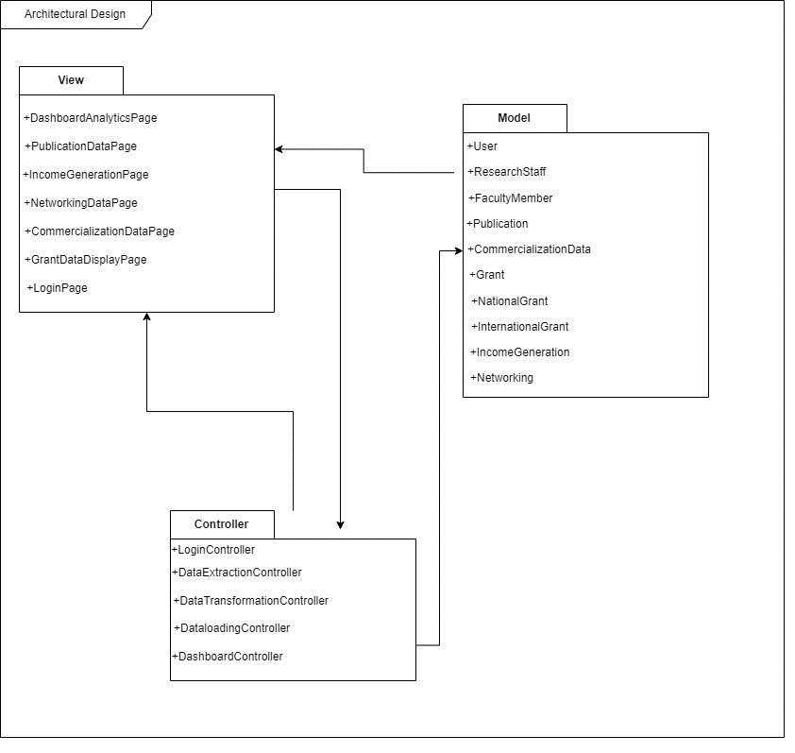

Figure 4 4: Architectural Model

## Database Design

The database design is one of the main parts of our system. Database requires the data to be saved in a proper format. The format is depicted in the database design. For developing our system, database design is a major part. The database design of our system is given below:

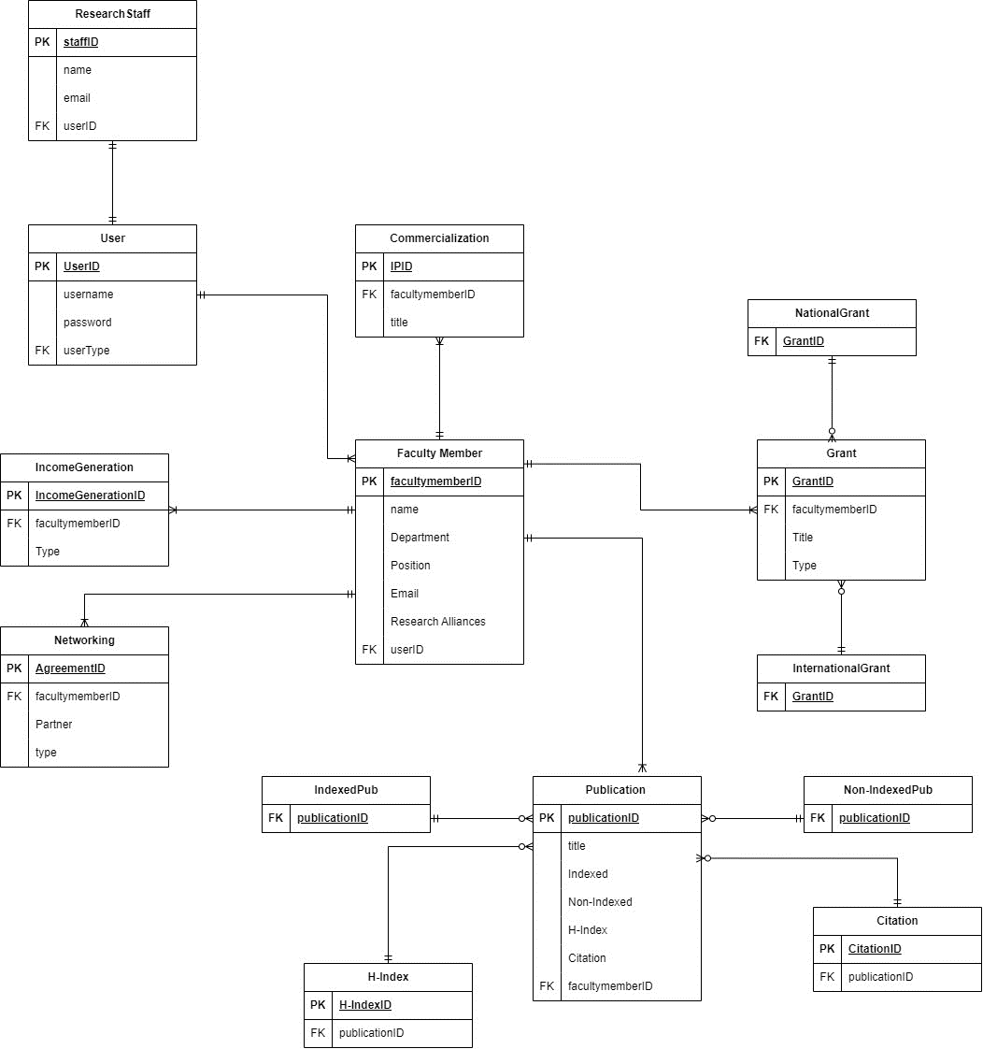

Figure 4 5. Database Diagram

Data Dictionary:

Below is the data dictionary designed for three fields:

|  |  |  |  |
| --- | --- | --- | --- |
| **Field Name** | **Datatype** | **Constraint** | **Description** |
| **User** | | | |
| UserId | INT | Primary Key | Unique ID for user |
| username | VARCHAR | Not NULL | Username of the user |
| password | VARCHAR | Not NULL | Password of the user |
| userType | VARCHAR | Foreign Key | Unique type of user |
| **Research Staff** | | | |
| staffID | INT | Primary Key | Unique ID for user |
| name | VARCHAR | Not NULL | Name of the user |
| email | VARCHAR | Not NULL | Email of the user |
| userID | INT | Foreign Key | Unique ID for user |
| **Income Generation** | | | |
| IncomeGenerationID | INT | Primary Key | Unique ID for Income Generation field |
| facultymemeberID | INT | Foreign Key | Unique ID of the faculty member |
| Type | VARCHAR | Not NULL | Type of Income Generation |

## Interface Design

Users will be taken to a login page for entering the system. From the login page, the user will be taken to a dashboard home page.

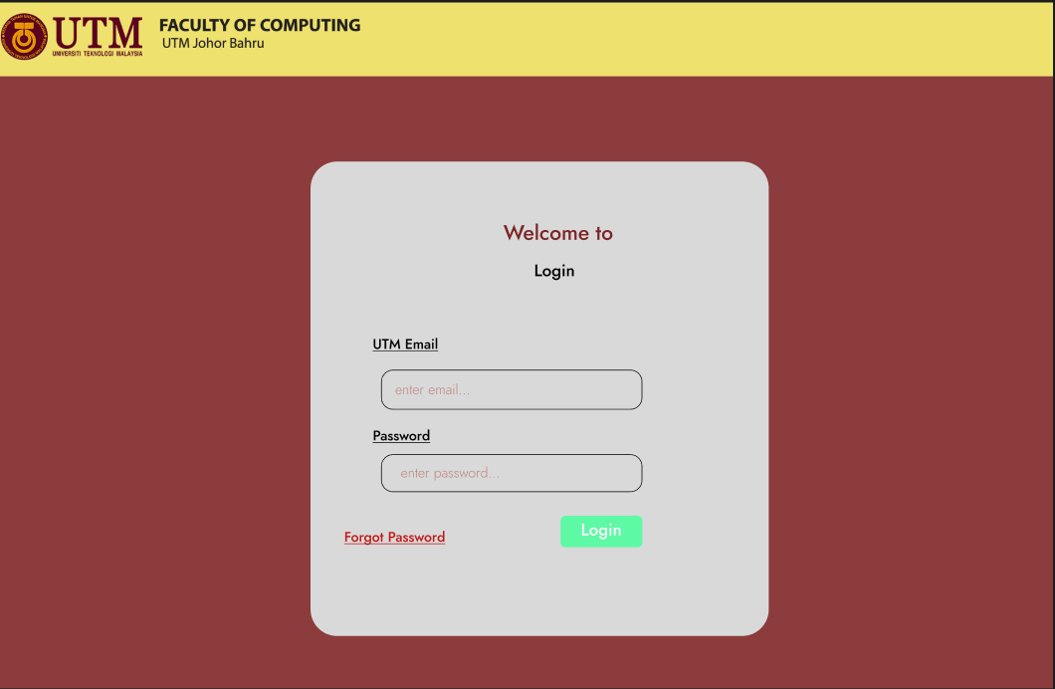

Figure 4 6: Login Page

From the dashboard, the user can choose what data they want to view. If they want to view the publication data, they’ll be able to view it.

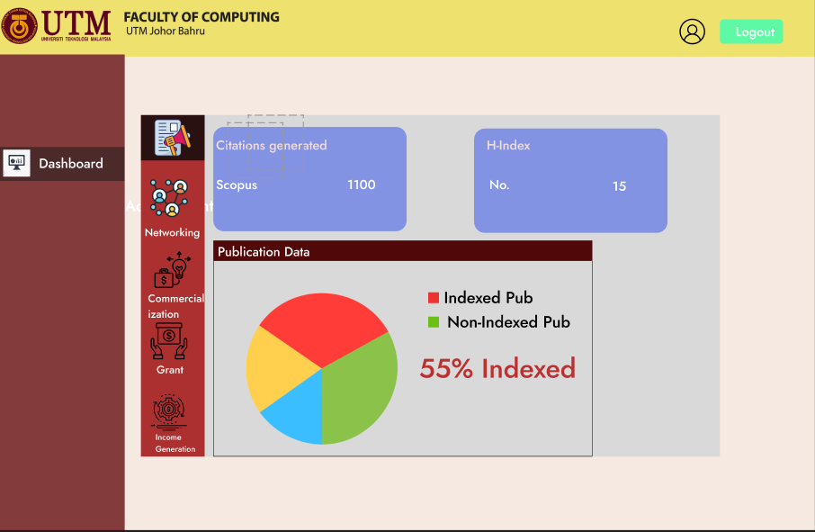

Figure 4 7:Publication Page

The user can view other data like networking data as well.

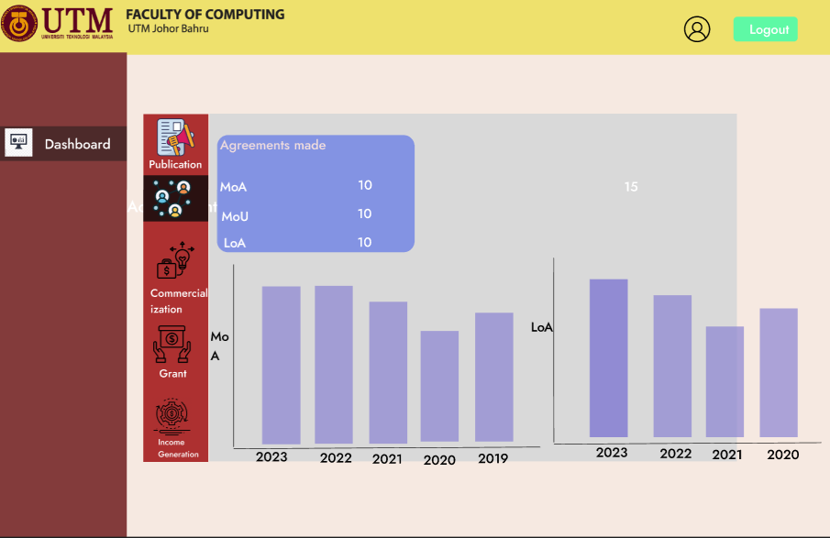

Figure 4 8: Dashboard for Networking

## Chapter Summary

This chapter discusses all the important diagrams and methods that are required to develop the system. The requirements are the initial phase of the system. But it is just a part of the process. For developing the system, the development process is broken down into different phases. The diagrams depict a detailed description of the system features and functions. To summarize, this chapter includes all the important steps that are required to develop the system.

# Conclusion

## Introduction

This chapter is the conclusion of the first phase of the development of our system which is dashboard for the faculty of computing researchers. The dashboard will display various data related to the project and will help in evaluating for the future improvements. This document has discussed all the necessary details that are needed for the project.

## Achievement of Project Objectives

The problems related to the stakeholder are discussed in this document. The achievement of the project objectives is also mentioned in this document. The project requirements and specifications are discussed in this document. All the necessary methods and system specifications are also discussed in this document.

The goal was to set up the documentation in a way that it helps during actual development of the system. So, the whole documentation of the system was made available in this document which will help to complete PSM1. This documentation will be used to make the final product in PSM2. So, the achievement for the project is half-way through success.

## Suggestions for Future Improvement

According to the stakeholders, although this document represents almost all of the important features, it still isn’t perfect. The development of the product will help in making this document worthy. To make things easier, this document will come in handy. There are many tests that must be done before the placement of the final product. So, for better product and improvement in the future, we have to conduct some testing that weren’t done in this phase of the development process.

REFERENCES

* Pauwels, K., Ambler, T., Clark, B. H., LaPointe, P., Reibstein, D. J., Skiera, B., Wierenga, B., & Wiesel, T. (2009). Dashboards as a Service. *Journal of Service Research*, *12*(2), 175–189. <https://doi.org/10.1177/1094670509344213>
* Susnjak, T., Ramaswami, G. S., & Mathrani, A. (2022). Learning analytics dashboard: a tool for providing actionable insights to learners. *International Journal of Educational Technology in Higher Education*, *19*(1). <https://doi.org/10.1186/s41239-021-00313-7>
* Elsevier. (n.d.). *My Research Dashboard*. <https://www.elsevier.com/connect/editors-update/my-research-dashboard>
* Matheus, R., Janssen, M., & Maheshwari, D. (2020). Data science empowering the public: Data-driven dashboards for transparent and accountable decision-making in smart cities. *Government Information Quarterly*, *37*(3), 101284. <https://doi.org/10.1016/j.giq.2018.01.006>
* Kadijević, Đ. (2020). *Modern statistical literacy, data science, dashboards, and automated analytics and its applications*. <https://ipir.ipisr.org.rs/handle/123456789/322>
* Power, D. J. (2016). Data science: supporting decision-making. *Journal of Decision Systems*, *25*(4), 345–356. <https://doi.org/10.1080/12460125.2016.1171610>
* Bhardwaj, A. (2014, September 2). *DataHub: Collaborative Data Science & Dataset Version Management at Scale*. arXiv.org. <https://arxiv.org/abs/1409.0798>

Appendix A System Requirements Specification



**Software Requirements Specification**

Faculty of Computing Staff Publication Dashboard

Version 1.0

25/06/2023

Faculty of Computer Science, Software Engineering

Revision Page

1. **Overview**

This document is the first draft of the Software Requirements Specification (SRS) for the Faculty of Computing Staff Publication Dashboard.

1. **Target Audience**

* **Prof Madya Dr. Siti Zaiton Bt. Mohd Hashim, Faculty of Computing, Universiti Teknologi Malaysia (UTM).**
* **Faculty of computing Staff, UTM.**

1. **Project Team Members**

* Adib Bin Morshed

1. **Version Control History**

|  |  |  |  |
| --- | --- | --- | --- |
| **Version** | **Primary Author(s)** | **Description of Version** | **Date Completed** |
| Version 1.0 | Adib Bin Morshed | SRS of Faculty of Computing Staff publication Dashboard | 25 June,2023 |

**Note:**

This Software Requirements Specification (SRS) template is based on IEEE Std 830-1998, organized by modules according to system features (Appendix A.5 of the IEEE Std, 830-1998, Section 5) and customized to meet the need of SCSJ2203 course at Faculty of Computing, UTM. Compiled and checked by Shahida Sulaiman, PhD on 20 March 2016. Examples of models are from Satzinger (2011).

Table of Contents

|  |  |  |  |  |  |  |
| --- | --- | --- | --- | --- | --- | --- |
| **1** | **Introduction** | | | | |  |
|  | 1.1 | Purpose | | | |  |
|  | 1.2 | Scope | | | |  |
|  | 1.3 | Definitions, Acronyms and Abbreviations | | | |  |
|  | 1.4 | References | | | |  |
|  | 1.5 | Overview | | | |  |
| **2** | **Overall Description** | | | | |  |
|  | 2.1 | Product Perspective | | | |  |
|  |  | 2.1.1 | System Interfaces | | |  |
|  |  | 2.1.2 | User Interfaces | | |  |
|  |  | 2.1.3 | Hardware Interfaces | | |  |
|  |  | 2.1.4 | Software Interfaces | | |  |
|  |  | 2.1.5 | Communication Interfaces | | |  |
|  |  | 2.1.6 | Memory | | |  |
|  |  | 2.1.7 | Operations | | |  |
|  |  | 2.1.8 | Site Adaptations Requirements | | |  |
|  | 2.2 | Product Functions | | | |  |
|  | 2.3 | User Characteristic | | | |  |
|  | 2.4 | Constraints | | | |  |
|  | 2.5 | Assumption and Dependencies | | | |  |
|  | 2.6 | Apportioning of Requirements | | | |  |
| **3** | **Specific Requirements** | | | | |  |
|  | 3.1 | External Interface Requirements | | | |  |
|  |  | 3.1.1 | | User Interfaces | |  |
|  |  | 3.1.2 | | Hardware Interfaces | |  |
|  |  | 3.1.3 | | Software Interfaces | |  |
|  |  | 3.1.4 | | Communication Interfaces | |  |
|  | 3.2 | System Features | | | |  |
|  |  | 3.2.1 | | Module <Name of Module1> | |  |
|  |  |  | | 3.2.1.1 | UC001: Use Case <Name of Use Case1> |  |
|  |  |  | | 3.2.1.2 | UC002: Use Case <Name of Use Case2> |  |
|  |  |  | | 3.2.1.3 | UC003: Use Case <Name of Use Case3> |  |
|  |  | 3.2.2 | | Module <Name of Module2> | |  |
|  |  |  | | 3.2.1.1 | UC004: Use Case <Name of Use Case4> |  |
|  |  |  | | 3.2.1.2 | UC005: Use Case <Name of Use Case5> |  |
|  |  | 3.2.n | | Module <Name of the *n* Module> | |  |
|  | 3.3 | Performance Requirements | | | |  |
|  | 3.4 | Design Constraints | | | |  |
|  | 3.5 | Software System Attributes | | | |  |
|  | 3.6 | Other Requirements | | | |  |
|  |  |  | |  | |  |

1. Introduction
   1. **Purpose**

The main purpose of this document is to describe the necessary requirements and specifications of the system. The description of the requirements is based on functional, non-functional features and functionalities. The requirements were gathered from our stakeholders. This SRS is important for the development of the system since it contains all the requirements that have been discussed with the stakeholders. This document is developed for the ease of understanding of the system by the developer and stakeholders.

* 1. **Scope**

The proposed system is named the research publication dashboard for faculty of computing staff. This system is specifically designed for the stakeholders who are researchers and research staff of the faculty of computing at Universiti Teknologi Malaysia (UTM). This system will help to recognize patterns and performance measures to evaluate the current situation of the research department. Although it’ll have all the necessary data required to make the evaluation, there will be a few limitations as well. This system will not include some data related to researchers which is a limitation of the system. Nevertheless, it’ll be used for the performance measure of the publications by the researchers and research staff. This document is needed for the better understanding of the system by the stakeholders and developer.

* 1. **Definitions, Acronyms and Abbreviation**

|  |  |
| --- | --- |
| Acronyms | Definition |
| SRS | Software Requirements Specification |
| UCS | Use Case Specification |
| UTM | Universiti Teknologi Malaysia |

* 1. **References**

1. Department of English, L. (2020). Software Requirements Specification (SRS). *Slcc.pressbooks.pub*. <https://slcc.pressbooks.pub/technicalwritingatslcc/chapter/software-requirements-specification-srs>
   1. **Overview**

The requirements for the project have been divided into three main sections. The purpose of this document has been described in the first section. An overview of the system's features, interactions, and functionality has been described in Section 2. Additionally, assumptions and dependencies, system constraints are also discussed in section 2. The system’s specific requirements including the use case specifications, descriptions, interfaces, sequence, and activity diagrams have been depicted in section 3.

1. Overall Description

An overview of the system will be described in this section. The use case will be shared and detailed description of the use cases will be documented in this section as well. For better understanding of the system, flow of the use case will be provided in this section as well.

The overall use case contains several subsystems that are considered as accepted after discussing with the stakeholder. The use case is divided into 5 different subsystems consisting of authentication and view subsystem, publication subsystem, commercialization subsystem, networking subsystem and grant subsystem. The four actors for this use case are the faculty members, research officer, research manager and dashboard. Figure 2.1 presents the use case diagram for the whole system.

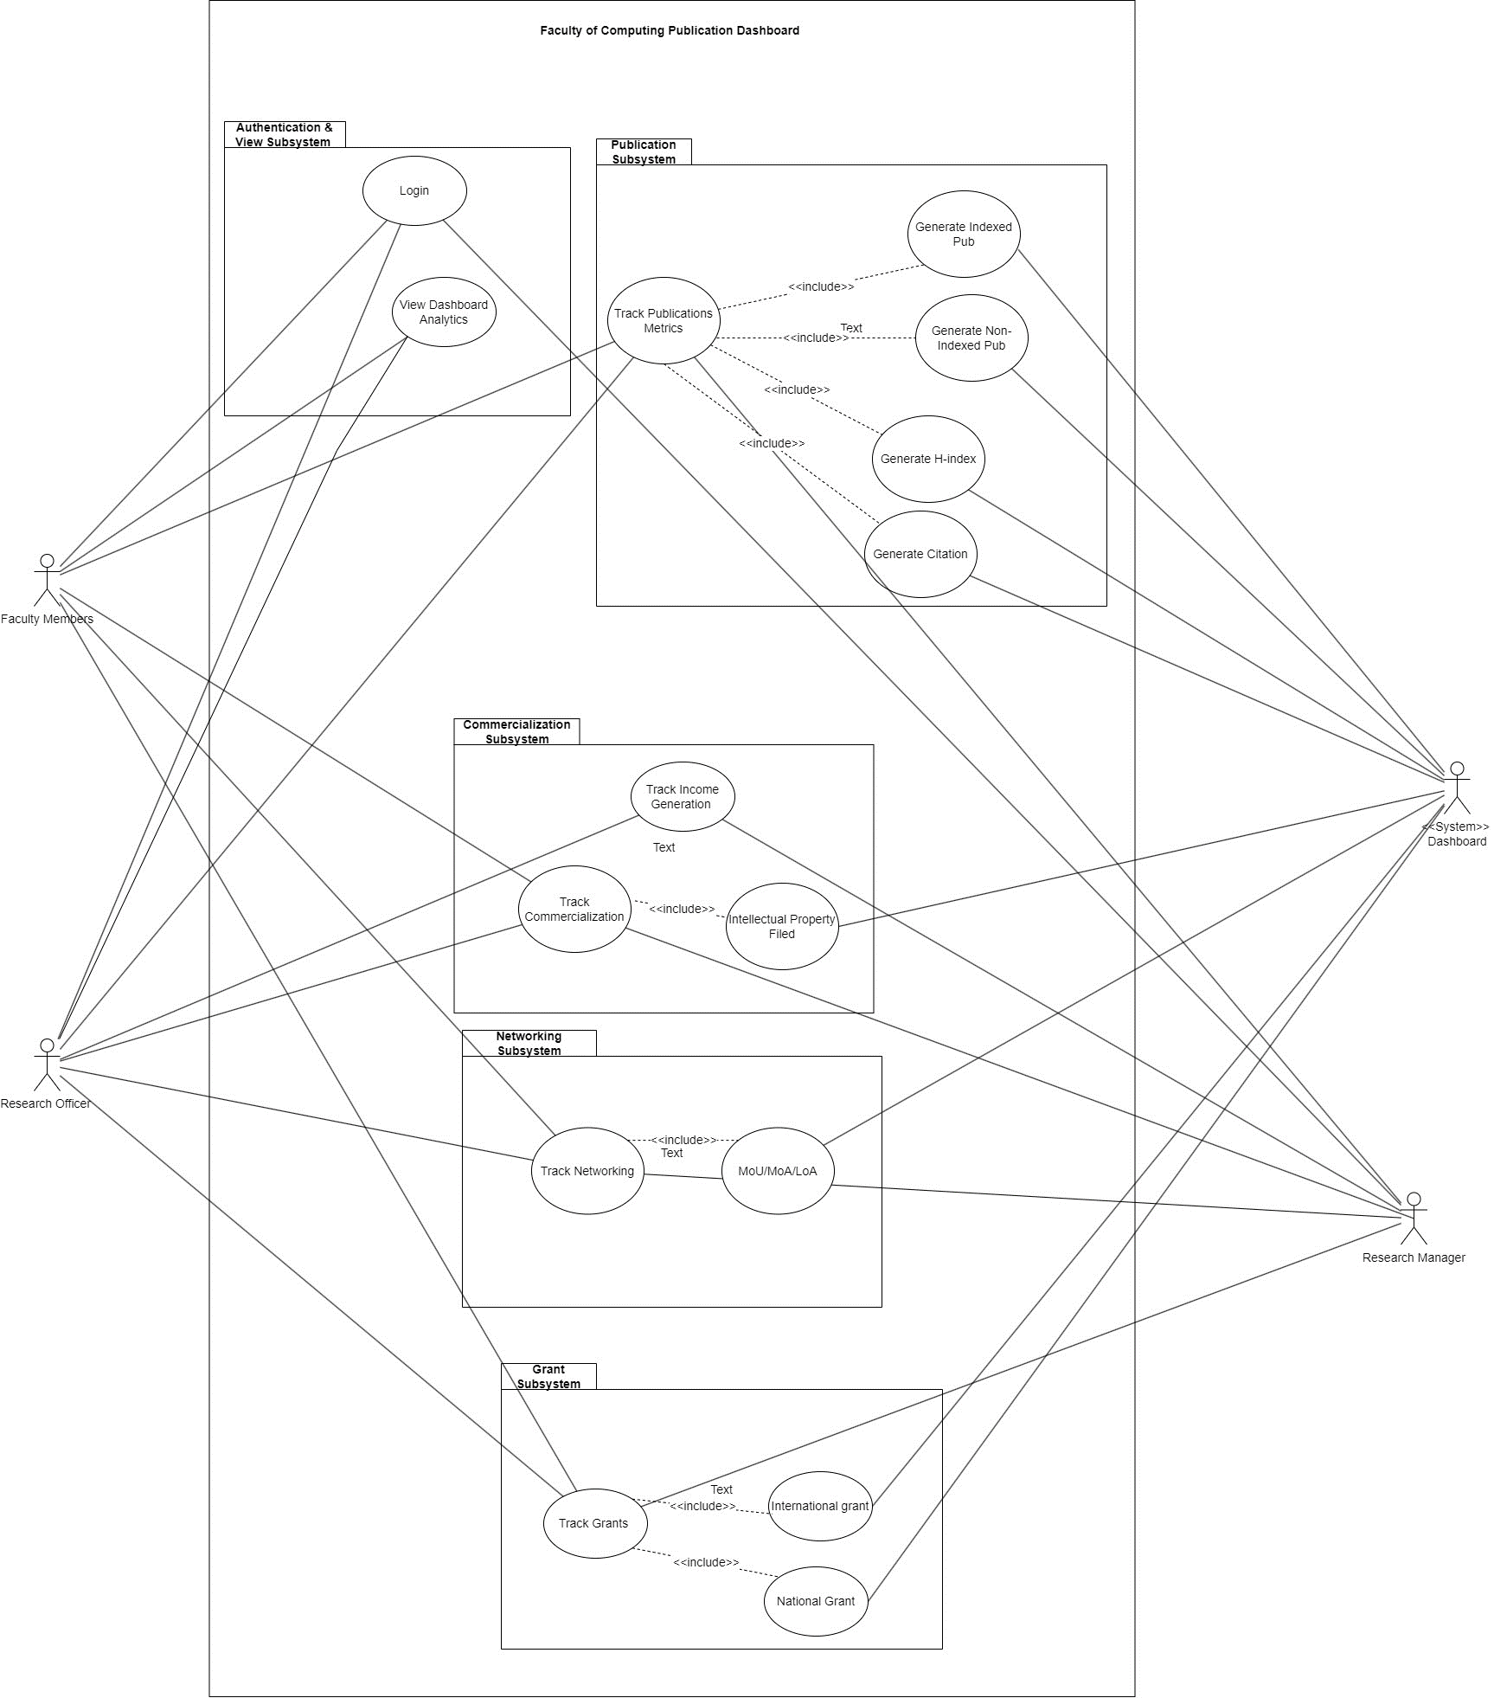

**Figure 2.1: Use Case Diagram of Faculty of Computing Staff Publication Dashboard**

* 1. **Product Perspective**

This SRS describes a dashboard system for the faculty of computing that will help to recognize patterns of the publications made by the faculty members. The dashboard system will display data from different sources that’ll be used to evaluate the performance of the faculty members in the research field. This product will help to display index, non-index publication, H-index and citations generated by taking data from other sources such as the Scopus, google scholar, UTM scholar and so on. My system will also display data related to income generation and commercialization. Commercialization data will include intellectual property filed. The system will generate networking data including the agreement data as well. Research officer and manager will be able to track the data for making reports and recommendations for improvement and evaluate the current situation. Faculty members will be able to see the condition of the research data as well. The purpose of this system is to improve performance measures of the faculty of computing staff.

* + 1. **System Interfaces**

The publication dashboard for the faculty of computing staff will be developed with a web-based approach. The web-based system will be developed by implementing the ReactJS for frontend and Django for backend. We’ll be using MongoDB for storing scraped data after filtering and cleaning it from an excel file.

* + 1. **User Interfaces**

The system will have user interfaces that will be easy for the users to navigate and understand while using the system. The user interfaces will be made attractive for the users to have a good impression while using the system. Below are descriptions of some of the interfaces that’ll be developed for our system.

* + - 1. **Login Interface**

The system will have a login interface for the users that’ll allow the users to access the dashboard page after giving their valid email address and password.

* + - 1. **Dashboard Interfaces**

The dashboard interfaces are the main interfaces of the system that’ll display data taken from different sources. The user will be taken to the respective dashboard after logging into the system. Inside the dashboard there’ll be different pages showing different data that can be viewed by the faculty members and staff. The pages include publication data page, networking data page, commercialization data page, and grant data page.

* + 1. **Hardware Interfaces**

This system can be accessed using desktop computers as well as laptops that have web browsers installed on it. A stable internet connection is required to access the system. The development is done mainly for the mentioned devices only.

* + 1. **Software Interfaces**

The interfaces that are related to the system are mainly web-based. Internet connection is required to access the system. After ensuring that, the system can be accessed using google chrome, Mozilla Firefox, Microsoft Edge, and Apple Safari. The above-mentioned browsers are required to use the system. It can also be accessed by both the Windows and the Mac operating system.

* + 1. **Communication Interfaces**

TCP/IP protocols like HTTP, HTTPS, and FTP are used to carry out communication over the internet. The usage of such protocols makes it easier to ensure the highest level of compatibility and dependability possible.

* + 1. **Memory**

The utilization of memory is subject to the usage of the hardware platform required for our system. The accuracy of the usage of memory will depend on the of the capabilities of the hardware platform that is designed to operate this system.

* + 1. **Operations**

End-users will be navigated to the system login page at first. From there on, they must log in using their valid email address and password. They’ll be given initial information about logging into the system. They’ll be taken to a user dashboard where they’ll be able to visualize different data analytics related to the publication. For using this system, only registered users by the developer will be able to use the system at first. The operation of the dashboard analytics will be done on the database end. The data will be collected from different sources and will be displayed in the dashboard after cleaning, refining, and transforming the data. Users will be able to view the data in the that’ll be displayed in the dashboard. Their navigation operation will be conducted after logging into the system.

* + 1. **Site Adaptation Requirements**

The system is compatible with different platforms and multiple operating systems. It can be accessed through different web browsers that are compatible with the platform’s operating systems. It is adaptable to different platforms and systems. It is quite adaptable for the users to navigate through the system. A website link will be created for the users to access the website. Overall, the system is adaptable for users from different backgrounds.

* 1. **Product Functions**

1. *.*

Table 2.2 provides the explanation of the product functions.

Table 2.2: Product Functions

|  |  |  |
| --- | --- | --- |
| **Module** | **Product Function** | **Description** |
| Authentication and View | Login | It will allow the user to login to the system. |
| View Dashboard Analytics | It will allow the user to view the dashboard analytics of different research related data. |
| Publication | Track Publication Metrics | This will allow the research staff to track the publication metrics by reviewing the data related to publication. |
| Generate Indexed Publication | This will be generated by the system dashboard by using data science techniques for the users to view their update. |
| Generate Non-Indexed Publication | This will be generated by the system dashboard by using data science techniques for the users to view non-Indexed publications. |
| Generate H-Index | This will be generated by the system dashboard by using data science techniques for the users to view H-Index data generated. |
| Generate Citation | This will be generated by the system dashboard by using data science techniques for the users to view Citations made data. |
| Commercialization | Track Income Generation | This will allow the research staff to track the Income generation by reviewing the data related to income generation. |
| Track Commercialization Data | This will allow the research staff to track and edit the Commercialization data by reviewing the data related to commercialization. |
| Generate Intellectual Property Filed | This will be generated by the system dashboard by using data science techniques for the users to view the number of intellectual property filed for the researchers. |
| Networking | Track Networking | This will allow the research staff to track and edit the Networking data by reviewing the data related to networking. |
| Generate MoU/MoA/LoU data | The system dashboard will generate data related to the agreement/letter of undertaking by using data science techniques for the users to view and evaluate on the current condition. |
| Grant | Track Grant | This will allow the research staff to track and edit the Grant data by reviewing the data related to Grant management. |
|  | Generate International grant Data | The system dashboard will generate data related to the international grant that has been received by using data science techniques for the research staff to view and evaluate on the current condition. |
|  | Generate National grant Data | The system dashboard will generate data related to the national grant that has been received by using data science techniques for the research staff to view and evaluate on the current condition. |

* 1. **User Characteristics**

The user characteristics are described in the table below:

Table 2.3: User Characteristics

|  |  |  |
| --- | --- | --- |
| No. | User | Characteristics |
|  | Faculty Members | This user is the main part of the system. The system is basically built for the usage of the faculty members. The faculty members will be able to get an insight of their research work and what measures can be taken to do improvement on research by the faculty of computing staff. |
|  | Research Officer | Research officer plays a crucial role in our system design. All the data that will be collected will have to go through the research officer for filtering it properly before displaying in the system. This role is one of the major parts of the project. Research officer will help in data filtering before displaying in the form of a dashboard. |
|  | Research Manager | Research manager will help in collecting the data that will be displayed in the dashboard. Research manager is the one who manages the data related to research. So, the role of the research manager is very important for carrying out the development of the system. |

* 1. **Constraints**

The constraints of this system are given below:

* The system must be compatible with multiple web browsers and operating systems.
* The system will be easily accessible by the users with an active internet connection.
* The user interface will be designed in a way that’ll be easy and intuitive for the users to use.
* The dashboard will be visualized with correct data collected from different data sources and the visualization will be done in an attractive manner.
  1. **Assumption and Dependencies**

It is important to have an active internet connection while using this system. This system must be used online. A big part of this system is to have an up-to-date database system. The database will contain all the necessary data required for displaying in the dashboard. Events like an outage must be considered in case the database fails to load. The system will not function properly without having proper internet connection, web browser access and database access.

Depending on the stakeholders, new functionalities and features maybe added to the application during development, which may alter the interdependencies of the requirements. The system may be modified depending on these changes. The changes are also dependant on the availability of the resources. Enough data must be collected for displaying in the dashboard. The collection of data depends on the availability and usability of the data. It is important to evaluate the validity of the data as well. As we can see, all the functions are inter-dependent on each other so any changes made will have an affect on the system as well.

* 1. **Apportioning of Requirements**

Several requirements may be delayed until future versions of the system are released. The requirements will be identified in later phase of the document. The next part of the document is SDD which will identify the basic requirements needed for the next version of the application. However, depending on the ongoing process and time the requirements might be delayed like the dashboard features specification and so on.

1. Specific Requirements

This section will contain both the functional and non-functional requirements. This section includes the use case specifications with the sequence and the activity diagrams as well.

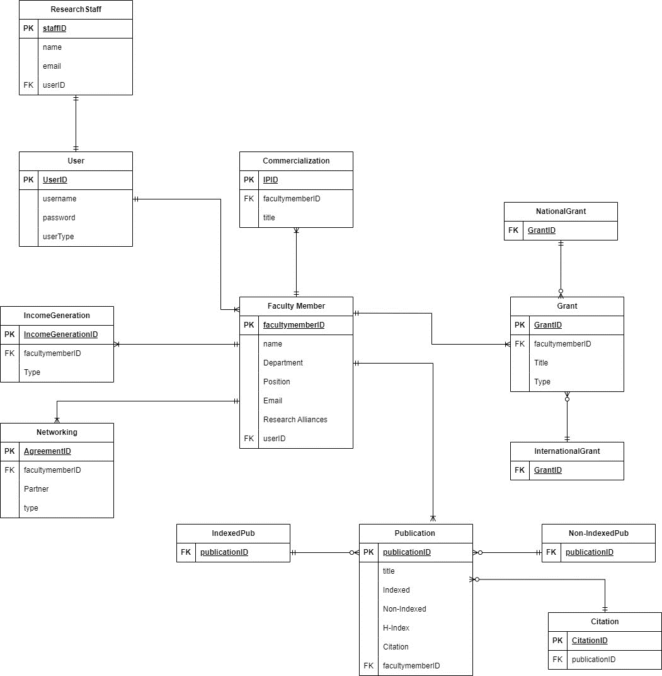

**Figure 3.1: Domain Model of Faculty of Computing Staff Publication Dashboard**

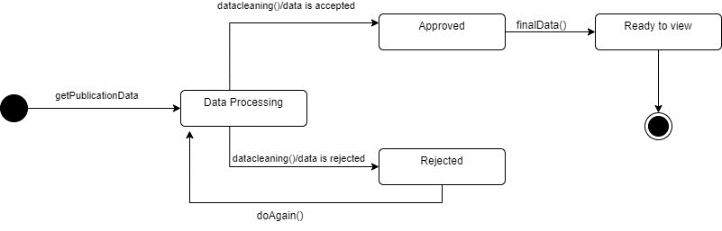

**Figure 3.2: State Machine Diagram of Publication**

* 1. **External Interface Requirements**
     1. **User Interfaces**

The user interfaces are described based on different roles of the interfaces:

* + - 1. **Login Interface**

This interface will be designed to make sure the user enters the system with valid email address and password. The login interface is crucial part of the interface design. Users will be taken to the login portal once they enter the system. From there on, they’ll have to key in their login credentials to enter the system. They’ll be taken to their respective dashboard for visualization of the dashboard.

* + - 1. **Main interface for the researchers and research staff**

Once the enter the system, they’ll be taken to the dashboard analytics from where they can view different data analytics related to the publication. The dashboard analytics will contain data related to the publication, commercialization, networking, income generation and grants. Meanwhile the publication interface will contain data which are part of the publication. The data for publication interface will include the indexed pub, non-indexed pub, H-index, and the citation. The data for commercialization interface will include the number of intellectual properties filed. There’ll be a networking interface as well which will contain data related to the agreements made. The grant interface will contain data which will include both the international and national grants received by the faculty of computing staff.

* + 1. **Hardware Interfaces**

For using this system, web browser and proper running desktop computer or laptop of any specifications can be used. A reliable internet connection is required for accessing the system.

* + 1. **Software Interfaces**

The interfaces that are related to the system are mainly web-based. Internet connection is required to access the system. After ensuring that, the system can be accessed using google chrome, Mozilla Firefox, Microsoft Edge, and Apple Safari. The above-mentioned browsers are required to use the system. It can also be accessed by both the Windows and the Mac operating system.

* + 1. **Communication Interfaces**

The system will work in a connection made with the LAN (Local Area Network). TCP/IP protocols like HTTP, HTTPS and FTP are utilized for internet-based communication for its durability and compatibility.

* 1. **System Features**

Detailed description of the use case specifications with the relevant sequence and activity diagrams are outlined in this section of the document. Functional requirements of each module are also given in this section as well.

* + 1. **Module Authentication and View Subsystem**

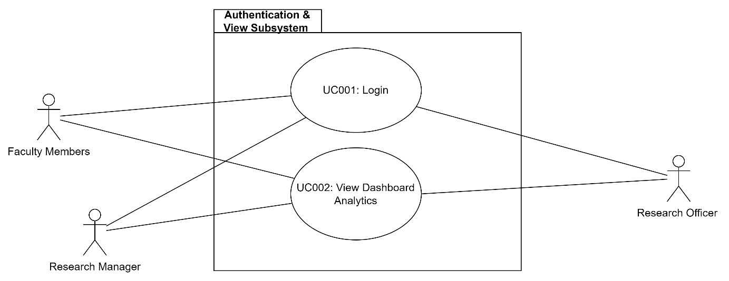

**Figure 3.3: Module Login and View Subsystem**

1. FR001: Login- The system shall allow the user to login successfully to the system.
2. FR002- View Dashboard Analytics- The system shall allow the user to view dashboard analytics in the form of charts/ graphs by providing an insight into the development made in research by the faculty.
   * + 1. **UC001: Use Case Login**

**Table 3.1: Use Case Description for Login**

|  |  |
| --- | --- |
| **Use case ID** | UC001 |
| **Use case name** | Login |
| **Description** | This use case describes flow for user log in into the system. |
| **Actor** | Faculty Members, Research officer and Research Manager |
| **Pre-condition** | 1. There is an active network connection to the platform |
| **Normal Flow(s)** | 1. User enters the system. 2. Login page is displayed. 3. User enters the email and password. 4. User clicks on the ‘Login’ Button. 5. System validates the user. 6. If user enters wrong or invalid email or password, then exception flow 1 and exception flow 2 are performed. Otherwise proceed to normal flow 7 7. User is logged in. 8. Use case ends |
| **Alternative Flow(s)** | - |
| **Exception Flow(s)** | 1. **Invalid email**    1. The system displays invalid email message.    2. Normal Flow 3 is executed again. 2. **Invalid Password**    1. The system displays invalid password message.    2. Normal Flow 3 is executed again. |
| **Post-Conditions** | 1. User successfully login to the system. |
| **Related Requirement** | 1. View Dashboard Analytics |

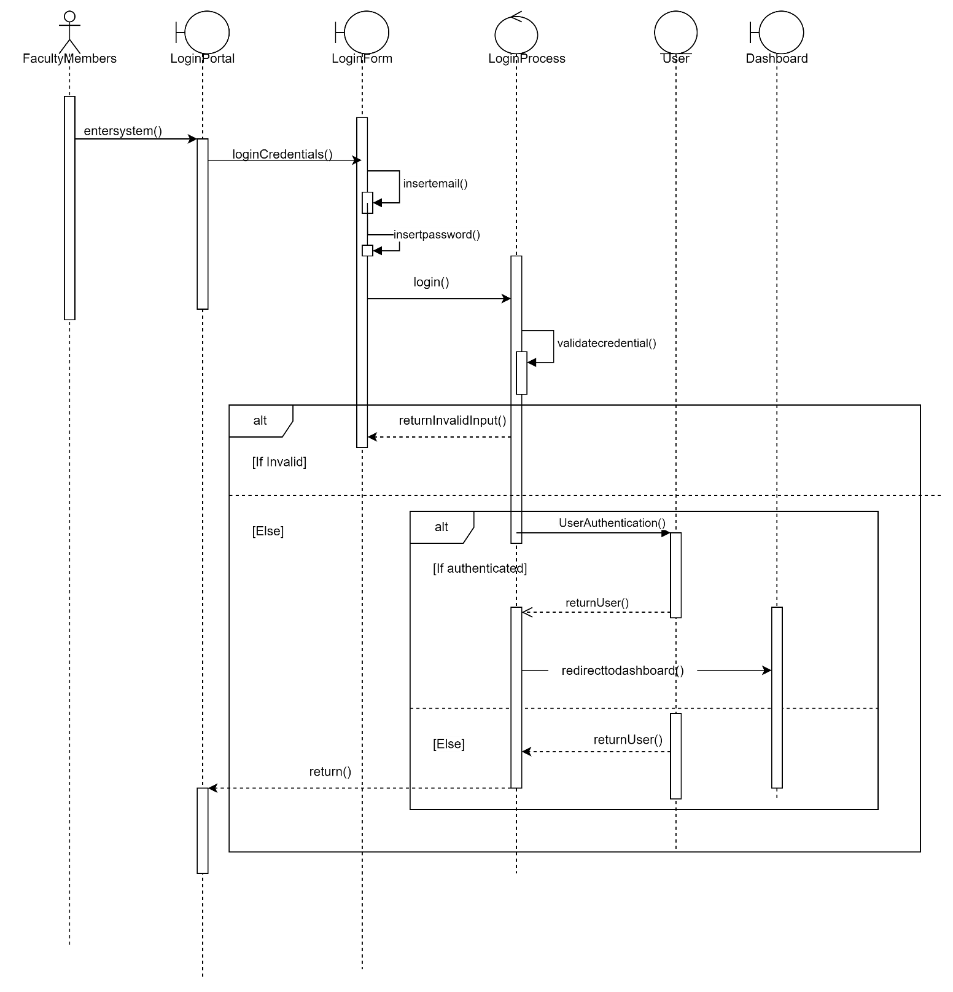

**Figure 3.4: System Sequence Diagram of Login**



**Figure 3.4: Activity Diagram of Login**

* + - 1. **UC002: Use Case View Dashboard Analytics**

1. **Table 3.2: View Dashboard Analytics**

|  |  |
| --- | --- |
| **Use case ID** | UC002 |
| **Use case name** | View Dashboard Analytics |
| **Description** | This use case describes the process through which the users can view dashboard analytics to gain insights into various aspects of the faculty’s research data. |
| **Actor** | Faculty Members, Research officer and Research Manager |
| **Pre-condition** | 1. There is an active network connection to the platform |
| **Normal Flow(s)** | 1. Faculty member/ Research Staff logs into the system with valid credentials. 2. After successful authentication, the user is taken to the system dashboard. 3. User clicks on the dashboard statistics button. 4. The system then retrieves data from the database. EF2 is performed if there’s an error in retrieving data. 5. The system will perform data preprocessing before displaying in the dashboard.    1. Data Cleaning:  * Data cleaning by removing duplicate records or entries. * Excluding incomplete data * Handling missing values by imputing them * Check data errors   1. Data Transformation: * Convert data stored in excel in different format.   1. Data Categorization: * Group data based on specific criteria  1. User will be shown data based on the above methods. 2. User can filter data and can interact with the dashboard. 3. The system will display the pre-processed data in the form of graphs. If data is not available, AF1 will be performed. If there’s an error in retrieving data from database, EF1 will be performed. |
| **Alternative Flow(s)** | 1. **Unavailable Data:**     1. The system displays an error message warning about the unavailability of the data    2. The user is prompted to Continue from NF3 |
| **Exception Flow(s)** | 1. **Connection error with the database:**    1. The system displays an error message.    2. User is prompted to start from NF3. 2. **Error Retrieving data from Database:**    1. System displays an error message.    2. User is prompted to retry. |
| **Post-condition** | 1. User can view the dashboard analytics. |
| **Related Requirement** | - |

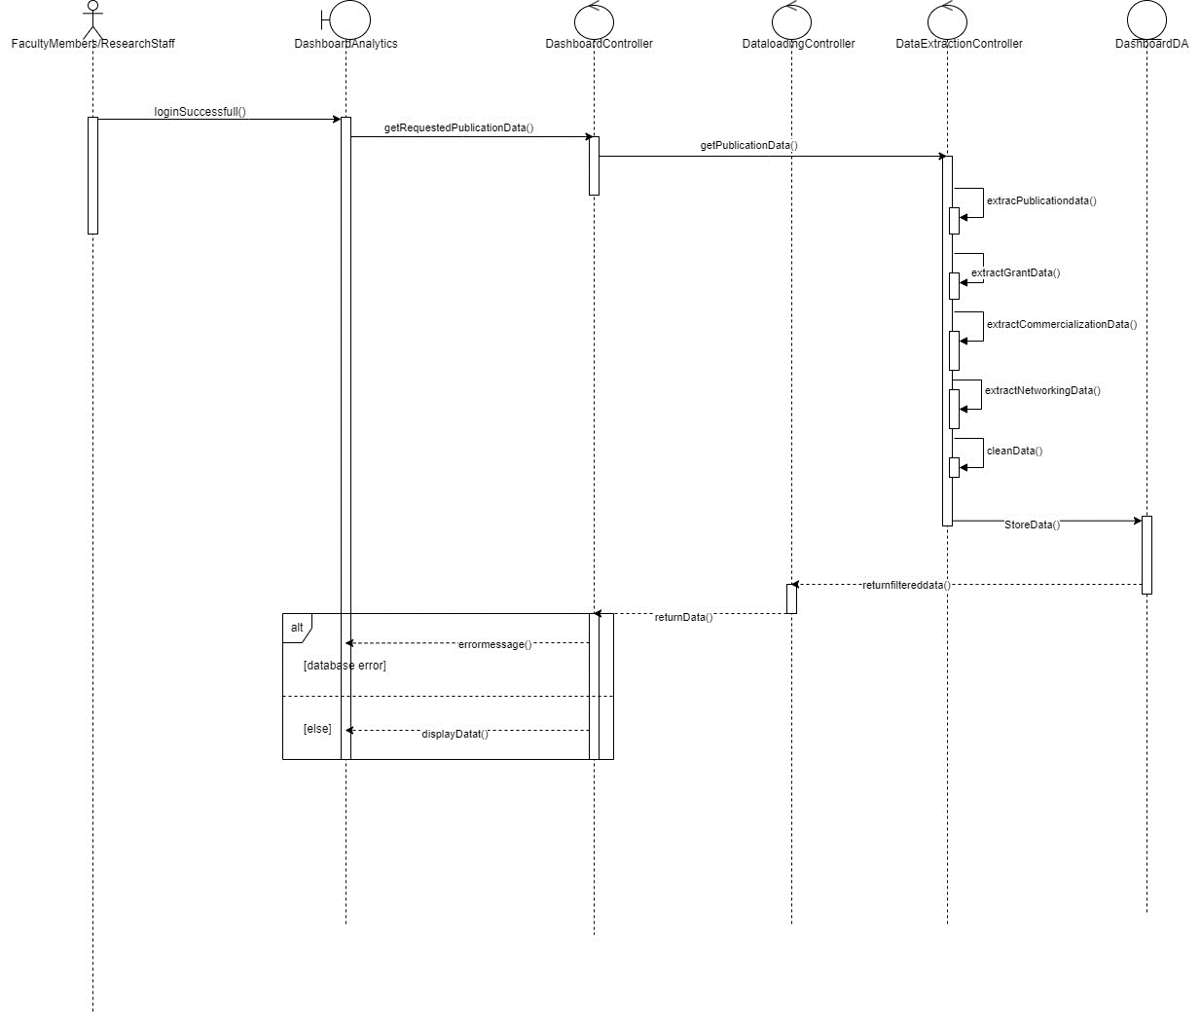

**Figure 3.5: Sequence diagram for View Dashboard Analytics**

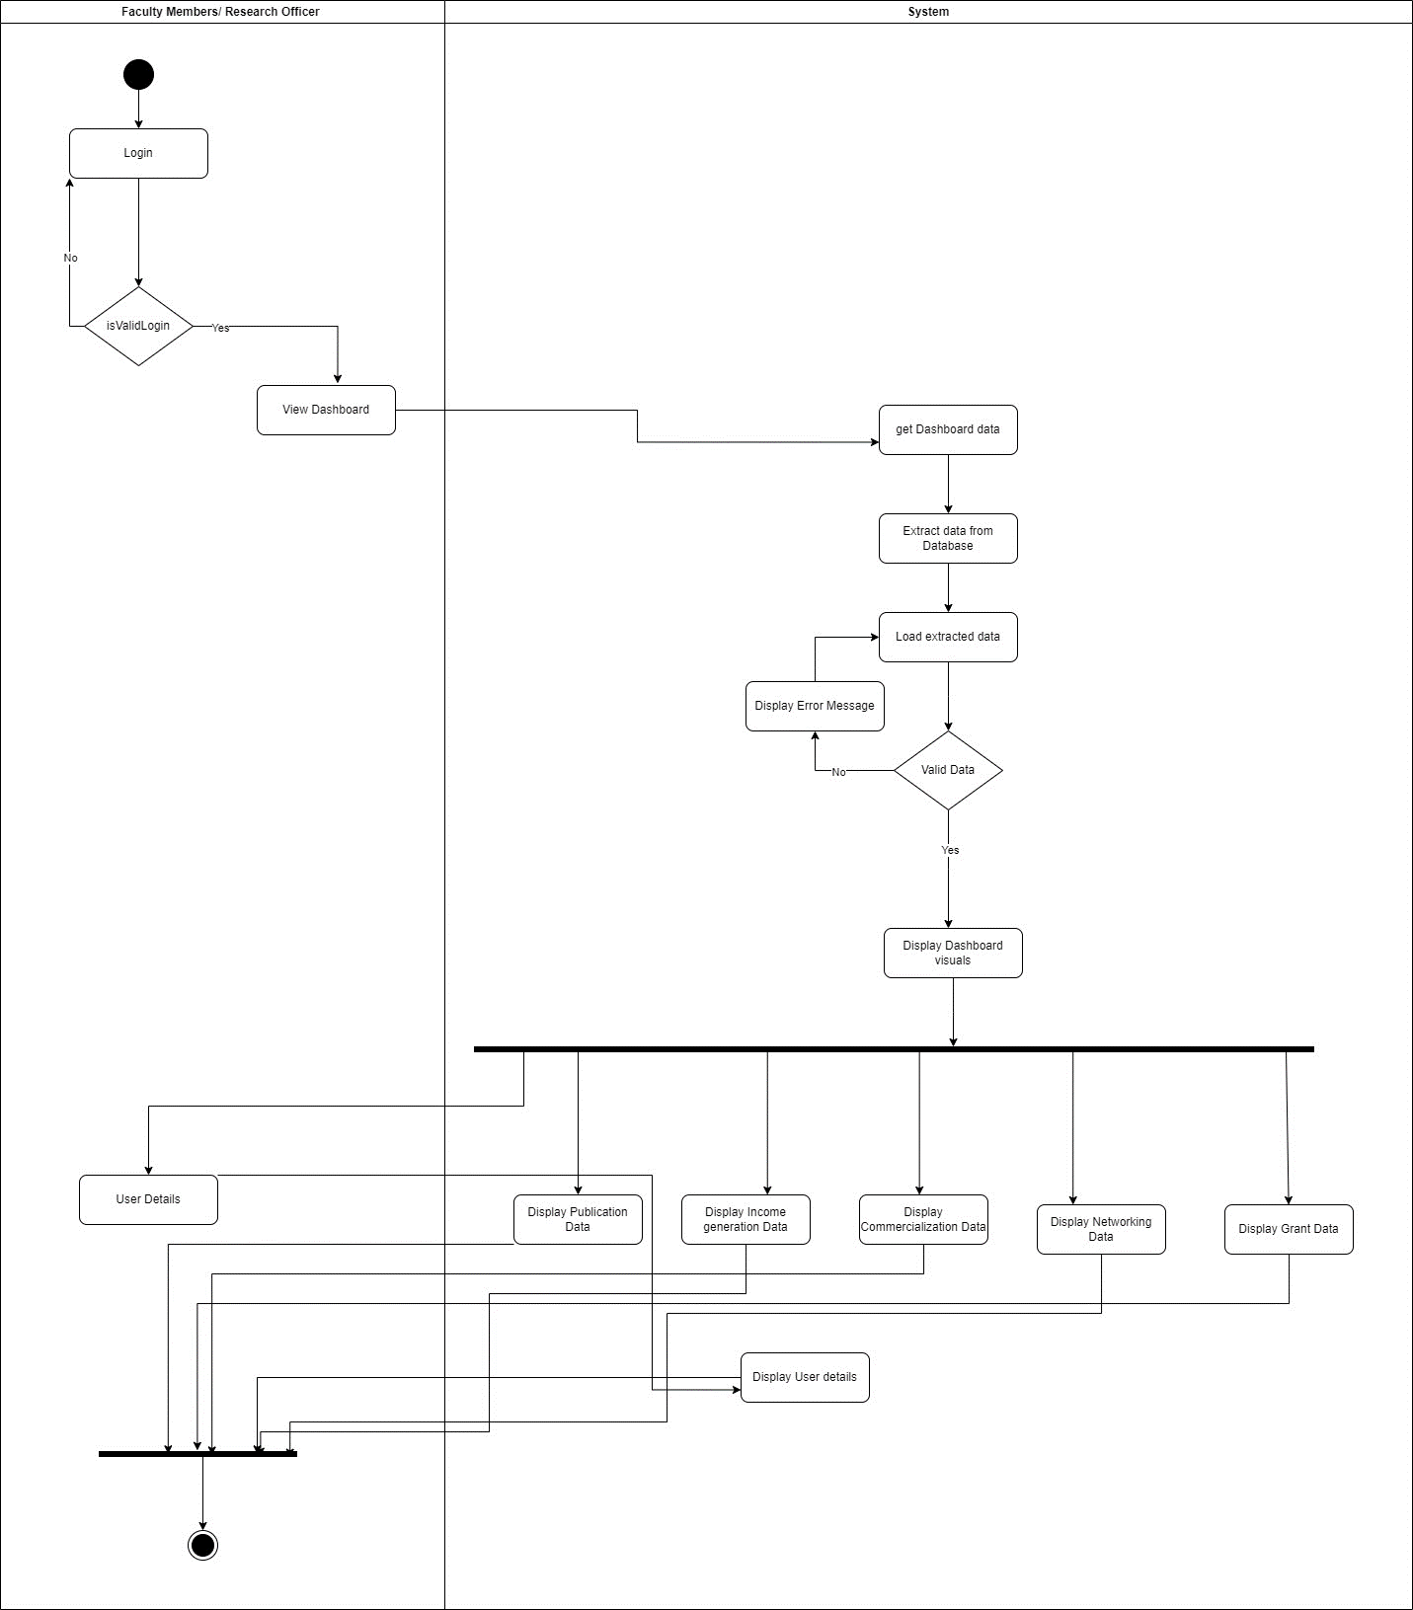

**Figure 3.5: Activity Diagram for View Dashboard Analytics**

* + 1. **Module Publication Subsystem**

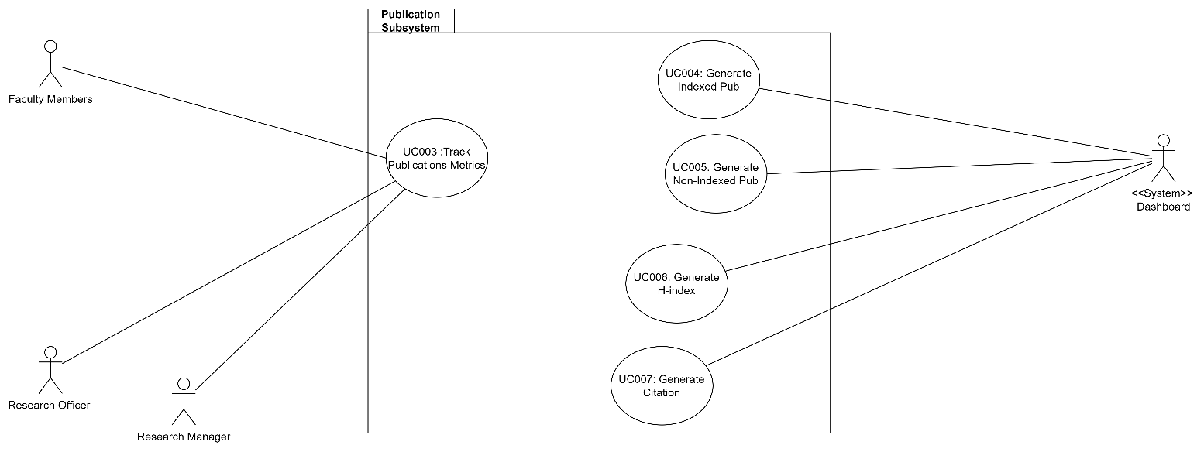

**Figure 3.6: Module Publication Subsystem**

Functional Requirements for the following module are given below:

1. FR001: Track Publication Metrics- The user can view and track the publication metrics of the publications made.
2. FR002: Generate Indexed Publications- The system will generate indexed publications by adapting data science techniques like data cleansing, data filtering, data categorization and data loading.
3. FR003: Generate Non-Indexed Publications- The system will generate non-indexed publications by adapting data science techniques like data cleansing, data filtering, data categorization and data loading.
4. FR004: Generate H-Index Publications- The system will generate H-Index by adapting data science techniques like data cleansing, data filtering, data categorization and data loading.
5. FR005: Generate Citation- The system will generate Citation by adapting data science techniques like data cleansing, data filtering, data categorization and data loading.
   * + 1. **UC003: Use case Track Publication Metrics**

**Table 3.3: Track Publication Metrics**

|  |  |
| --- | --- |
| **Use case ID** | UC003 |
| **Use case name** | Track Publication Metrics |
| **Description** | This use case describes the process through which the users can view Publication metrics generated. |
| **Actor** | Faculty Members, Research officer and Research Manager |
| **Pre-condition** | 1. There is an active network connection to the platform. 2. User needs to be logged in |
| **Normal Flow(s)** | 1. User enters the system. 2. User is taken to the home page after logging in successfully. 3. From the main dashboard page, user clicks on the “Track Publication metrics” option. If no data is available, AF 1 is performed. 4. The system generates the scraping process to retrieve publication data from external sources. 5. The scraped data will undergo data preprocessing before being displayed in the dashboard.    1. Data Cleaning:  * Data cleaning by removing duplicate records or entries. * Excluding incomplete data * Handling missing values by imputing them * Check data errors * Include Title, Authors, Publication date, Indexed Status (indexed or non-indexed)   1. Data Transformation * Convert data stored in excel in different format.  1. System then stores the pre-processed publication data in the database. 2. Publication metrics is updated based on the new publication data. If right data is not displayed, EF3 is performed. 3. User can view the updated publication metrics in the form of graphs and charts allowing them to visualize the growth and development. If there’s a connection error, EF 1 is performed. If there’s an error in retrieving data from database, EF2 is performed. 4. User can view the publication details by hovering over the respective data points in the graphs or charts. |
| **Alternative Flow(s)** | 1. **Unavailable Data:**     1. The system displays a message warning about the unavailability of the data    2. The user is prompted to Continue from NF3 |
| **Exception Flow(s)** | 1. **Connection error with the database:**    1. The system displays an error message.    2. User is prompted to refresh and start from NF8. 2. **Error Retrieving data from Database:**    1. System displays an error message.    2. User is prompted to retry. 3. **Wrong data Displayed:**     1. User will contact administrator.    2. Data preprocessing will be done again. |
| **Post-condition** | User can view and track the publication data metrics. |
| **Related Requirement** | - |

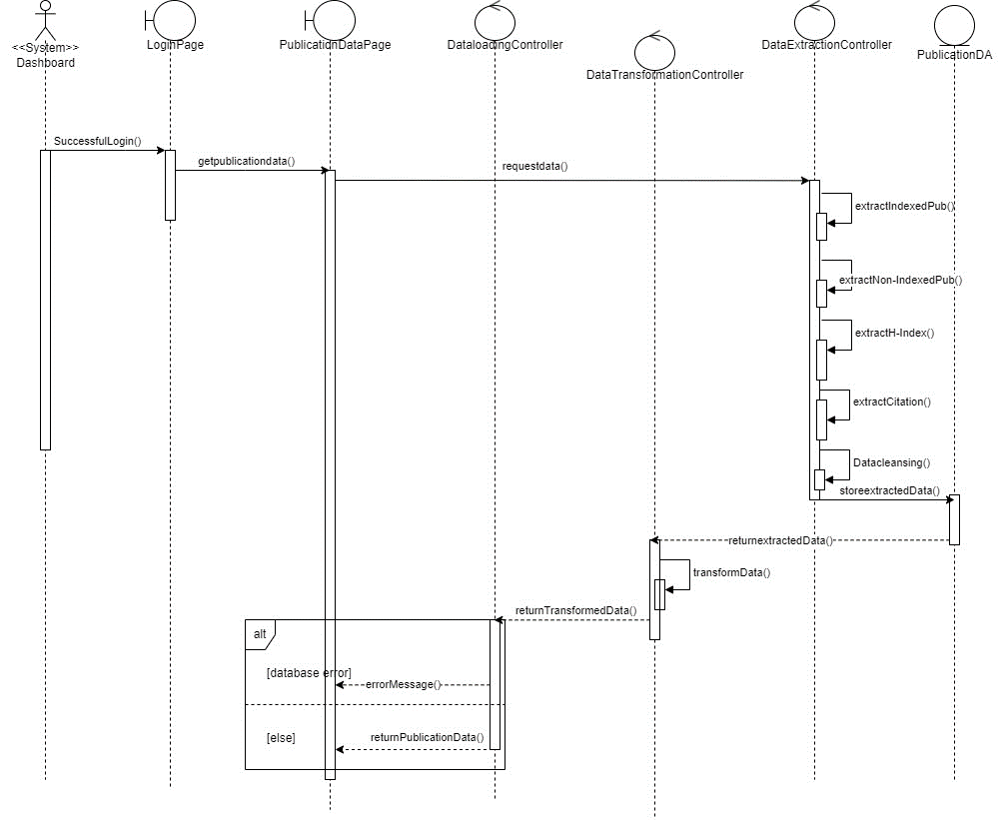

**Figure 3.7: Sequence Diagram for UC003**

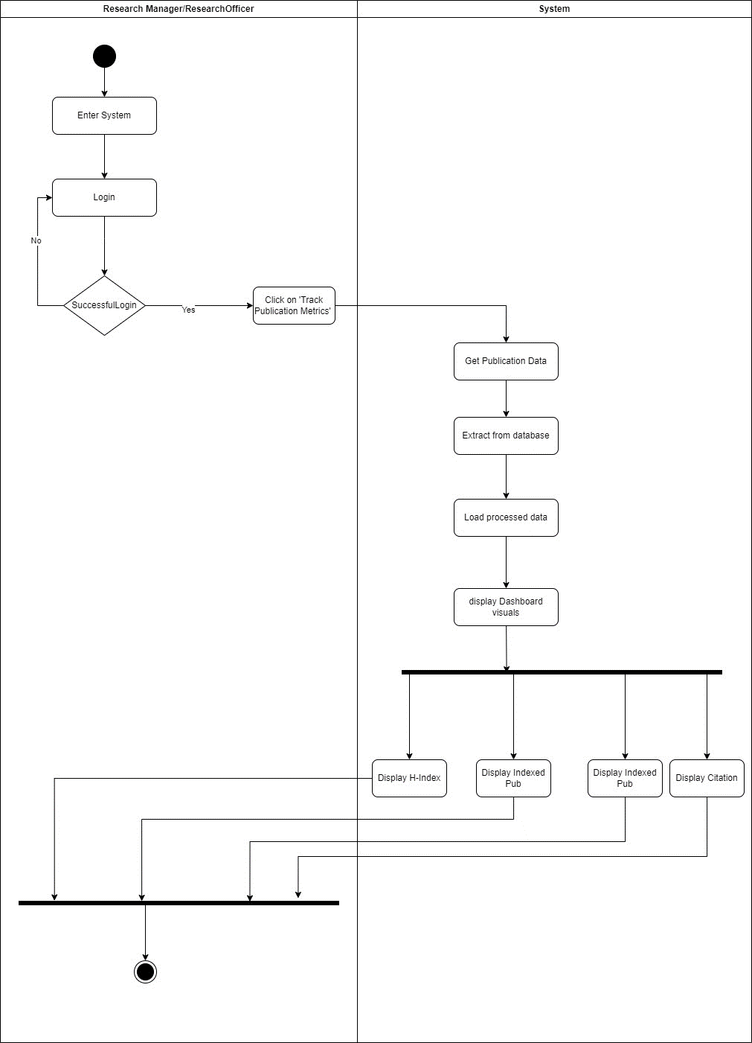

**Figure 3.8: Activity for UC003**

* + - 1. **UC004: Use Case Generate Indexed Publication**

|  |  |
| --- | --- |
| **Use case ID** | UC004 |
| **Use case name** | Generate Indexed Publications |
| **Description** | This use case describes the process through which system generates Indexed Publications. |
| **Actor** | System (Dashboard) |
| **Pre-condition** | 1. There is an active network connection to the platform. |
| **Normal Flow(s)** | 1. User enters the system. 2. User is taken to the home page after logging in successfully. 3. From the main dashboard page, user clicks on the “Track Publication metrics” option. 4. The system generates the scraping process to retrieve publication data including the Indexed Publications from external sources. 5. The scraped data will undergo data preprocessing before being displayed in the dashboard.    1. Data Cleaning:  * Data cleaning by removing duplicate records or entries. * Excluding incomplete data * Handling missing values by imputing them * Check data errors. * Include only the Indexed publication data.  1. System then stores the pre-processed publication data in the database. 2. System displays the Indexed publication data after filtering the publication data and retrieving data from the database. If there’s an error while retrieving data, EF2 will be performed. 3. System displays the data in the form of Bar/Pie chart. 4. User can view the publication details by hovering over the respective data points in the graphs or charts. If the data displayed isn’t correct, EF 3 will be performed. |
| **Alternative Flow(s)** | **-** |
| **Exception Flow(s)** | 1. **Error Retrieving data from Database:**    1. System displays an error message.    2. User is prompted to retry. 2. **Wrong data Displayed:**     1. User will contact administrator.    2. Data preprocessing will be done again. |
| **Post-condition** | User can view and track the publication data metrics. |
| **Related Requirement** | - |

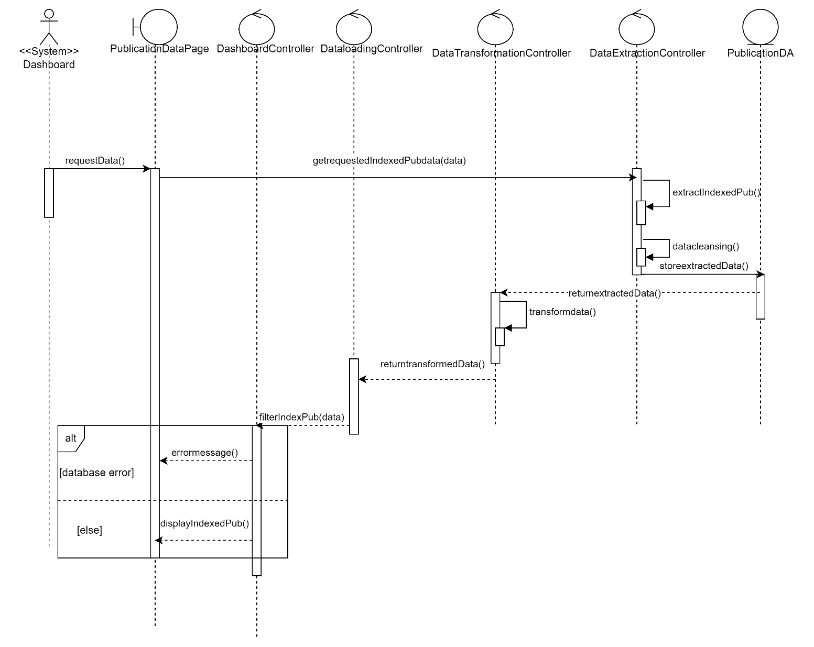

**Figure 3.9: Sequence for UC004**

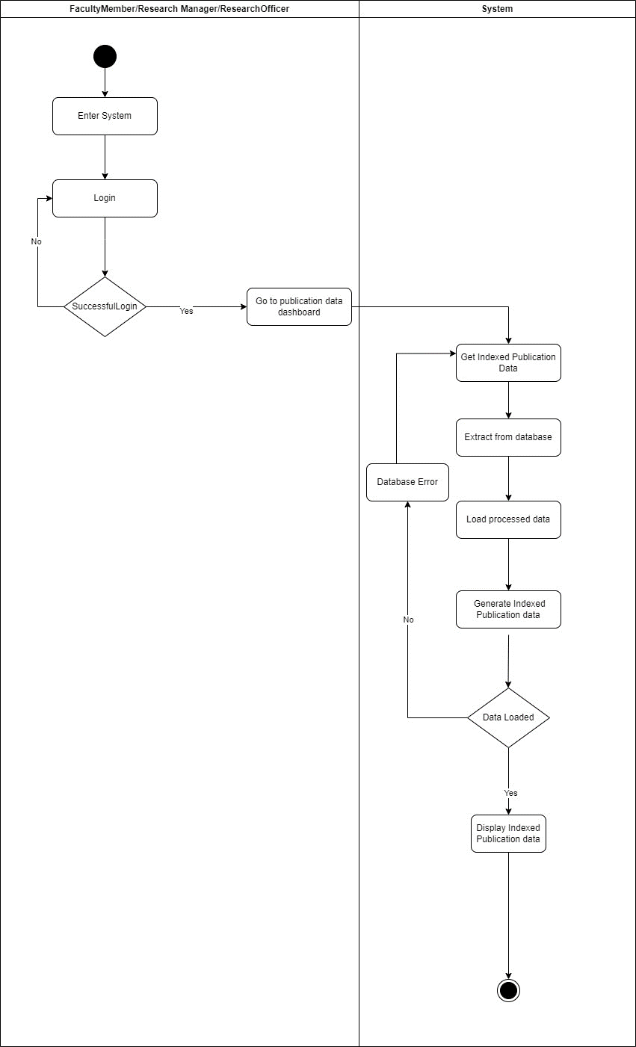

**Figure 3.9: Activity for UC004**

* + - 1. **UC005: Use Case Generate Non-Indexed Publication**

|  |  |
| --- | --- |
| **Use case ID** | UC005 |
| **Use case name** | Generate Non-Indexed Publications |
| **Description** | This use case describes the process through which system generates Non-Indexed Publications. |
| **Actor** | System (Dashboard) |
| **Pre-condition** | 1. There is an active network connection to the platform. |
| **Normal Flow(s)** | 1. User enters the system. 2. User is taken to the home page after logging in successfully. 3. From the main dashboard page, user clicks on the “Track Publication metrics” option. 4. The system generates the scraping process to retrieve publication data including the Non-Indexed Publications from external sources. 5. The scraped data will undergo data preprocessing before being displayed in the dashboard.    1. Data Cleaning:  * Data cleaning by removing duplicate records or entries. * Excluding incomplete data * Handling missing values by imputing them * Check data errors. * Include only the Non-Indexed publication data.  1. System then stores the pre-processed publication data in the database. 2. System displays the non-Indexed publication data after filtering the publication data and retrieving data from the database. If there’s an error while retrieving data, EF2 will be performed. 3. System displays the data in the form of Bar/Pie chart. 4. User can view the publication details by hovering over the respective data points in the graphs or charts. If the data displayed isn’t correct, EF 3 will be performed. |
| **Alternative Flow(s)** | **-** |
| **Exception Flow(s)** | 1. **Error Retrieving data from Database:**    1. System displays an error message.    2. User is prompted to retry. 2. **Wrong data Displayed:**     1. User will contact administrator.    2. Data preprocessing will be done again. |
| **Post-condition** | User can view and track the non-indexed publication data metrics. |
| **Related Requirement** | - |

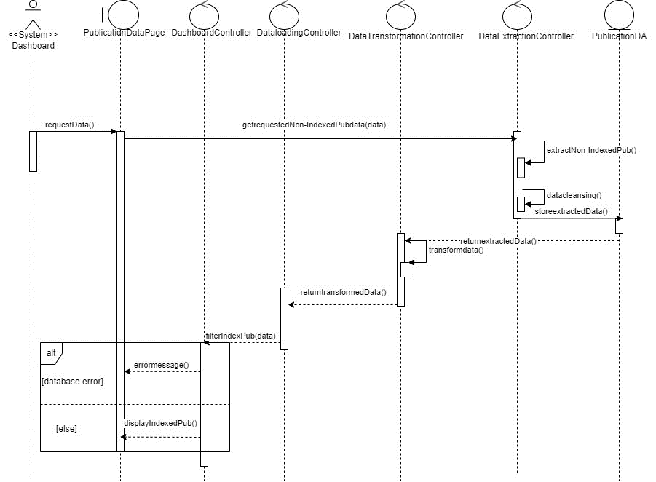

**Figure 3.10: Sequence for UC005**

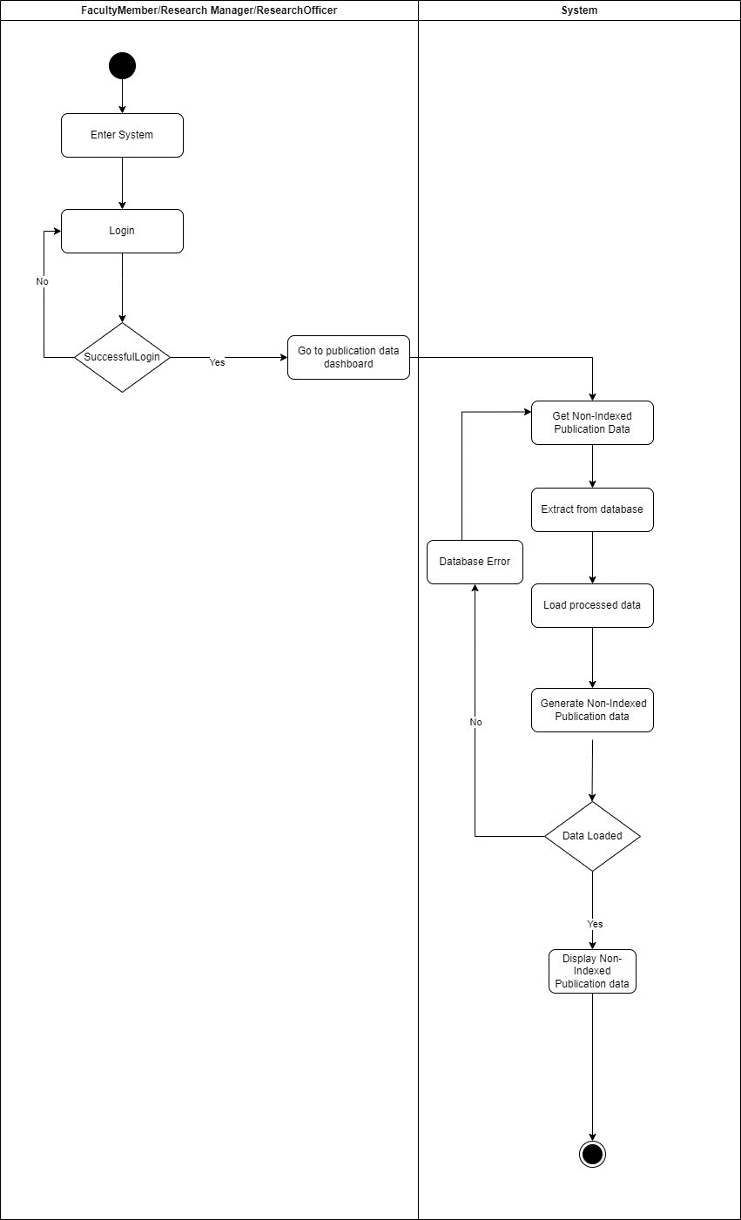

**Figure 3.11: Activity for UC005**

* + - 1. **UC006: Use Case Generate H-Index**

|  |  |
| --- | --- |
| **Use case ID** | UC006 |
| **Use case name** | Generate H-Index |
| **Description** | This use case describes the process through which system generates H-Index. |
| **Actor** | System (Dashboard) |
| **Pre-condition** | 1. There is an active network connection to the platform. |
| **Normal Flow(s)** | 1. User enters the system. 2. User is taken to the home page after logging in successfully. 3. From the main dashboard page, user clicks on the “Track Publication metrics” option. 4. The system generates the scraping process to retrieve publication data including the H-Index Publications from external sources. 5. The scraped data will undergo data preprocessing before being displayed in the dashboard.    1. Data Cleaning:  * Data cleaning by removing duplicate records or entries. * Excluding incomplete data * Handling missing values by imputing them * Check data errors. * Include only the H-Index publication data.  1. System then stores the pre-processed publication data in the database. 2. System displays the H-Index publication data after filtering the publication data and retrieving data from the database. If there’s an error while retrieving data, EF2 will be performed. 3. System displays the data in the form of Bar/Pie chart. 4. User can view the publication details by hovering over the respective data points in the graphs or charts. If the data displayed isn’t correct, EF 3 will be performed. |
| **Alternative Flow(s)** | **-** |
| **Exception Flow(s)** | 1. **Error Retrieving data from Database:**    1. System displays an error message.    2. User is prompted to retry. 2. **Wrong data Displayed:**     1. User will contact administrator.    2. Data preprocessing will be done again. |
| **Post-condition** | User can view and track the H-Index publication data metrics. |
| **Related Requirement** | - |

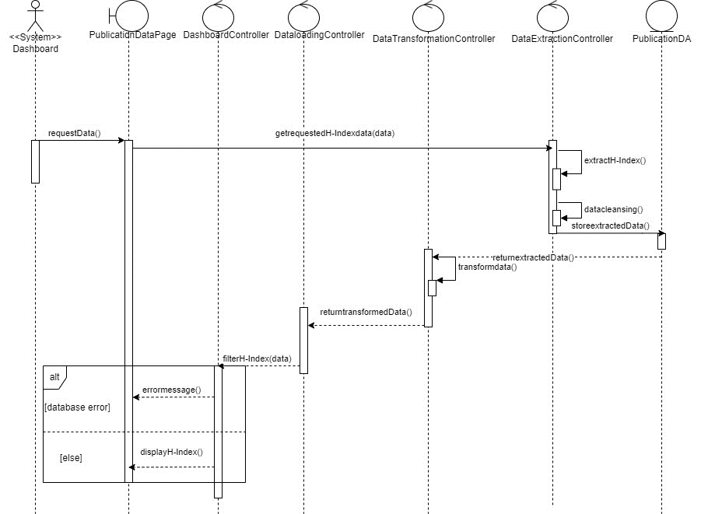

**Figure 3.12: Sequence for UC006**

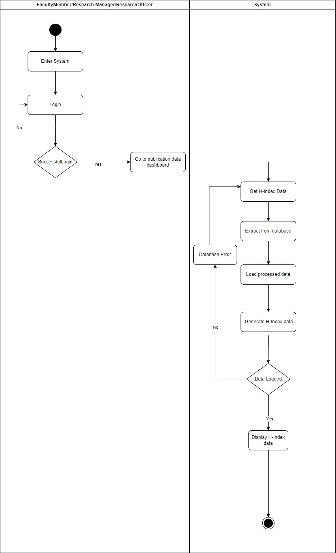

**Figure 3.13: Activity for UC006**

* + - 1. **UC007: Use Case Generate Citation**

|  |  |
| --- | --- |
| **Use case ID** | UC007 |
| **Use case name** | Generate Citation |
| **Description** | This use case describes the process through which system generates Citations. |
| **Actor** | System (Dashboard) |
| **Pre-condition** | 1. There is an active network connection to the platform. |
| **Normal Flow(s)** | 1. User enters the system. 2. User is taken to the home page after logging in successfully. 3. From the main dashboard page, user clicks on the “Track Publication metrics” option. 4. The system generates the scraping process to retrieve publication data including the citation Publications from external sources. 5. The scraped data will undergo data preprocessing before being displayed in the dashboard.    1. Data Cleaning:  * Data cleaning by removing duplicate records or entries. * Excluding incomplete data * Handling missing values by imputing them * Check data errors. * Include only the citation publication data.  1. System then stores the pre-processed publication data in the database. 2. System displays the citation publication data after filtering the publication data and retrieving data from the database. If there’s an error while retrieving data, EF2 will be performed. 3. System displays the data in the form of Bar/Pie chart. 4. User can view the publication details by hovering over the respective data points in the graphs or charts. If the data displayed isn’t correct, EF 3 will be performed. |
| **Alternative Flow(s)** | **-** |
| **Exception Flow(s)** | 1. **Error Retrieving data from Database:**    1. System displays an error message.    2. User is prompted to retry. 2. **Wrong data Displayed:**     1. User will contact administrator.    2. Data preprocessing will be done again. |
| **Post-condition** | User can view and track the citation data. |
| **Related Requirement** | - |

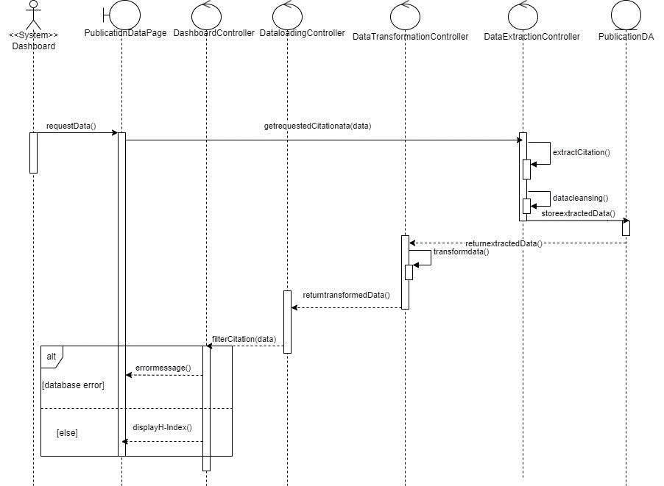

**Figure 3.14: Activity for UC007**



**Figure 3.15: Activity for UC007**

* + 1. **Module Commercialization Subsystem**

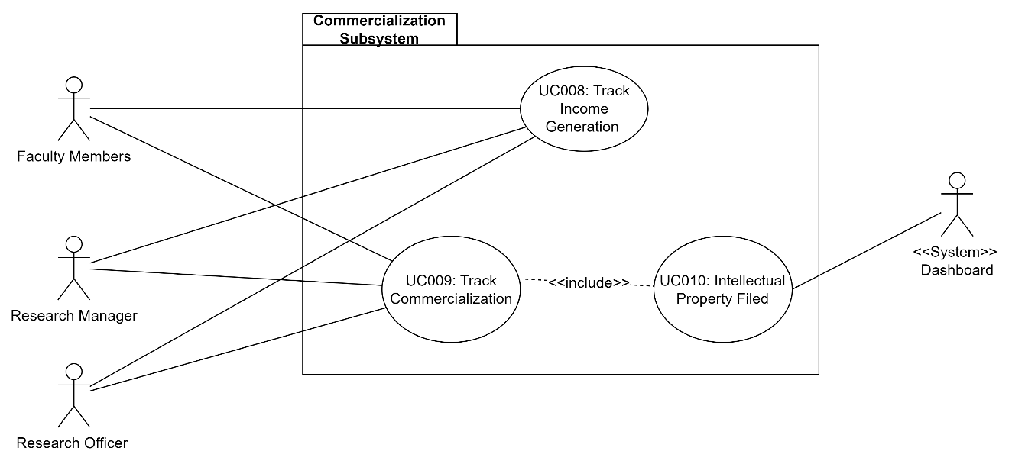

Functional Requirements are given below:

* 1. FR001: Track Income Generation: This will allow the Research staff to track the income generation of the faculty.
  2. FR002: Track Commercialization: This will allow the Research staff to track the commercialization data of the faculty of computing.
  3. FR003: This will allow the system dashboard to generate the data of Intellectual Property filed.
     + 1. **UC008: Use case Track Income Generation**

|  |  |
| --- | --- |
| **Use case ID** | UC008 |
| **Use case name** | Track Income Generation |
| **Description** | This use case describes the process through which the users can view and track the Income Generation metrics. |
| **Actor** | Faculty Members, Research officer and Research Manager |
| **Pre-condition** | 1. There is an active network connection to the platform. 2. User needs to be logged in |
| **Normal Flow(s)** | 1. User enters the system. 2. User is taken to the home page after logging in successfully. 3. From the main dashboard page, user clicks on the “Track Income Generated metrics” option. If no data is available, AF 1 is performed. 4. The system generates the scraping process to retrieve Income Generation data from external sources. 5. The scraped data will undergo data preprocessing before being displayed in the dashboard.    1. Data Cleaning:  * Data cleaning by removing duplicate records or entries. * Excluding incomplete data * Handling missing values by imputing them * Check data errors * Include conference organized, training Conducted   1. Data Transformation * Convert data stored in excel in different format.  1. System then stores the pre-processed publication data in the database. 2. Income Generation metrics is updated based on the new Income Generation data. If right data is not displayed, EF3 is performed. 3. User can view the updated Income generation metrics in the form of graphs and charts allowing them to visualize the growth and development. If there’s a connection error, EF 1 is performed. If there’s an error in retrieving data from database, EF2 is performed. 4. User can view the Income Generation details by hovering over the respective data points in the graphs or charts. |
| **Alternative Flow(s)** | 1. **Unavailable Data:**     1. The system displays a message warning about the unavailability of the data.    2. The user is prompted to Continue from NF3 |
| **Exception Flow(s)** | 1. **Connection error with the database:**    1. The system displays an error message.    2. User is prompted to refresh and start from NF8. 2. **Error Retrieving data from Database:**    1. System displays an error message.    2. User is prompted to retry. 3. **Wrong data Displayed:**     1. User will contact administrator.    2. Data preprocessing will be done again. |
| **Post-condition** | User can view and track the Income Generation data. |
| **Related Requirement** | - |

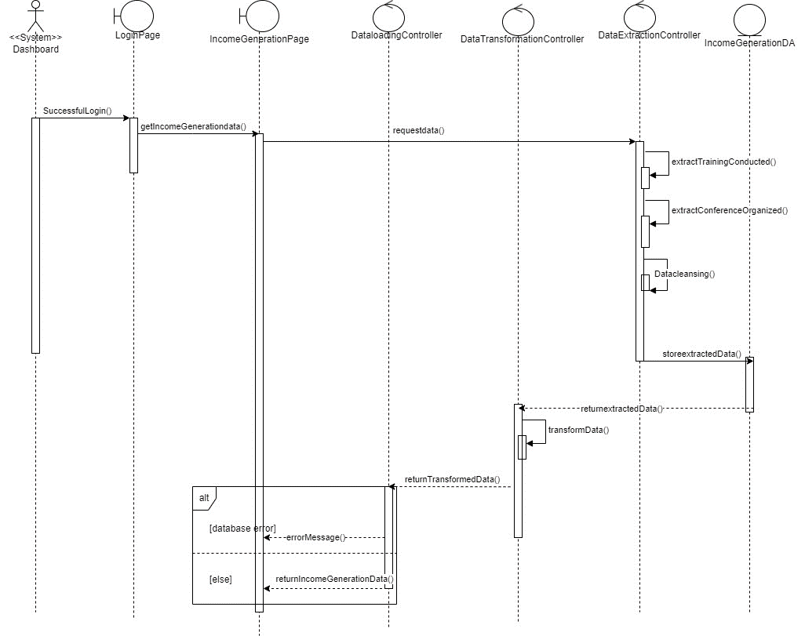

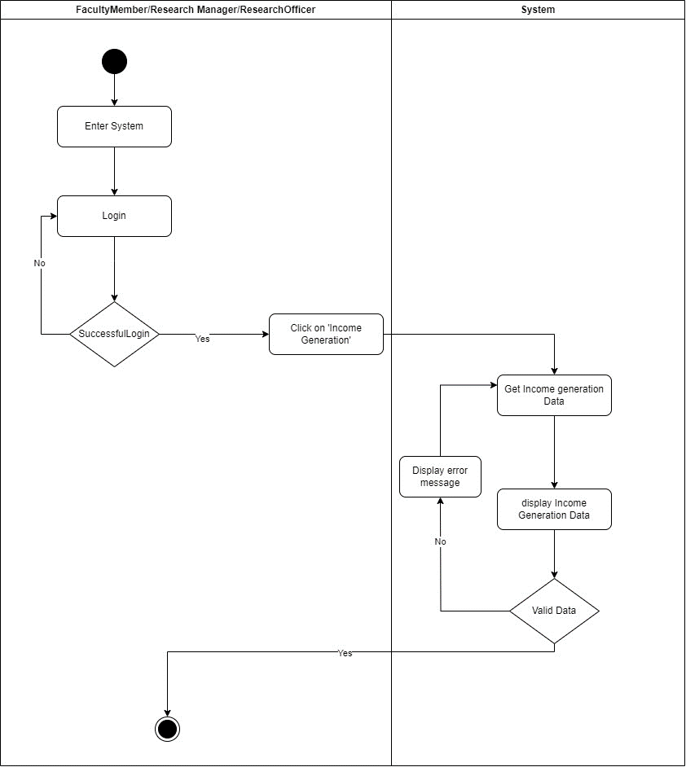

* + - 1. **UC009: Use Case Track Commercialization**

|  |  |
| --- | --- |
| **Use case ID** | UC009 |
| **Use case name** | Track Commercialization |
| **Description** | This use case describes the process through which the users can view and track the Commercialization Data. |
| **Actor** | Faculty Members, Research officer and Research Manager |
| **Pre-condition** | 1. There is an active network connection to the platform. 2. User needs to be logged in. |
| **Normal Flow(s)** | 1. User enters the system. 2. User is taken to the home page after logging in successfully. 3. From the main dashboard page, user clicks on the “Commercialization” option. If no data is available, AF 1 is performed. 4. The system generates the scraping process to retrieve Commercialization data from external sources. 5. The scraped data will undergo data preprocessing before being displayed in the dashboard.    1. Data Cleaning:  * Data cleaning by removing duplicate records or entries. * Excluding incomplete data * Handling missing values by imputing them * Check data errors * Include Intellectual Property filed.   1. Data Transformation * Convert data stored in excel in different format.  1. System then stores the pre-processed Commercialization data in the database. 2. Commercialization metrics is updated based on the new Commercialization data. If right data is not displayed, EF3 is performed. 3. User can view the updated Commercialization in the form of graphs and charts allowing them to visualize the growth and development. If there’s a connection error, EF 1 is performed. If there’s an error in retrieving data from database, EF2 is performed. 4. User can view the Commercialization details by hovering over the respective data points in the graphs or charts. |
| **Alternative Flow(s)** | 1. **Unavailable Data:**     1. The system displays a message warning about the unavailability of the data.    2. The user is prompted to Continue from NF3 |
| **Exception Flow(s)** | 1. **Connection error with the database:**    1. The system displays an error message.    2. User is prompted to refresh and start from NF8. 2. **Error Retrieving data from Database:**    1. System displays an error message.    2. User is prompted to retry. 3. **Wrong data Displayed:**     1. User will contact administrator.    2. Data preprocessing will be done again. |
| **Post-condition** | User can view and track the Commercialization data. |
| **Related Requirement** | - |

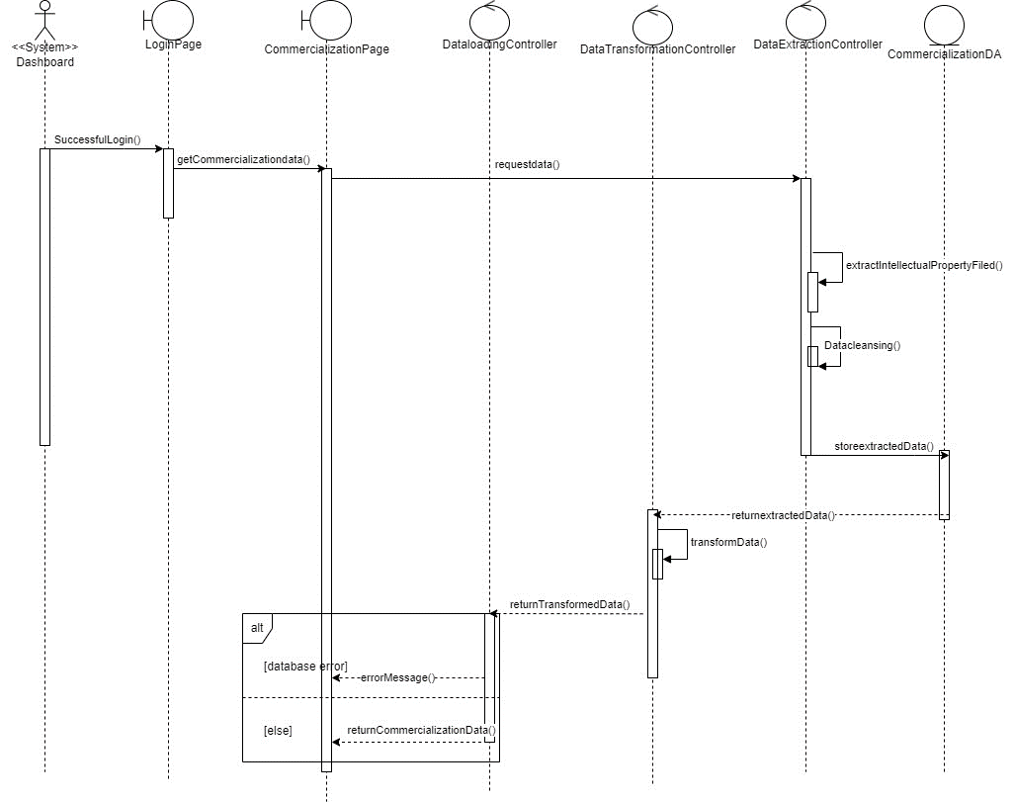

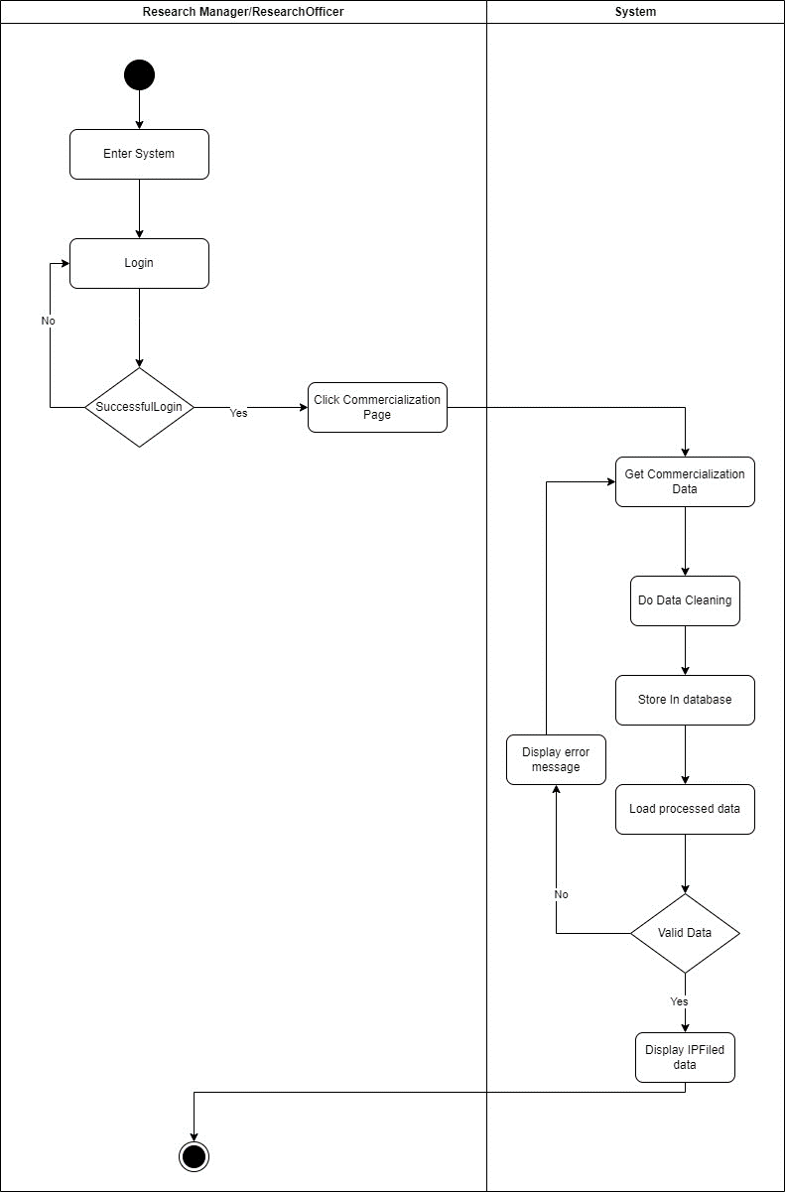

* + - 1. **UC010: Use Case Generate Intellectual Property Filed**

|  |  |
| --- | --- |
| **Use case ID** | UC010 |
| **Use case name** | Generate Intellectual Property Filed |
| **Description** | This use case describes the process through which system generates Intellectual Property Filed. |
| **Actor** | System (Dashboard) |
| **Pre-condition** | 1. There is an active network connection to the platform. |
| **Normal Flow(s)** | 1. User enters the system. 2. User is taken to the home page after logging in successfully. 3. From the main dashboard page, user clicks on the “Track Commercialization” option. 4. The system generates the scraping process to retrieve Intellectual Property Filed data from external sources. 5. The scraped data will undergo data preprocessing before being displayed in the dashboard.    1. Data Cleaning:  * Data cleaning by removing duplicate records or entries. * Excluding incomplete data * Handling missing values by imputing them * Check data errors. * Data will include Intellectual Property Filed.  1. System then stores the pre-processed Intellectual property data in the database. 2. System displays the Intellectual Property data after filtering the data and retrieving data from the database. If there’s an error while retrieving data, EF1 will be performed. 3. System displays the data in the form of Bar/Pie chart. 4. User can view the IP filed data details by hovering over the respective data points in the graphs or charts. If the data displayed isn’t correct, EF 2 will be performed. |
| **Alternative Flow(s)** | **-** |
| **Exception Flow(s)** | 1. **Error Retrieving data from Database:**    1. System displays an error message.    2. User is prompted to retry. 2. **Wrong data Displayed:**     1. User will contact administrator.    2. Data preprocessing will be done again. |
| **Post-condition** | User can view and track the Intellectual Property Filed data. |
| **Related Requirement** | - |

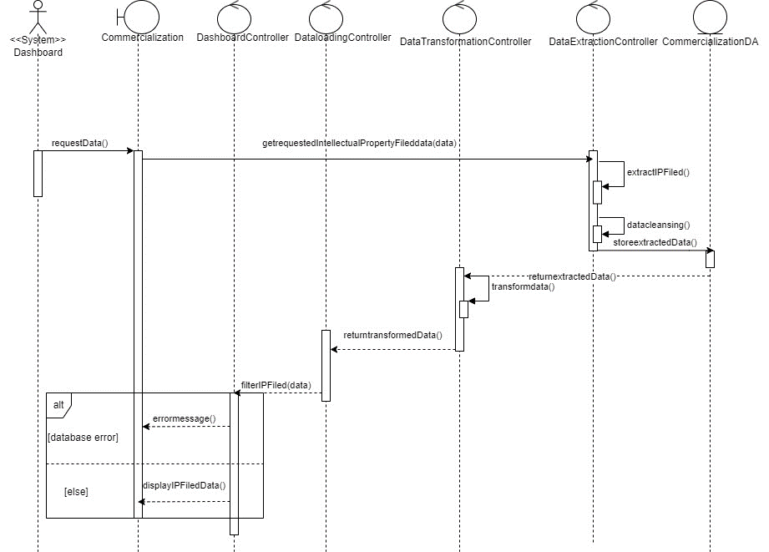

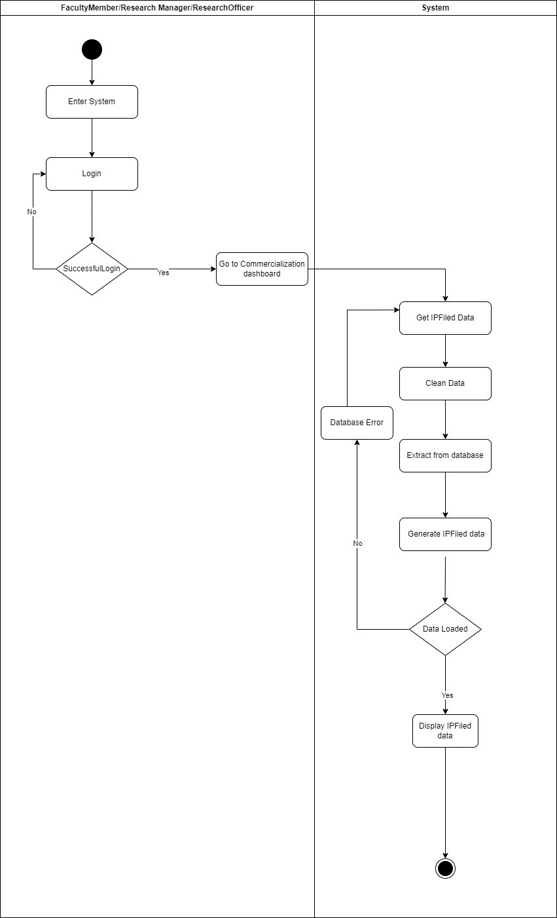

* + 1. **Module Networking Subsystem**

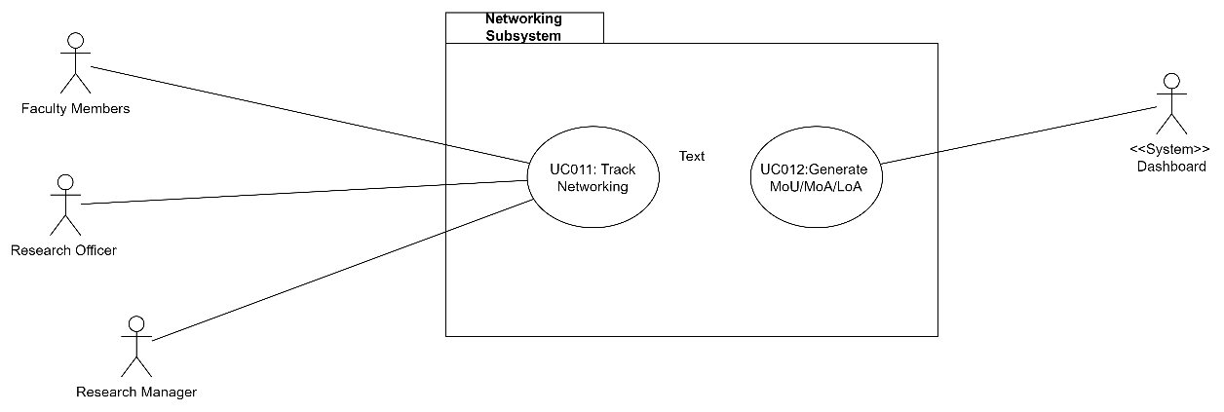

Functional Requirements are given below:

1. FR001: Track Networking: This will allow the Research staff to track the networking data of the faculty.
2. FR002: Generate the agreement details: This will allow the system dashboard to generate the data of agreements.
   * + 1. **UC011: Use Case Track Networking**

|  |  |
| --- | --- |
| **Use case ID** | UC011 |
| **Use case name** | Track Networking |
| **Description** | This use case describes the process through which the users can view and track the Networking Data. |
| **Actor** | Faculty Members, Research officer and Research Manager |
| **Pre-condition** | 1. There is an active network connection to the platform. 2. User needs to be logged in. |
| **Normal Flow(s)** | 1. User enters the system. 2. User is taken to the home page after logging in successfully. 3. From the main dashboard page, user clicks on the “Networking” option. If no data is available, AF 1 is performed. 4. The system generates the scraping process to retrieve Networking data from external sources. 5. The scraped data will undergo data preprocessing before being displayed in the dashboard.    1. Data Cleaning:  * Data cleaning by removing duplicate records or entries. * Excluding incomplete data * Handling missing values by imputing them * Check data errors * Include MoU/MoA/LoA.   1. Data Transformation * Convert data stored in excel in different format.  1. System then stores the pre-processed Networking data in the database. 2. Networking metrics is updated based on the new Networking data. If right data is not displayed, EF3 is performed. 3. User can view the updated Networking in the form of graphs and charts allowing them to visualize the growth and development. If there’s a connection error, EF 1 is performed. If there’s an error in retrieving data from database, EF2 is performed. 4. User can view the Networking details by hovering over the respective data points in the graphs or charts. |
| **Alternative Flow(s)** | 1. **Unavailable Data:**     1. The system displays a message warning about the unavailability of the data.    2. The user is prompted to Continue from NF3 |
| **Exception Flow(s)** | 1. **Connection error with the database:**    1. The system displays an error message.    2. User is prompted to refresh and start from NF8. 2. **Error Retrieving data from Database:**    1. System displays an error message.    2. User is prompted to retry. 3. **Wrong data Displayed:**     1. User will contact administrator.    2. Data preprocessing will be done again. |
| **Post-condition** | User can view and track the Networking data. |
| **Related Requirement** | - |

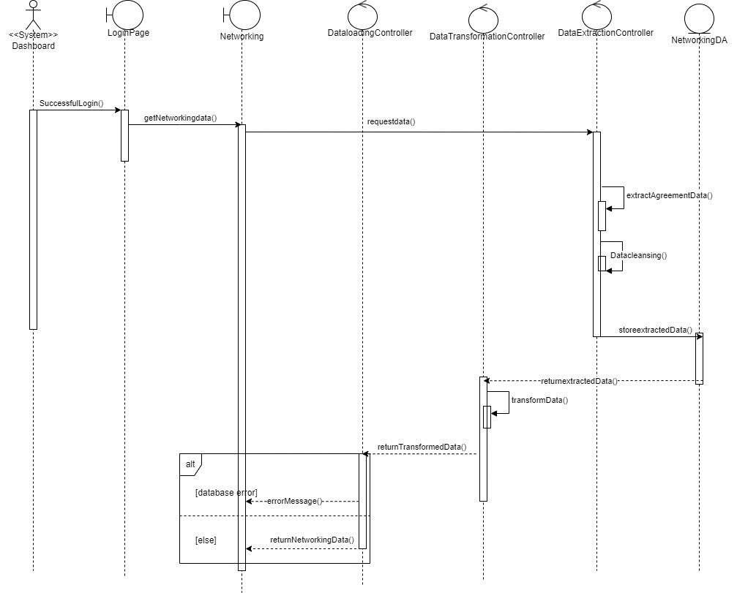

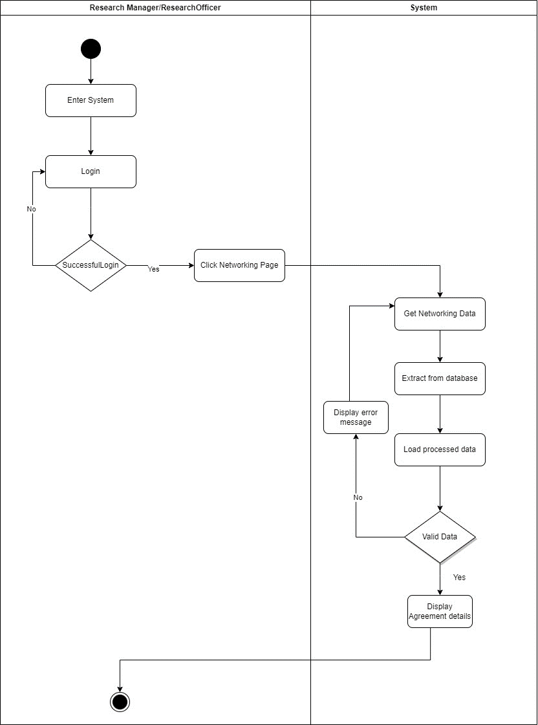

* + - 1. **UC012: Use Case Generate MoU/LoA/MoA**

|  |  |
| --- | --- |
| **Use case ID** | UC012 |
| **Use case name** | Generate Agreement Data |
| **Description** | This use case describes the process through which system generates Agreement Data. |
| **Actor** | System (Dashboard) |
| **Pre-condition** | 1. There is an active network connection to the platform. |
| **Normal Flow(s)** | 1. User enters the system. 2. User is taken to the home page after logging in successfully. 3. From the main dashboard page, user clicks on the “Track Networking” option. 4. The system generates the scraping process to retrieve Agreement data from external sources. 5. The scraped data will undergo data preprocessing before being displayed in the dashboard.    1. Data Cleaning:  * Data cleaning by removing duplicate records or entries. * Excluding incomplete data * Handling missing values by imputing them * Check data errors. * Data will include MoU/MoA/LoA.  1. System then stores the pre-processed Agreement data in the database. 2. System displays the Agreement data after filtering the data and retrieving data from the database. If there’s an error while retrieving data, EF1 will be performed. 3. System displays the data in the form of Bar/Pie chart. 4. User can view the Agreement Data details by hovering over the respective data points in the graphs or charts. If the data displayed isn’t correct, EF 2 will be performed. |
| **Alternative Flow(s)** | **-** |
| **Exception Flow(s)** | 1. **Error Retrieving data from Database:**    1. System displays an error message.    2. User is prompted to retry. 2. **Wrong data Displayed:**     1. User will contact administrator.    2. Data preprocessing will be done again. |
| **Post-condition** | User can view and track the Intellectual Property Filed data. |
| **Related Requirement** | - |

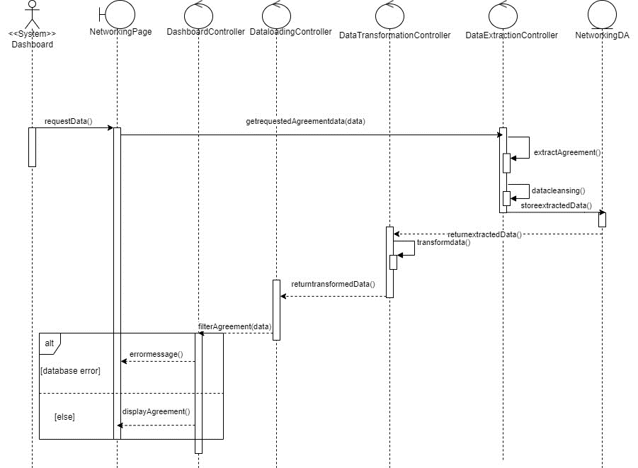

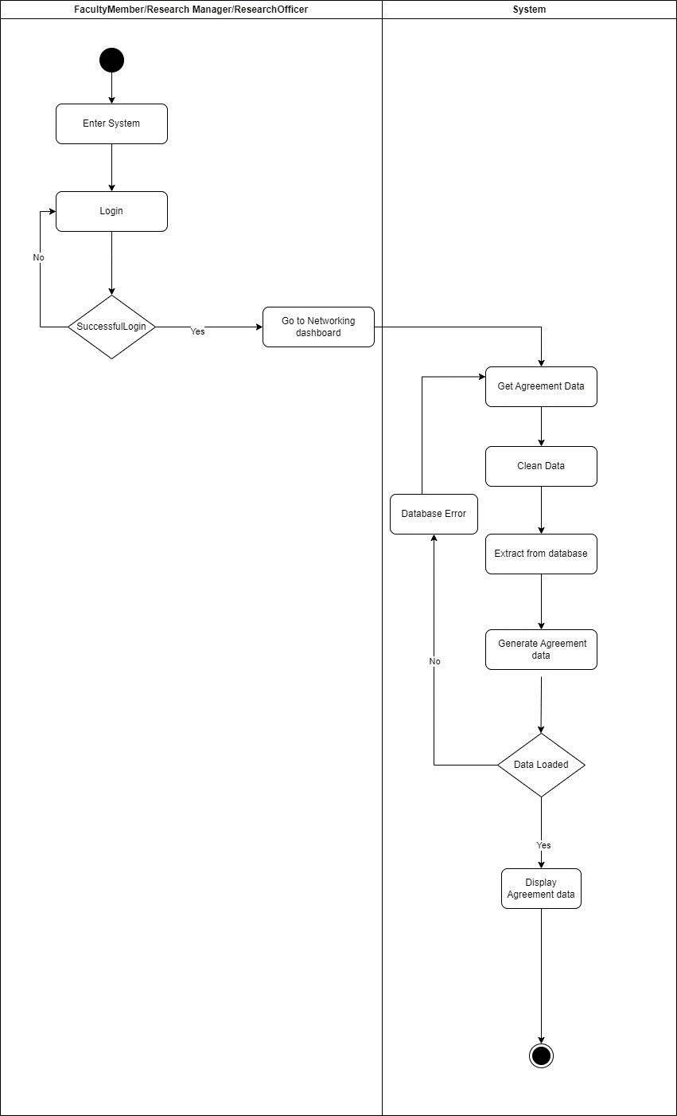

* + 1. **Module Grant Subsystem**

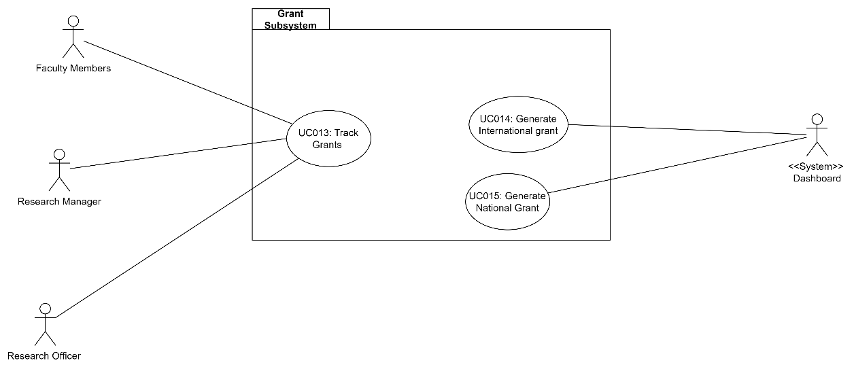

Functional Requirements are given below:

1. FR001: Track Grant: This will allow the Research staff to track the Grant of the faculty.
2. FR002: Generate International Grant: This will allow the System to generate International Grant.
3. FR003: Generate National Grant: This will allow the System to generate National Grant.
   * + 1. **Use Case Track Grant**

|  |  |
| --- | --- |
| **Use case ID** | UC011 |
| **Use case name** | Track Grant |
| **Description** | This use case describes the process through which the users can view and track the Grant Data. |
| **Actor** | Faculty Members, Research officer and Research Manager |
| **Pre-condition** | 1. There is an active network connection to the platform. 2. User needs to be logged in. |
| **Normal Flow(s)** | 1. User enters the system. 2. User is taken to the home page after logging in successfully. 3. From the main dashboard page, user clicks on the “Grant” option. If no data is available, AF 1 is performed. 4. The system generates the scraping process to retrieve Grant data from external sources. 5. The scraped data will undergo data preprocessing before being displayed in the dashboard.    1. Data Cleaning:  * Data cleaning by removing duplicate records or entries. * Excluding incomplete data * Handling missing values by imputing them * Check data errors * Include International and national grant.   1. Data Transformation * Convert data stored in excel in different format.  1. System then stores the pre-processed Grant data in the database. 2. Grant data metrics is updated based on the new Grant data. If right data is not displayed, EF3 is performed. 3. User can view the updated Grant in the form of graphs and charts allowing them to visualize the growth and development. If there’s a connection error, EF 1 is performed. If there’s an error in retrieving data from database, EF2 is performed. 4. User can view the Grant details by hovering over the respective data points in the graphs or charts. |
| **Alternative Flow(s)** | 1. **Unavailable Data:**     1. The system displays a message warning about the unavailability of the data.    2. The user is prompted to Continue from NF3 |
| **Exception Flow(s)** | 1. **Connection error with the database:**    1. The system displays an error message.    2. User is prompted to refresh and start from NF8. 2. **Error Retrieving data from Database:**    1. System displays an error message.    2. User is prompted to retry. 3. **Wrong data Displayed:**     1. User will contact administrator.    2. Data preprocessing will be done again. |
| **Post-condition** | User can view and track the Networking data. |
| **Related Requirement** | - |

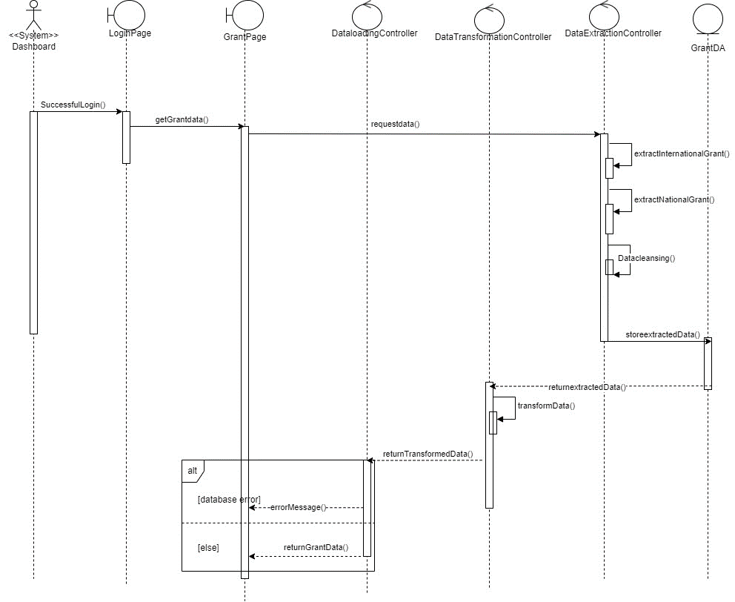

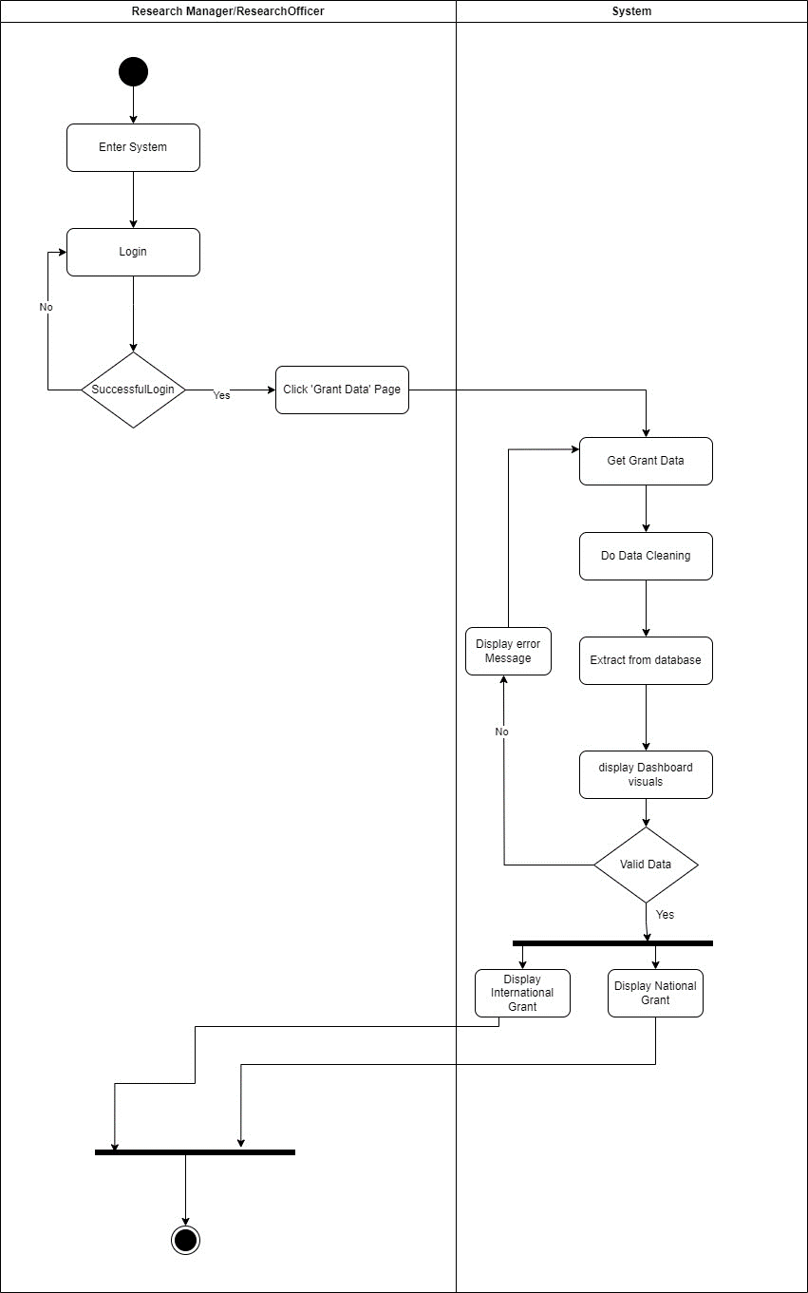

* + - 1. **UC014: Use Case Generate International Grant Data**

|  |  |
| --- | --- |
| **Use case ID** | UC014 |
| **Use case name** | Generate International Grant Data |
| **Description** | This use case describes the process through which system generates International Grant Data. |
| **Actor** | System (Dashboard) |
| **Pre-condition** | 1. There is an active network connection to the platform. |
| **Normal Flow(s)** | 1. User enters the system. 2. User is taken to the home page after logging in successfully. 3. From the main dashboard page, user clicks on the “Track Grant” option. 4. The system generates the scraping process to retrieve International Grant data from external sources. 5. The scraped data will undergo data preprocessing before being displayed in the dashboard.    1. Data Cleaning:  * Data cleaning by removing duplicate records or entries. * Excluding incomplete data * Handling missing values by imputing them * Check data errors. * Data is related to International Grant  1. System then stores the pre-processed international data in the database. 2. System displays the international data after filtering the data and retrieving data from the database. If there’s an error while retrieving data, EF1 will be performed. 3. System displays the data in the form of Bar/Pie chart. 4. User can view the international Data details by hovering over the respective data points in the graphs or charts. If the data displayed isn’t correct, EF 2 will be performed. |
| **Alternative Flow(s)** | **-** |
| **Exception Flow(s)** | 1. **Error Retrieving data from Database:**    1. System displays an error message.    2. User is prompted to retry. 2. **Wrong data Displayed:**     1. User will contact administrator.    2. Data preprocessing will be done again. |
| **Post-condition** | User can view details of the International Grants data. |
| **Related Requirement** | - |

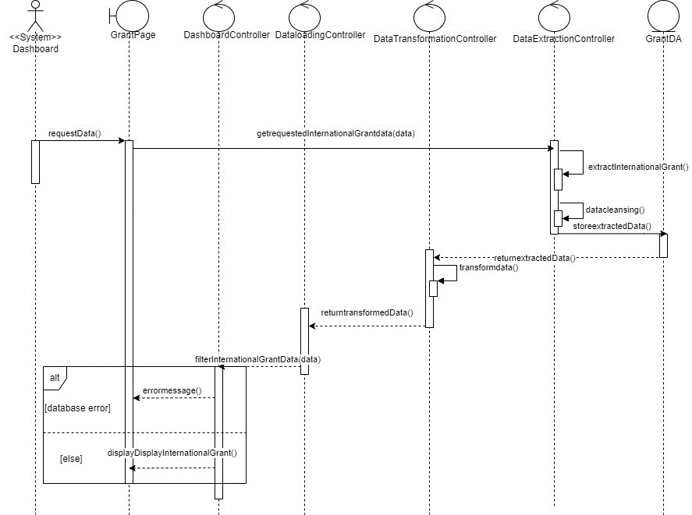

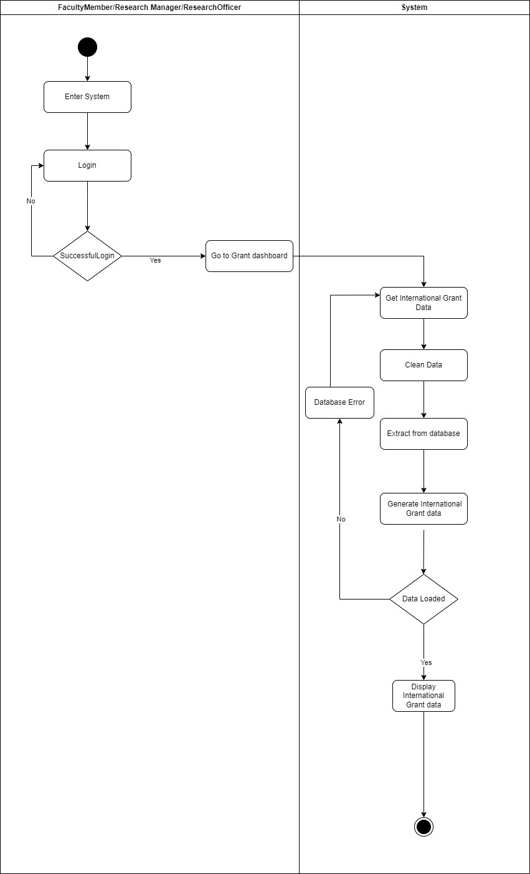

* + - 1. **UC015: Use Case Generate National Grant Data**

|  |  |
| --- | --- |
| **Use case ID** | UC015 |
| **Use case name** | Generate National Grant Data |
| **Description** | This use case describes the process through which system generates National Grant Data. |
| **Actor** | System (Dashboard) |
| **Pre-condition** | 1. There is an active network connection to the platform. |
| **Normal Flow(s)** | 1. User enters the system. 2. User is taken to the home page after logging in successfully. 3. From the main dashboard page, user clicks on the “Track Grant” option. 4. The system generates the scraping process to retrieve National Grant data from external sources. 5. The scraped data will undergo data preprocessing before being displayed in the dashboard.    1. Data Cleaning:  * Data cleaning by removing duplicate records or entries. * Excluding incomplete data * Handling missing values by imputing them * Check data errors. * Data is related to National Grant  1. System then stores the pre-processed National data in the database. 2. System displays the National data after filtering the data and retrieving data from the database. If there’s an error while retrieving data, EF1 will be performed. 3. System displays the data in the form of Bar/Pie chart. 4. User can view the National Data details by hovering over the respective data points in the graphs or charts. If the data displayed isn’t correct, EF 2 will be performed. |
| **Alternative Flow(s)** | **-** |
| **Exception Flow(s)** | 1. **Error Retrieving data from Database:**    1. System displays an error message.    2. User is prompted to retry. 2. **Wrong data Displayed:**     1. User will contact administrator.    2. Data preprocessing will be done again. |
| **Post-condition** | User can view details of the National Grants data. |
| **Related Requirement** | - |

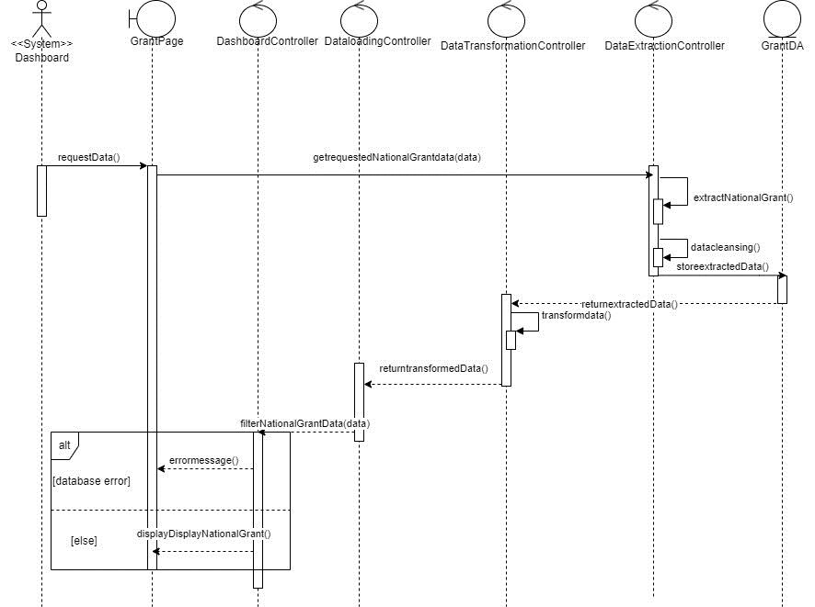

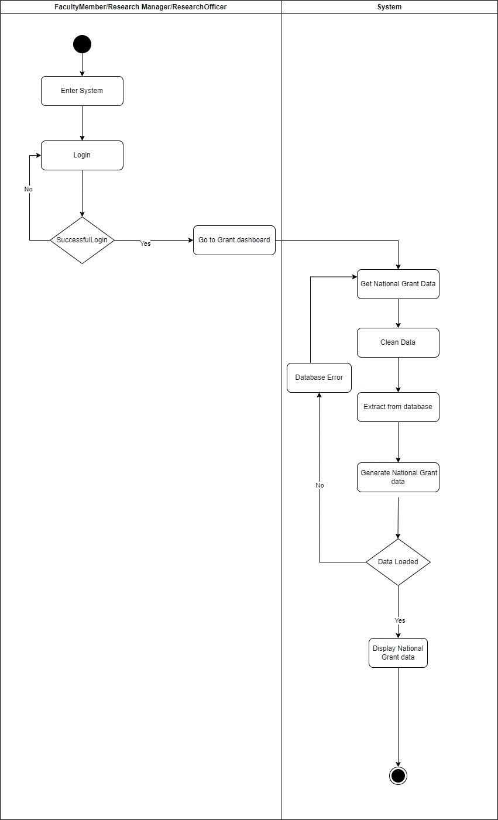

* 1. **Performance Requirements**

1. Response Time: The response time of the system should be quick to guarantee an efficient user experience. To avoid user frustration, the response time for generating and exhibiting dashboard analytics, including graphs and charts, should be minimal. Response time play a key role in maintaining user satisfaction while using the system.
2. Scalability: System must be designed in a way to maintain high scale data. The approach should scale well to accommodate a larger dataset as the number of researchers, and scholarly works grows every day.
3. Database Efficiency: The publication data should be stored in a database that allows for fast retrieval of the data. This will help in indexing and displaying the data accurately in the dashboard.
4. Safety- All the data that’ll be used must be kept safe and must be delivered to the server in a way that guarantees integrity.
   1. **Design Constraints**

The design must be done in a way to ensure that it is operable on all desktop computers and laptops. It should be accessible through any web browsers with the help of an internet connection.

* 1. **Software System Attributes**

1. Reliability: Reliability: The system should be dependable, with consistent and accurate operation. It should elegantly manage mistakes and exceptions, recover from failures, and minimise data loss or corruption. The system should also have backup and recovery techniques to prevent data loss and assure system availability.
2. Security: The system must prioritise data and user information security. It should put in place proper authentication and authorisation methods to ensure that only authorised people may access the data. In addition, the system should use secure data transmission methods to protect data during transit and comply with applicable data protection and privacy standards.
3. Usability: The system should be simple to use and intuitive, allowing faculty and research staff to explore and engage with the dashboard and its features. The user interface should be developed in way that will ensure users can simply obtain needed information, perform actions, and comprehend visualisations without confusion or excessive complexity.
4. Portability: The system should be built to be portable, allowing it to work on multiple operating systems or environments. It should make use of technologies and frameworks that are cross-platform compatible, ensuring flexibility in deployment options.
   1. **Other Requirements**

No other requirements are required for this project.

Appendix B System Design Documentation



SCSJ3323: Software Design and Architecture

**Software Design Document**

Faculty of Computing Staff Publication Dashboard

Version 1.0

25/06/2023

School of Computing, Software Engineering

Prepared by: Adib Bin Morshed

Revision Page

1. **Overview**

This document is the first draft of the Software Design and Architecture (SDD) for the Faculty of Computing Staff Publication Dashboard.

1. **Target Audience**

* **Prof Madya Dr. Siti Zaiton Bt. Mohd Hashim, Faculty of Computing, Universiti Teknologi Malaysia (UTM).**
* **Faculty of computing Staff, UTM.**

1. **Project Team Members**

* Adib Bin Morshed

1. **Version Control History**

|  |  |  |  |
| --- | --- | --- | --- |
| **Version** | **Primary Author(s)** | **Description of Version** | **Date Completed** |
| Version 1.0 | Adib Bin Morshed | SDD of Faculty of Computing Staff publication Dashboard | 25 June,2023 |

**Note:**

This template is an annotated outline for a software design document adapted from the IEEE Recommended Practice for Software Design Descriptions. The IEEE Recommended Practice for Software Design Descriptions have been reduced in order to simplify this assignment while still retaining the main components and providing a general idea of a project definition report. Please refer to IEEE Std 1016­1998 1 for the full IEEE Recommended Practice for Software Design Descriptions. Examples of models are from Satzinger (2011). Compiled by Shahliza Abdul Halim, PhD and checked by Shahida Sulaiman, PhD on 2 May 2016.

Table of Contents

|  |  |  |  |  |  |
| --- | --- | --- | --- | --- | --- |
| **1** | **Introduction** | | | | 1 |
|  | 1.1 | Purpose | | | 1 |
|  | 1.2 | Scope | | |  |
|  | 1.3 | Definitions, Acronyms and Abbreviations | | |  |
|  | 1.4 | Reference Materials | | |  |
|  | 1.5 | System Overview | | |  |
| **2** | **System Architectural Design** | | | |  |
|  | 2.1 | Architectural Style and Rationale | | |  |
|  | 2.2 | Component Model | | |  |
|  | 2.3 | Use Case Diagram | | |  |
| 3 | **Detailed Description of Modules** | | | |  |
|  | 3.1 | Complete Package Diagram | | |  |
|  | 3.2 | Modules Detailed Descriptions | | |  |
|  |  | 3.2.1 | Module Authentication & View | |  |
|  |  |  | 3.2.1.1 | Package Diagram |  |
|  |  |  | 3.2.1.2 | Class Diagram |  |
|  |  |  | 3.2.1.3 | Sequence Diagrams |  |
|  |  | 3.2.2 | Module Publication | |  |
|  |  |  | 3.2.2.1 | Package Diagram |  |
|  |  |  | 3.2.2.2 | Class Diagram |  |
|  |  |  | 3.2.2.3 | Sequence Diagrams |  |
|  |  | 3.2.3 | Module Commercialization | |  |
|  |  |  | 3.2.3.1 | Package Diagram |  |
|  |  |  | 3.2.3.2 | Class Diagram |  |
|  |  |  | 3.2.2.3 | Sequence Diagram |  |
| 4 | **Data Design** | | | |  |
|  | 4.1 | Data Description | | |  |
|  | 4.2 | Data Dictionary | | |  |
| 5 | **User Interface Design** | | | |  |
|  | 5.1 | Overview of User Interface | | |  |
|  | 5.2 | Screen Images | | |  |
| 6 | **Requirements Matrix** | | | |  |
| 7 | **Appendices** | | | |  |

1. Appendices (if any)
2. Introduction
   1. **Purpose**

The main purpose of this document is to describe the necessary methods and designs adapted for this system. This document will include the database design, class diagram design and the architectural model required to fulfil the requirements set by the stakeholder. The requirements were gathered from our stakeholders. This SDD is important for the development of the system since it contains all the diagrams required to design the system according to the requirements that have been discussed with the stakeholders. This document is developed for the ease of understanding of the system by the developer and stakeholders.

* 1. **Scope**

The proposed system is named the research publication dashboard for faculty of computing staff. This system is specifically designed for the stakeholders who are researchers and research staff of the faculty of computing at Universiti Teknologi Malaysia (UTM). This system will help to recognize patterns and performance measures to evaluate the current situation of the research department. Although it’ll have all the necessary data required to make the evaluation, there will be a few limitations as well. This system will not include some data related to researchers which is a limitation of the system. Nevertheless, it’ll be used for the performance measure of the publications by the researchers and research staff. This document is needed for the better understanding of the system by the stakeholders and developer.

* 1. **Definitions, Acronyms and Abbreviation**

|  |  |
| --- | --- |
| **Acronyms** | **Definition** |
| SDD | Software Design Document |
| MVC | Model-View-Controller |
| UTM | Universiti Teknologi Malaysia |

* 1. **References**

1. Software Design Document: What is it & How to Create it! (Template Included). (2022, October 31). Bit Blog. https://blog.bit.ai/software-design-document/
   1. **Overview**

This document is divided into three main sections that detail the specifications for the Faculty of Computing Staff Publication Dashboard. A thorough explanation of the chosen system architecture design will be covered in section 2. After that, the database design of the system is mentioned in section 3. A prototype and user interface design will be provided in section 3.

1. System Architectural Design

This section will provide an overview of the chosen architecture style and rationale for this system. It’ll also include the architecture model and use case diagram of the whole system for a better understanding of the chosen architecture design.

* 1. **Architecture Style and Rationale**

The chosen architectural style for this system is the MVC architecture. The MVC architecture refers to the Model-View-Controller architecture. The MVC architecture brings numerous benefits to the system. The system component is divided into three major parts. The three parts are model, view and controller. This architecture pattern makes it easier to manage code because of its structure.

The description of its three different parts is given below:

**Model:**

The business logic of the application is represented by the model layer. It focuses on the data structures and data operations which is one of the crucial factors for this system. Its sustainability is one of the big factors in choosing this architectural style.

* Represents the business logic of the application.
* Data storage and retrieval is handled in this layer.
* If there’s any change in data, this layer notifies the observer.

**View:**

The presentation layer is represented by the view layer. It is responsible for displaying the interface and data to the user. It receives data from the model and works as a presentation layer of the collected data in the form of tables, charts and so on.

* The data is displayed by this layer.
* Works as a presentation layer.
* User interface elements are rendered in this layer.
* It passes user input to the controller.

**Controller:**

The controller acts as a bridge between the model and view layer. It interacts with the model layer to update or retrieve data and interacts with the view layer to reflect the changes made.

* It receives user input, and it performs actions based on the user input.
* Interacts with the model to collect data.
* Interacts with the view layer to reflect changes made in the model layer.
* It controls the data flow between the model and the view layer.

The reason for choosing this architectural model is due to its durability, testability, reusability, and flexibility.



**Figure 2.1: Component Model of Dashboard**

* 1. **Component Model**

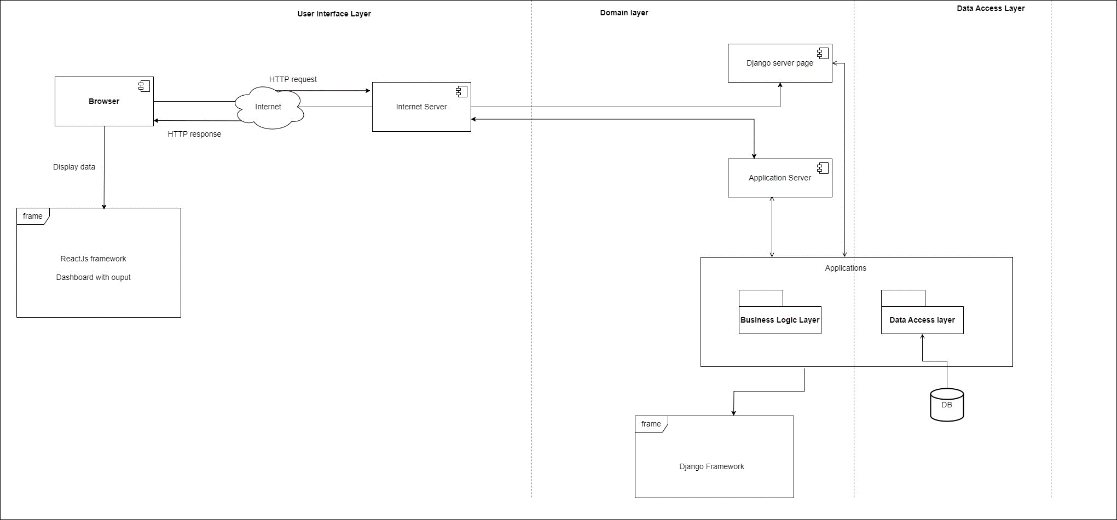

**Figure 2.2: Component Model of Dashboard**

The component model of the system is depicted above. It is divided into 3 layers. The user interface layer, Domain layer and Data access layer. ReactJS framework will be used for the frontend and Django will be used for the backend of the system. Our system will collect data from the data access layer and will display it in the dashboard which is in the user interface layer. This is the overall component structure of the system.

* 1. **Use Case Diagram**



**Figure 2.3: Use Case Diagram of Faculty of Computing Staff Publication Dashboard**

The use case diagram above consists of the key features of the system and depicts a clear picture of what the feature will look like. It also gives an idea of the users of the system.

1. Detailed Description of Components
   1. **Complete Package Diagram**

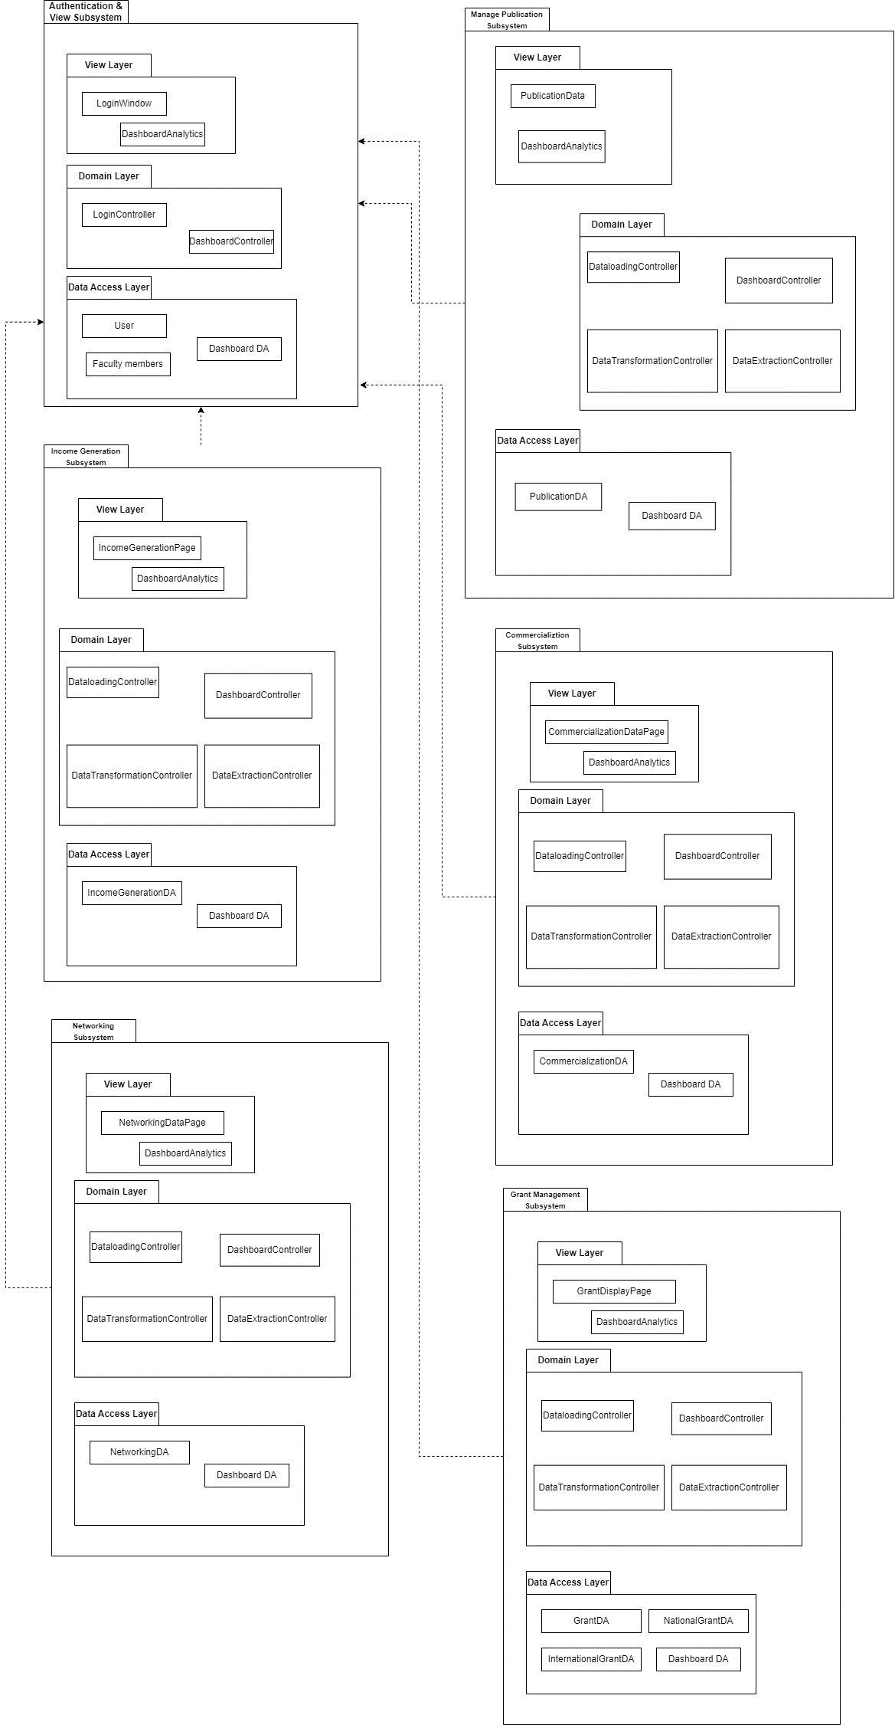

**Figure 3.1: Package Diagram of Staff Publication Dashboard**

* 1. **Detailed Description**
     1. **Subsystem Authentication & View** 
        1. **P001: Package Authentication & View**

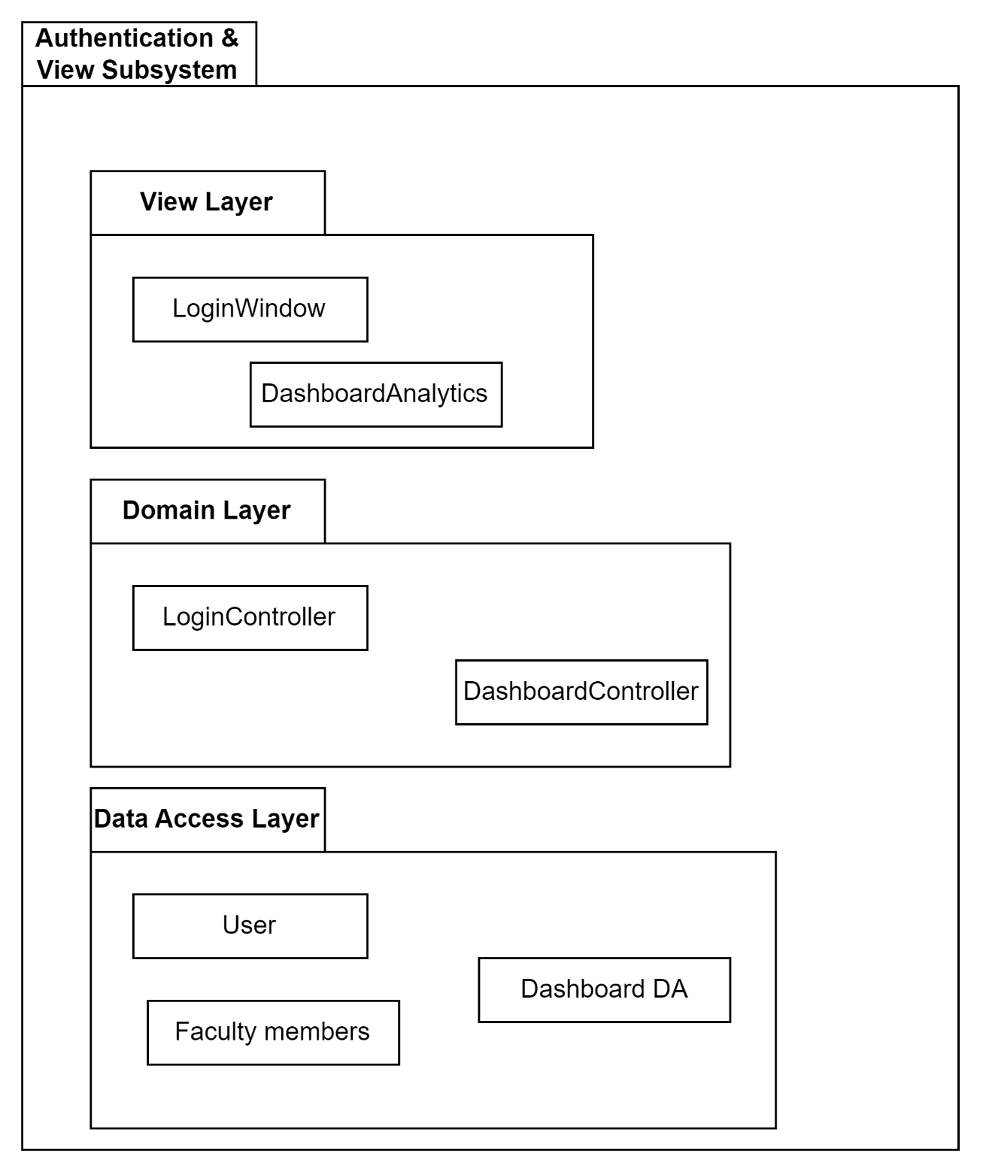

**P001 Authentication & View**

* + - 1. **Class Diagram**

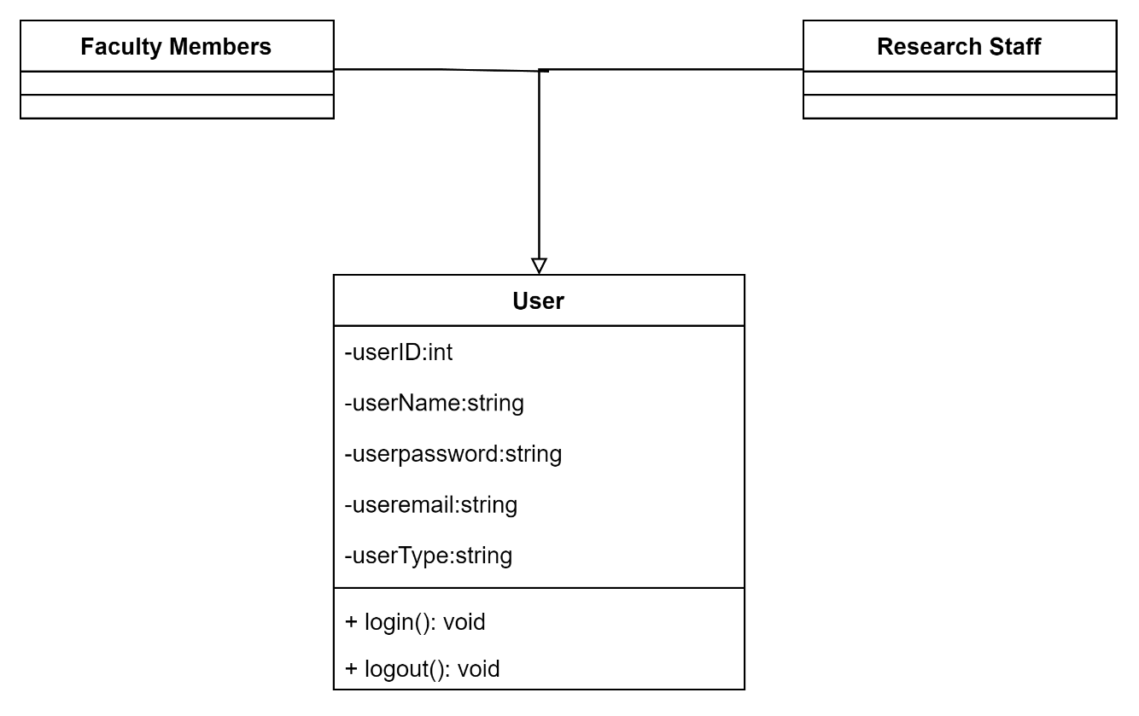

**C001 Class Diagram for Authentication**

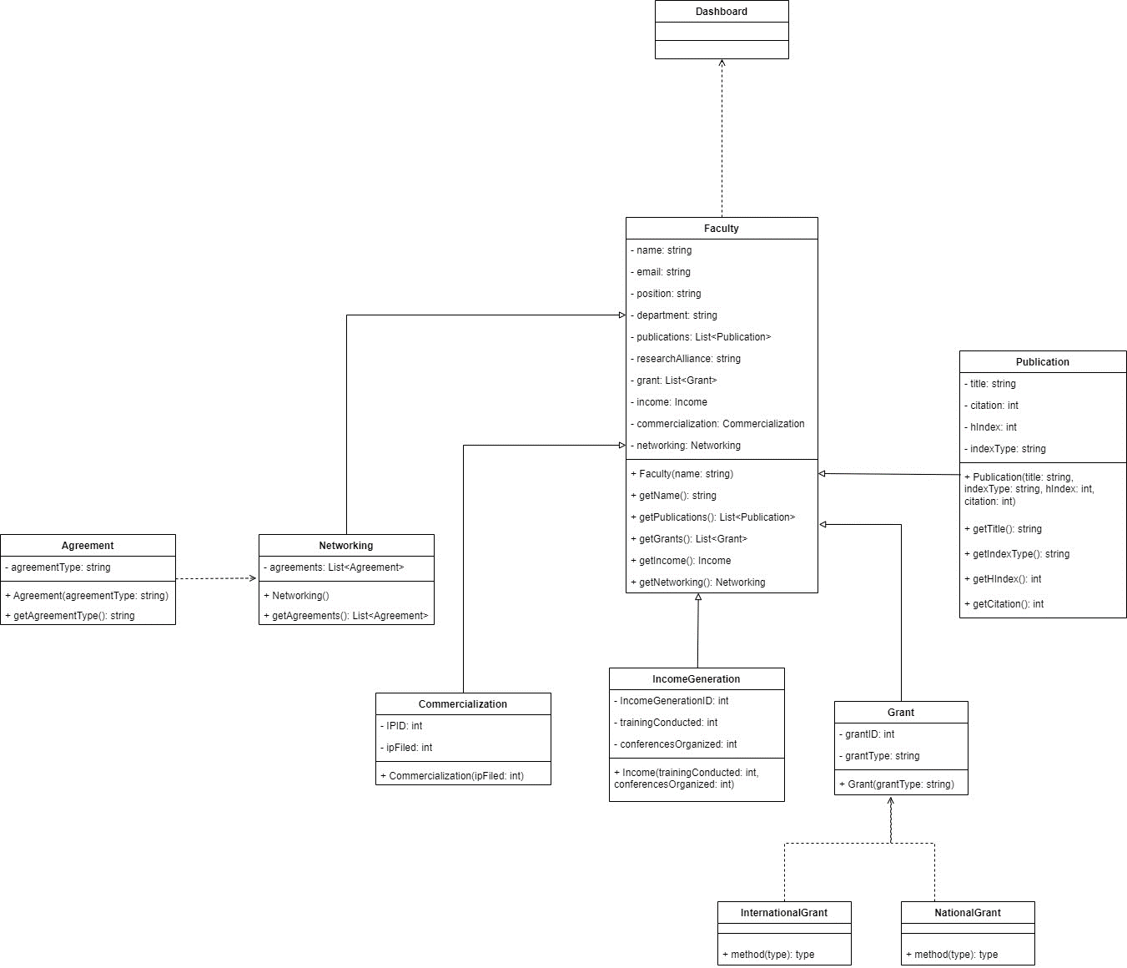

C002 Class Diagram for View Dashboard Analytics

* + - 1. **Sequence Diagrams**

a) SD001: Sequence diagram for Login

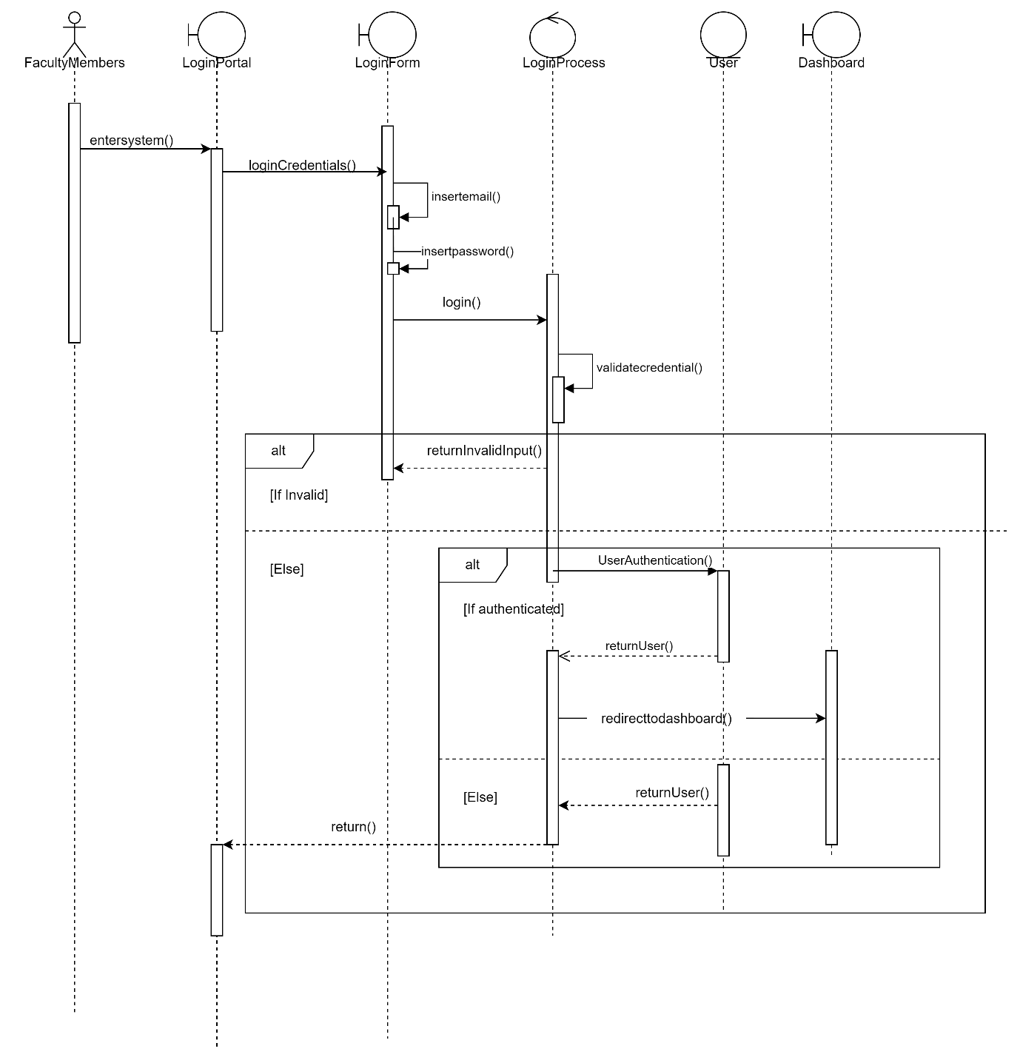

**SD001 Sequence Diagram of Login**

b) SD002: Sequence diagram for View Dashboard Analytics



**SD002 Sequence diagram for View Dashboard Analytics**

* + 1. **Subsystem Publication**
       1. **P002: Package Publication**

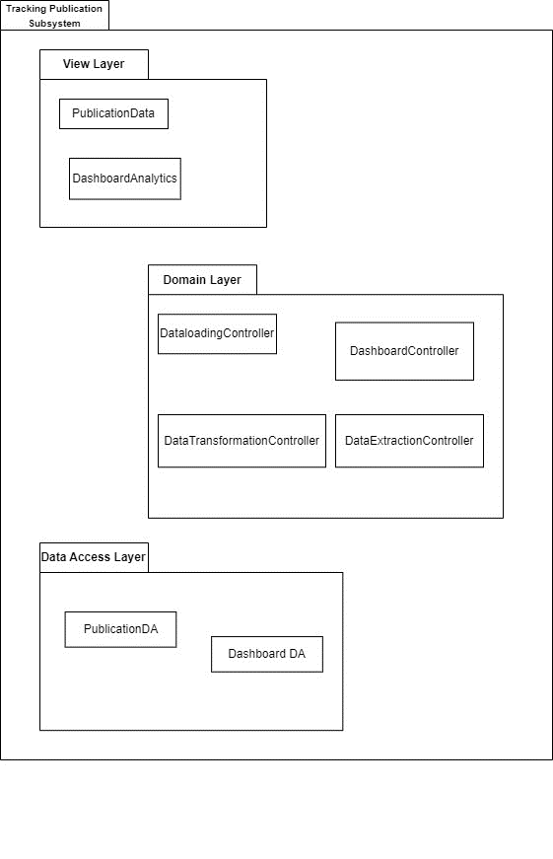

**P002 Packge Diagram for Publication**

* + - 1. **Class Diagram**

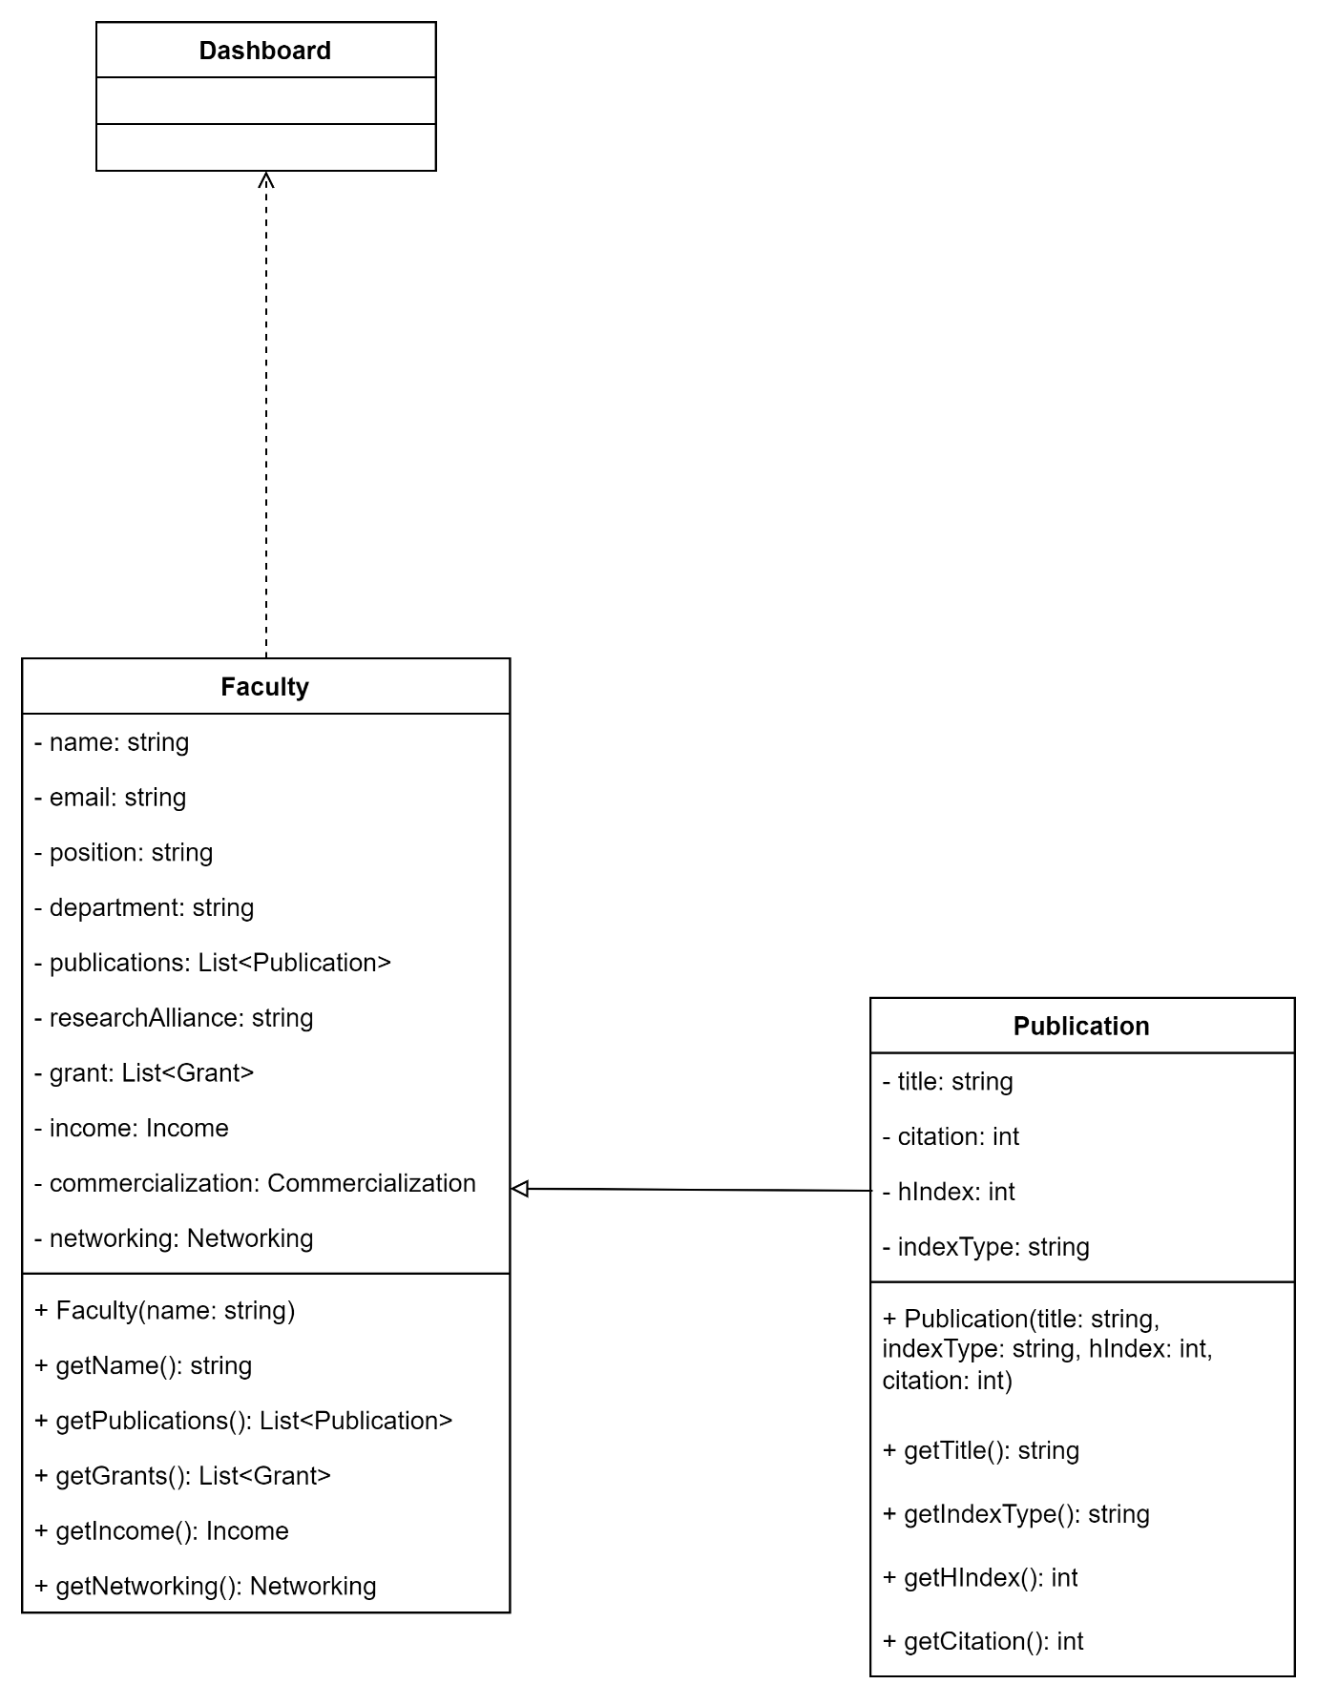

**C003 Class Diagram for Publication**

* + - 1. **Sequence Diagrams**



SD003

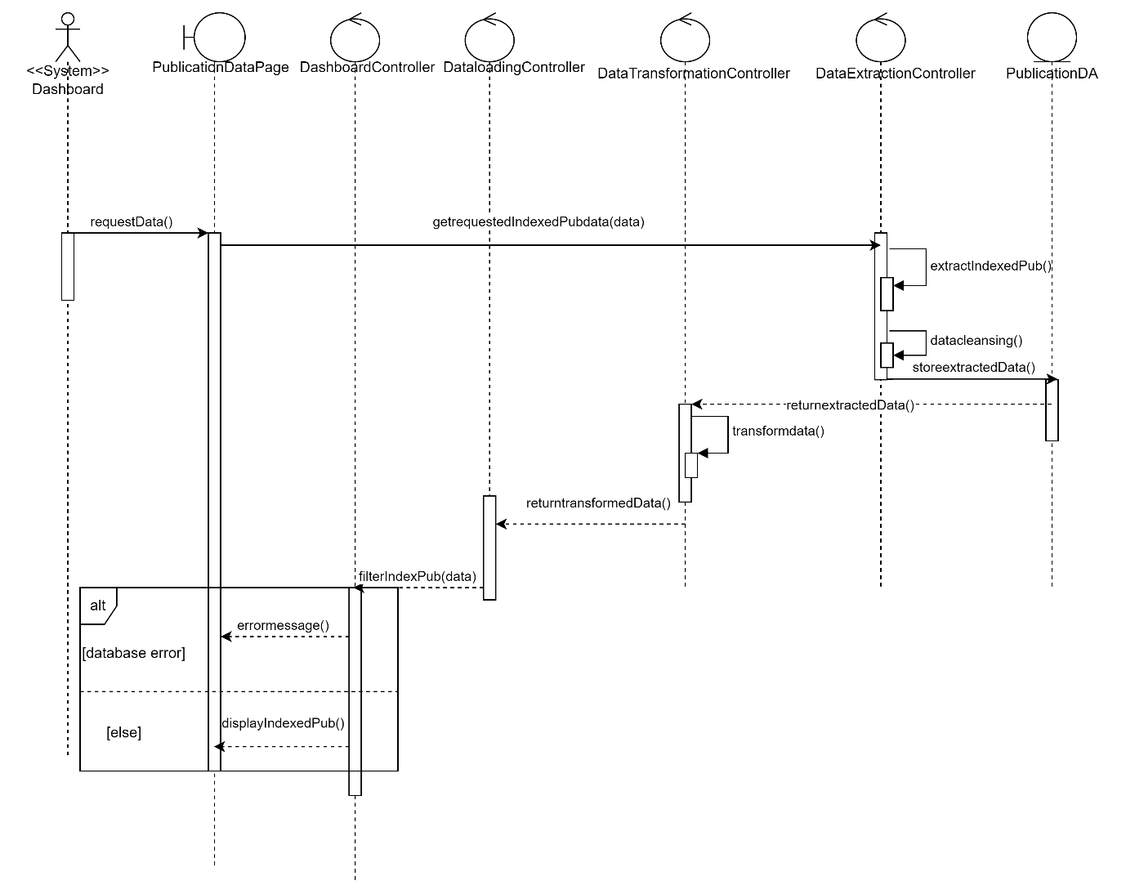

**SD004**



SD005



SD006



SD007

* + 1. **Subsystem Commercialization**
       1. **P003: Package Commercialization**

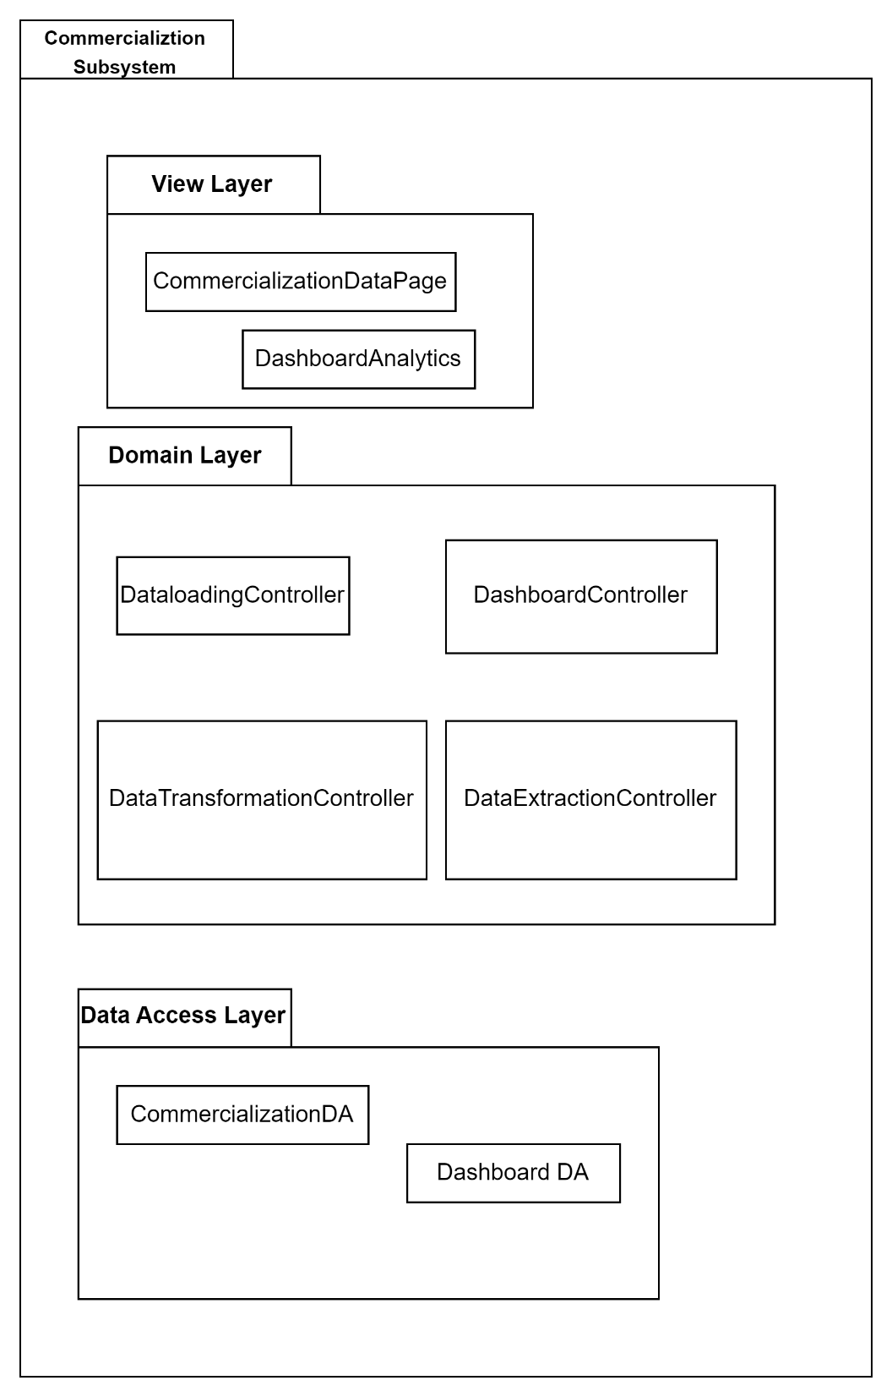

* + - 1. **Class Diagram**

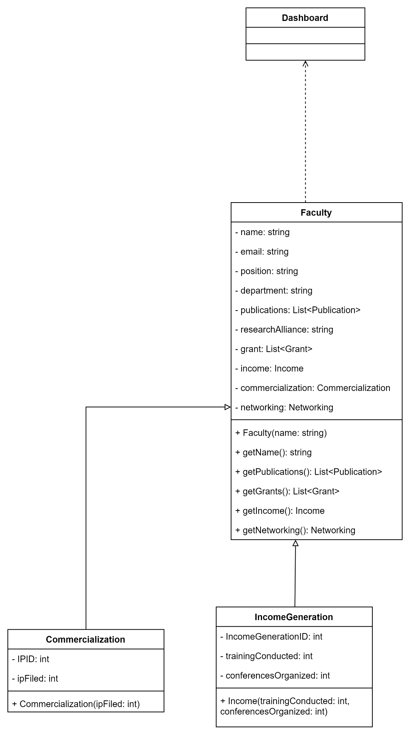

* + - 1. **Sequence Diagrams**



SD008



SD009



SD010

* + 1. **Subsystem Networking**
       1. **P004: Package Networking**

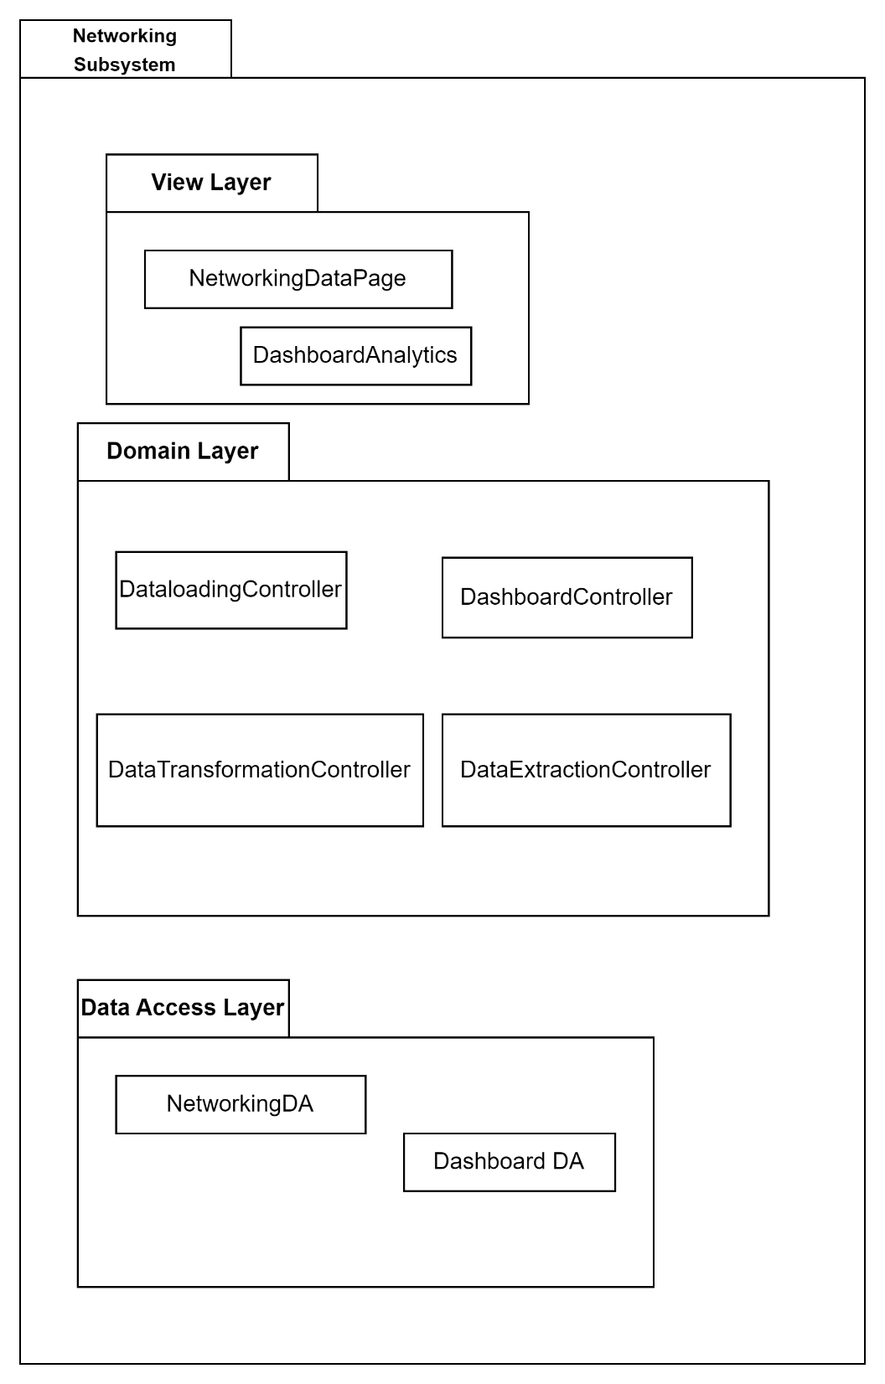

**P004**

* + - 1. **Class Diagram**

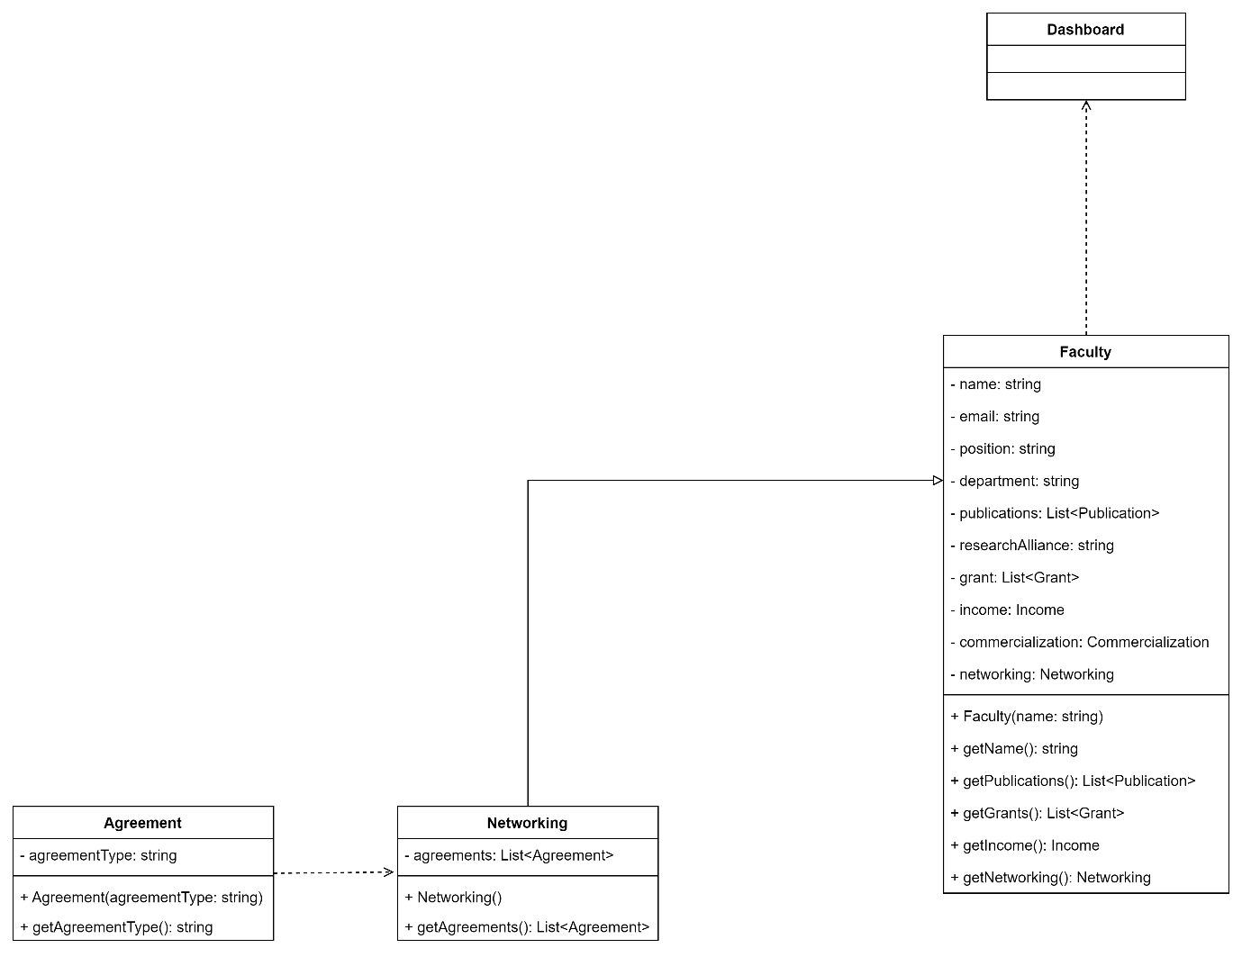

* + - 1. **Sequence Diagram**



S011



SD012

* + 1. **Subsystem Grant**
       1. **P005: Package Grant**

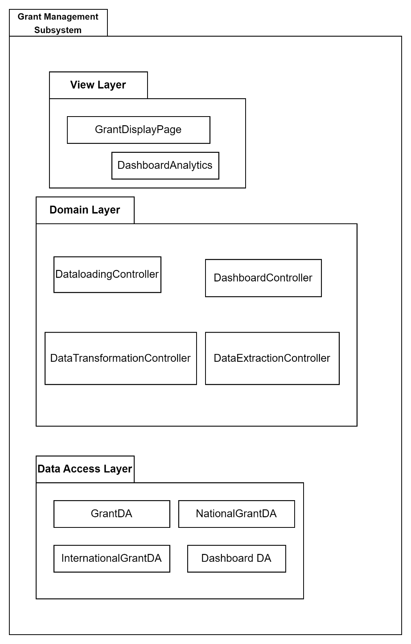

**P005**

* + - 1. **Class Diagram**

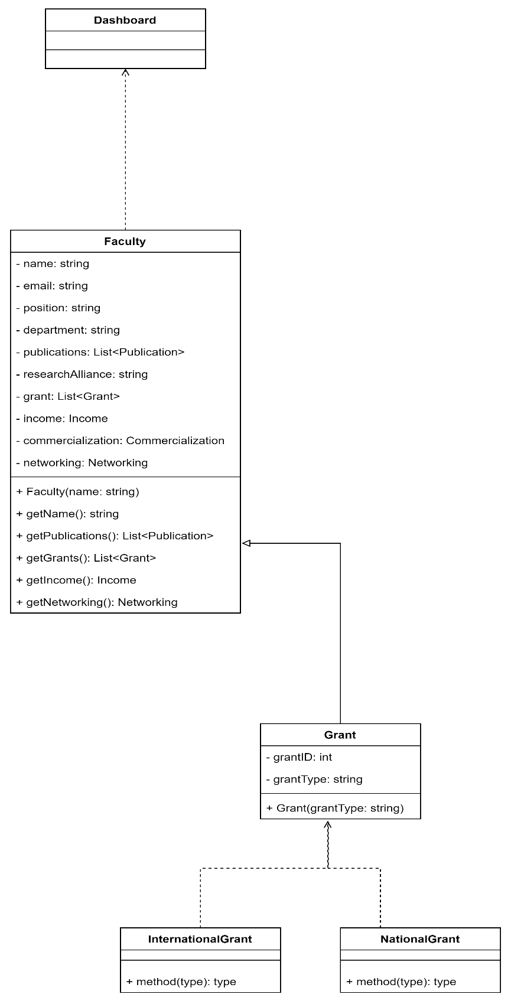

**C006**

* + - 1. **Sequence Diagram**



SD013



SD014



SD015

1. Data Design
   1. **Data Description**

In this section, the database design will be documented. The description of the database will be done in this section as well. Data Dictionary is also listed in this section.



ERD001 DataBase

|  |  |
| --- | --- |
| **Entity Name** | **Description** |
| Publication | It stores data related to the publication made by the researchers. |
| Citation | It stores citation data of the publications made by the researchers. |
| Indexed-Pub | It stores Indexed Publication data of the publications made by the researchers. |
| Non-Indexed Pub | It stores Non-Indexed Publication data of the publications made by the researchers. |
| H-Index | It stores number of H-Index Publication data of the publications made by the researchers. |
| Grant | It stores the number of grants received by the faculty. |
| International Grant | It stores all the number of international grants received by the faculty. |
| National Grant | It stores all the number of National grants received by the faculty. |
| Networking | It stores all the data related to Networking. |
| Income Generation | It stores all the data related to Networking. |
| User | It contains the information of different users in one place. |
| Faculty Members | It contains all the data and information of the faculty members that’ll be displayed. |
| Research Staff | It contains all the data and information of the Research staff that are required for our system. |
| Commercialization | It stores all the data of number of Intellectual Property filed. |

* 1. **Data Dictionary**

**DD001**

|  |  |  |  |
| --- | --- | --- | --- |
| **Field Name** | **Datatype** | **Constraint** | **Description** |
| **User** | | | |
| UserId | INT | Primary Key | Unique ID for user |
| username | VARCHAR | Not NULL | Username of the user |
| password | VARCHAR | Not NULL | Password of the user |
| userType | VARCHAR | Foreign Key | Unique type of user |
| **Research Staff** | | | |
| staffID | INT | Primary Key | Unique ID for user |
| name | VARCHAR | Not NULL | Name of the user |
| email | VARCHAR | Not NULL | Email of the user |
| userID | INT | Foreign Key | Unique ID for user |
| **Income Generation** | | | |
| IncomeGenerationID | INT | Primary Key | Unique ID for Income Generation field |
| facultymemeberID | INT | Foreign Key | Unique ID of the faculty member |
| Type | VARCHAR | Not NULL | Type of Income Generation |
| Networking | | | |
| AgreementID | INT | Primary Key | Unique ID for Agreements made |
| facultymemeberID | INT | Foreign Key | Unique ID of the faculty member |
| Partner | VARCHAR | NOT NULL | Describes the partner for networking |
| type | VARCHAR | Not NULL | Type of Agreement made |
| Commercialization | | | |
| **IPID** | INT | Primary Key | Unique ID for Intellectual Properties Filed |
| facultymemeberID | INT | Foreign Key | Unique ID of the faculty member |
| title | **VARCHAR** | **NOT NULL** | Title for the intellectual property filed |
| Faculty Member | | | |
| facultymemeberID | INT | Primary Key | Unique ID of the faculty member |
| name | VARCHAR | NOT NULL | Name of the user |
| Department | VARCHAR | NOT NULL | Department of the faculty member |
| Position | VARCHAR | NOT NULL | Position of the user |
| Email | VARCHAR | NOT NULL | Email of the user |
| Research Alliances | VARCHAR | NOT NULL | Research Alliances of the user |
| userID | INT | Foreign Key | Unique ID of the user |
| **Grant** | | | |
| GrantID | INT | Primary Key | Unique ID of the Grant |
| facultymemeberID | INT | Foreign Key | Unique ID of the faculty member |
| Title | VARCHAR | NOT NULL | Title of the grant |
| Type | CHAR | NOT NULL | Type of the grant |
| NationalGrant | | | |
| GrantID | INT | Foreign Key | Unique ID of the Grant |
| InternationalGrant | | | |
| GrantID | INT | Foreign Key | Unique ID of the Grant |
| Publication | | | |
| PublicationID | INT | Primary Key | Unique ID of the Publication |
| title | VARCHAR | NOT NULL | Title of the publication |
| Indexed | BOOLEAN | NOT NULL | Indicates Indexed Publication |
| Non-Indexed | BOOLEAN | NOT NULL | Indicates non-Indexed Publication |
| H-Index | INT | NOT NULL | Indicates number of H-Index |
| Citation | INT | NOT NULL | Indicates count of citation |
| facultymemeberID | INT | Foreign Key | Unique ID of the faculty member |
| Non-IndexedPub | | | |
| PublicationID | INT | Foreign Key | Unique ID of the Publication |
| IndexedPub | | | |
| PublicationID | INT | Foreign Key | Unique ID of the Publication |
| H-Index | | | |
| H-IndexID | INT | Primary Key | Unique ID for the H-Index |
| PublicationID | INT | Foreign Key | Unique ID of the Publication |
| Citation | | | |
| CitationID | INT | Primary Key | Unique ID for the Citation |
| publicationID | INT | Foreign Key | Unique ID of the Publication |

1. User Interface Design
   1. **Overview of User Interface**

*Describe the functionality of the system from the user’s perspective. Explain how the user will be able to use your system to complete all the expected features and the feedback information that will be displayed for the user.*

* 1. **Screen Images**



SN001 Login Page



SN002 Publication Page

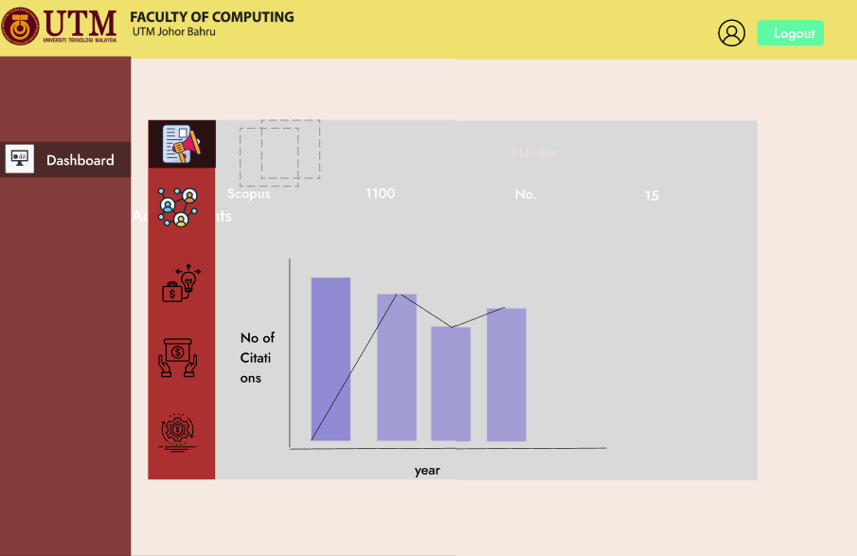

SN003 Citation Page



SN004 Networking Page

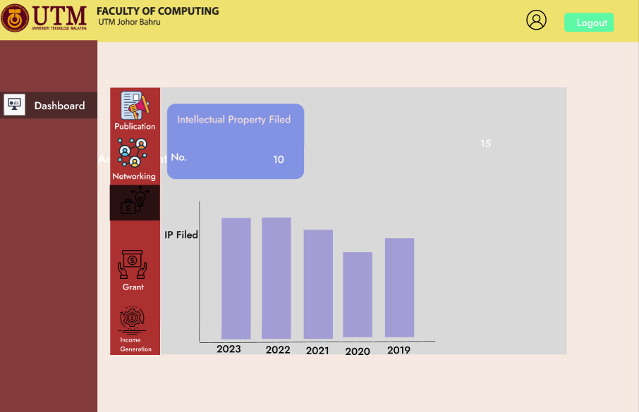

SN005 Page

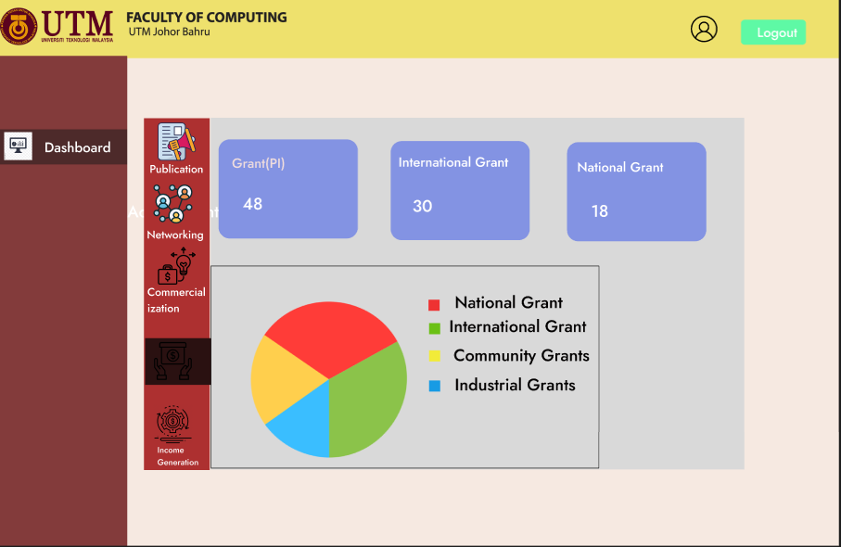

SN006 Login Page

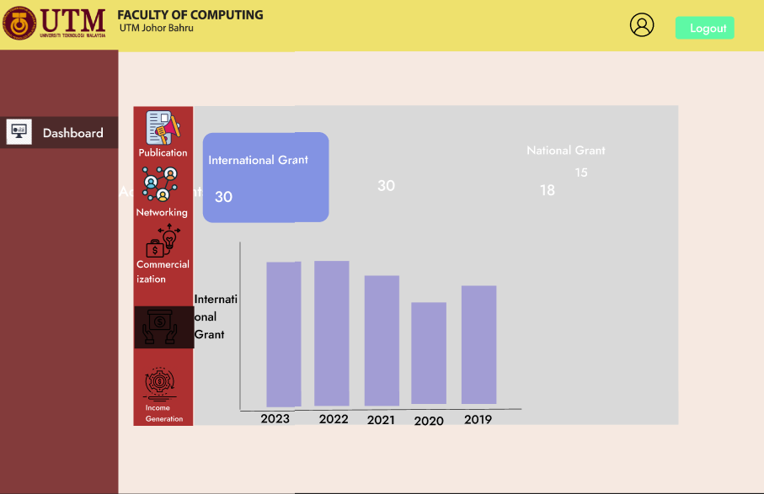

SN007 Login Page

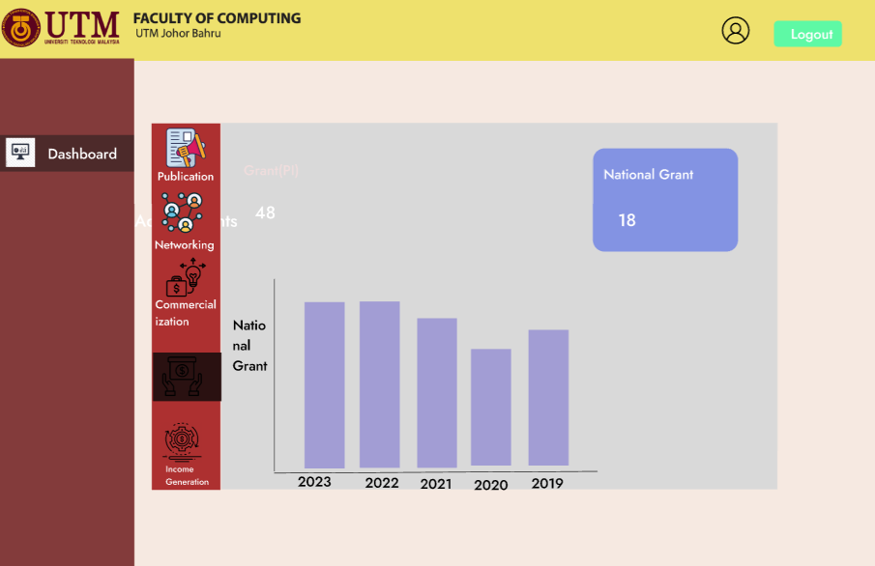

SN008 Login Page

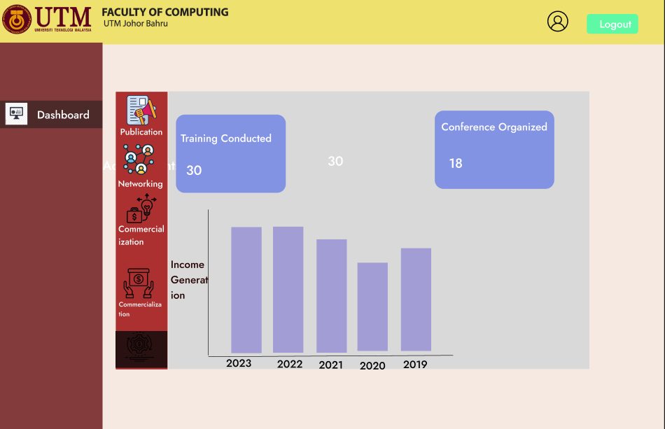

SN009 Login Page

1. Requirements Matrix

|  |  |  |  |  |  |
| --- | --- | --- | --- | --- | --- |
|  | P001 | P002 | P003 | P004 | P005 |
| UC001 | X |  |  |  |  |
| UC002 | X |  |  |  |  |
| UC003 |  | X |  |  |  |
| UC004 |  | X |  |  |  |
| UC005 |  | X |  |  |  |
| UC006 |  | X |  |  |  |
| UC007 |  | X |  |  |  |
| UC008 |  |  | X |  |  |
| UC009 |  |  | X |  |  |
| UC010 |  |  | X |  |  |
| UC011 |  |  |  | X |  |
| UC012 |  |  |  | X |  |
| UC013 |  |  |  |  | X |
| UC014 |  |  |  |  | X |
| UC015 |  |  |  |  | X |

1. Appendices

No appendices

Appendix C System Testing Documentation



**Software Testing Documentation**

Faculty of Computing Staff Publication Dashboard

Version 1.0

25/06/2023

School of Computing, Software engineering

Prepared by: Adib Bin Morshed

Revision Page

1. **Overview**

This document is the first draft of the Software Test Document (STD) for the Faculty of Computing Staff Publication Dashboard.

1. **Target Audience**

* **Prof Madya Dr. Siti Zaiton Bt. Mohd Hashim, Faculty of Computing, Universiti Teknologi Malaysia (UTM).**
* **Faculty of computing Staff, UTM.**

1. **Project Team Members**

Adib Bin Morshed

1. **Version Control History**

|  |  |  |  |
| --- | --- | --- | --- |
| **Version** | **Primary Author(s)** | **Description of Version** | **Date Completed** |
| Version 1.0 | Adib Bin Morshed | SRS of Faculty of Computing Staff publication Dashboard | 25 June,2023 |

**Note:**

This template is an annotated outline for a software testing document. It is based on IEEE standards 829, 1008, 1012 and 1012a. This document covers: unit testing (the verification of individual sub-systems or components of the system against their specifications), integration testing (the testing of inter-operating sub-systems or components against their specifications) and system testing (both verification against the system specification, and validation against the user requirements).This template has been simplified and customized to meet the need of SCSJ2203 course at Faculty of Computing, UTM. Compiled by Ruhaidah Samsudin, PhD and checked by Masitah Ghazali, PhD and Shahida Sulaiman, PhD (revised on 14 May 2016).

Table of Contents

|  |  |  |  |  |
| --- | --- | --- | --- | --- |
| **1** | **Introduction** | | | 1 |
|  | 1.1 | Purpose | | 1 |
|  | 1.2 | Scope | |  |
|  | 1.3 | Definitions, Acronyms and Abbreviations | |  |
|  | 1.4 | Reference Materials | |  |
|  | 1.5 | System Overview | |  |
| **2** | **Test Cases** | | |  |
|  | 2.1 | Test TC001 for Module <Name of Module1>: <Name of Use Case (UC001)> | |  |
|  |  | 2.1.1 | Test Case TC001_01 |  |
|  |  | 2.1.2 | Test Case TC001_02 |  |
|  | 2.2 | … | |  |
| **3** | **Test Approach Analysis** | | |  |
| **4** | **Additional Materials** | | |  |
|  |  | | |  |
|  |  |  | |  |
|  |  |  | |  |

1. Introduction

This section describes about the test cases developed for our system.

* 1. **Purpose**

The main purpose of this document is to describe the necessary test cases that are required to test the system. This document will include the test cases required to fulfil the requirements of the system. The requirements were gathered from our stakeholders. This STD is important for the development of the system since it contains all the necessary test data required to test the system according to the requirements that have been discussed with the stakeholders. This document is developed for the ease of understanding of the system by the developer and stakeholders.

* 1. **Scope**

The proposed system is named the research publication dashboard for faculty of computing staff. This system is specifically designed for the stakeholders who are researchers and research staff of the faculty of computing at Universiti Teknologi Malaysia (UTM). This system will help to recognize patterns and performance measures to evaluate the current situation of the research department. Although it’ll have all the necessary data required to make the evaluation, there will be a few limitations as well. This system will not include some data related to researchers which is a limitation of the system. Nevertheless, it’ll be used for the performance measure of the publications by the researchers and research staff. This document is needed for the better understanding of the system by the stakeholders and developer.

* 1. **Definitions, Acronyms and Abbreviation**

|  |  |
| --- | --- |
| **Acronyms** | **Definition** |
| STD | Software Testing Documentation |
| TC | Test Cases |

* 1. **System Overview**

This STD will contain only the test cases for each use cases and module.

1. Test Cases, Data and Expected Results
   1. **Test TC001 for Module Authentication & View: Login(UC001)**

|  |  |  |  |
| --- | --- | --- | --- |
| **Test Case ID** | TC001_1 | | |
| **Test Case Description** | Able to login Successfully | **Test Priority** | High |
| **Pre-Requisite** | There is an active internet connection | | |

Test execution steps:

|  |  |  |  |
| --- | --- | --- | --- |
| **No.** | **Action** | **Test data** | **Expected result** |
| 1. | The user opens the login page | - | System displays the login page |
| 2 | User clicks on the email field and enters his registered email | Email: abc@gmail.com | Email field works correctly and will display the username entered by the user |
| 3. | User clicks on the password field and enters the password | Password:  1234 | Password field is taking inputs and user can view the entered password |
| 4. | User clicks on the 'Login' Button to confirm login | - | Login button is visible and working |
| 5. | User is taken to their respective dashboard by the system | - | System verifies the user successfully by checking with the database |

|  |  |  |  |
| --- | --- | --- | --- |
| **Test Case ID** | TC001_2 | | |
| **Test Case Description** | Display error message for Unsuccessful Login | **Test Priority** | High |
| **Pre-Requisite** | There is an active internet connection | | |

Test execution steps:

|  |  |  |  |
| --- | --- | --- | --- |
| **No.** | **Action** | **Test data** | **Expected result** |
| 1. | The user opens the login page | - | System displays the login page |
| 2 | User clicks on the email field and enters his registered email | Email: abc@gmail.com | Email field works correctly and will display the username entered by the user |
| 3. | User clicks on the password field and enters the password | Password:  1234 | Password field is taking inputs and user can view the entered password |
| 4. | User clicks on the 'Login' Button to confirm login | - | Login button is visible and working |
| 5. | User is displayed an error message for unsuccessful login. | - | System displays error message for unsuccessful login. |

|  |  |  |  |
| --- | --- | --- | --- |
| **Test Case ID** | TC001_3 | | |
| **Test Case Description** | Display error message for invalid input | **Test Priority** | High |
| **Pre-Requisite** | There is an active internet connection | | |

Test execution steps:

|  |  |  |  |
| --- | --- | --- | --- |
| **No.** | **Action** | **Test data** | **Expected result** |
| 1. | The user opens the login page | - | System displays the login page |
| 2 | User clicks on the email field and enters his registered email | Email: abc | Email field works correctly and will display the username entered by the user |
| 3. | User clicks on the password field and enters the password | Password:  1234 | Password field is taking inputs and user can view the entered password |
| 4. | User clicks on the 'Login' Button to confirm login | - | Login button is visible and working |
| 5. | User is displayed an error message for unsuccessful login. | - | System displays error message for Invalid input. |

|  |  |  |  |
| --- | --- | --- | --- |
| **Test Case ID** | TC001_4 | | |
| **Test Case Description** | Display error message for Empty Input | **Test Priority** | High |
| **Pre-Requisite** | There is an active internet connection | | |

Test execution steps:

|  |  |  |  |
| --- | --- | --- | --- |
| **No.** | **Action** | **Test data** | **Expected result** |
| 1. | The user opens the login page | - | System displays the login page |
| 2 | User clicks on the email field and enters his registered email | Email: | Email field works correctly and will display the username entered by the user |
| 3. | User clicks on the password field and enters the password | Password:  1234 | Password field is taking inputs and user can view the entered password |
| 4. | User clicks on the 'Login' Button to confirm login | - | Login button is visible and working |
| 5. | User is displayed an error message for unsuccessful login. | - | System displays error message for empty input. |

* 1. **Test TC002 for Module1: View Dashboard Analytics (UC002)**

|  |  |  |  |
| --- | --- | --- | --- |
| **Test Case ID** | TC002_1 | | |
| **Test Case Description** | Able to view dashboard analytics clearly | **Test Priority** | High |
| **Pre-Requisite** | 1.There is an active internet connection  2. User Logs in to the system | | |

Test execution steps:

|  |  |  |  |
| --- | --- | --- | --- |
| **No.** | **Action** | **Test data** | **Expected result** |
| 1. | User is taken to the homepage after logging in | - | Home Page is displayed |
| 2 | User clicks on the Publication metrics button. | - | Button works properly and user is taken to publication metrics page. |
| 3. | User can view the dashboard analytics | - | All the data are displayed properly. |

|  |  |  |  |
| --- | --- | --- | --- |
| **Test Case ID** | TC002_2 | | |
| **Test Case Description** | Able to view error message | **Test Priority** | Medium |
| **Pre-Requisite** | 1.There is an active internet connection  2. User Logs in to the system | | |

Test execution steps:

|  |  |  |  |
| --- | --- | --- | --- |
| **No.** | **Action** | **Test data** | **Expected result** |
| 1. | User is taken to the homepage after logging in | - | Home Page is displayed |
| 2 | User clicks on the Publication metrics button. | - | Button works properly and user is taken to publication metrics page. |
| 3. | User cannot view the dashboard analytics due to connection error | - | Error message is shown. |

* 1. **Test TC003 for Module Publication: Track Publication Metrics (UC003)**

|  |  |  |  |
| --- | --- | --- | --- |
| **Test Case ID** | TC003_1 | | |
| **Test Case Description** | Able to view accurate data | **Test Priority** | Medium |
| **Pre-Requisite** | 1.There is an active internet connection  2. User Logs in to the system | | |

Test execution steps:

|  |  |  |  |
| --- | --- | --- | --- |
| **No.** | **Action** | **Test data** | **Expected result** |
| 1. | User is taken to the homepage after logging in | - | Home Page is displayed |
| 2 | User clicks on the Publication metrics button. | - | Button works properly and user is taken to publication metrics page. |
| 3. | User hovers over the indexed pub graphical representation of the data. | Indexed Pub | Indexed Pub data are viewable and accurate. |
| 4. | User hovers over the non-indexed pub graphical representation of the data. | Non-Indexed Pub | Non-Indexed Pub data are viewable and accurate. |
| 5. | User hovers over the no. of H-Index in the form of graphical representation of the data. | H-Index no. | H-Index Data are viewable and accurate. |
| 6. | User hovers over the no. of Citations in the form of graphical representation of the data. | Citation | Citation Data are viewable and accurate. |
| 7. | Users can view the accurate results of the data collected from the database. | Publication Data | Accurate results are displayed. |

|  |  |  |  |
| --- | --- | --- | --- |
| **Test Case ID** | TC003_2 | | |
| **Test Case Description** | Verify that user is unable to view accurate results. | **Test Priority** | Medium |
| **Pre-Requisite** | 1.There is an active internet connection  2. User Logs in to the system | | |

Test execution steps:

|  |  |  |  |
| --- | --- | --- | --- |
| **No.** | **Action** | **Test data** | **Expected result** |
| 1. | User is taken to the homepage after logging in | - | Home Page is displayed |
| 2 | User clicks on the Publication metrics button. | - | Button works properly and user is taken to publication metrics page. |
| 3. | Users cannot view the accurate results of the data collected from database. | Publication Data | Accurate results are not displayed. |

|  |  |  |  |
| --- | --- | --- | --- |
| **Test Case ID** | TC003_3 | | |
| **Test Case Description** | Verify that system is displaying invalid data. | **Test Priority** | Medium |
| **Pre-Requisite** | 1.There is an active internet connection  2. User Logs in to the system | | |

Test execution steps:

|  |  |  |  |
| --- | --- | --- | --- |
| **No.** | **Action** | **Input data** | **Expected result** |
| 1. | User is taken to the homepage after logging in | - | Home Page is displayed |
| 2 | User clicks on the Publication metrics button. | - | Button works properly and user is taken to publication metrics page. |
| 3. | Dashboard is displaying invalid data. | Publication Data | Invalid data are displayed. |

* 1. **Test TC004 for Module Publication: Generate Indexed Publication (UC004)**

|  |  |  |  |
| --- | --- | --- | --- |
| **Test Case ID** | TC004_1 | | |
| **Test Case Description** | Verify that system is successfully retrieving data from database | **Test Priority** | Medium |
| **Pre-Requisite** | 1.There is an active internet connection  2. User Logs in to the system | | |

Test execution steps:

|  |  |  |  |
| --- | --- | --- | --- |
| **No.** | **Action** | **Input data** | **Expected result** |
| 1. | User is taken to the homepage after logging in | - | Home Page is displayed |
| 2 | User clicks on the Publication metrics button. | - | Button works properly and user is taken to publication metrics page. |
| 3. | User can view the generated data from the database | Indexed Publication Data | Data has been successfully retrieved from database. |

|  |  |  |  |
| --- | --- | --- | --- |
| **Test Case ID** | TC004_2 | | |
| **Test Case Description** | Verify that system is displaying accurate data | **Test Priority** | Medium |
| **Pre-Requisite** | 1.There is an active internet connection  2. User Logs in to the system | | |

Test execution steps:

|  |  |  |  |
| --- | --- | --- | --- |
| **No.** | **Action** | **Input data** | **Expected result** |
| 1. | User is taken to the homepage after logging in | - | Home Page is displayed |
| 2 | User clicks on the Publication metrics button. | - | Button works properly and user is taken to publication metrics page. |
| 3. | User can view the accurate data from the database | Indexed Publication Data | Accurate data has been displayed. |

|  |  |  |  |
| --- | --- | --- | --- |
| **Test Case ID** | TC004_3 | | |
| **Test Case Description** | Verify that system is not displaying accurate data | **Test Priority** | High |
| **Pre-Requisite** | 1.There is an active internet connection  2. User Logs in to the system | | |

Test execution steps:

|  |  |  |  |
| --- | --- | --- | --- |
| **No.** | **Action** | **Input data** | **Expected result** |
| 1. | User is taken to the homepage after logging in | - | Home Page is displayed |
| 2 | User clicks on the Publication metrics button. | - | Button works properly and user is taken to publication metrics page. |
| 3. | User cannot view the accurate data | Indexed Publication Data | Accurate data has not been displayed. |

* 1. **Test TC005 for Module Publication: Generate Non-Indexed Publication (UC005)**

|  |  |  |  |
| --- | --- | --- | --- |
| **Test Case ID** | TC005_1 | | |
| **Test Case Description** | Verify that system is successfully retrieving data from database | **Test Priority** | Medium |
| **Pre-Requisite** | 1.There is an active internet connection  2. User Logs in to the system | | |

Test execution steps:

|  |  |  |  |
| --- | --- | --- | --- |
| **No.** | **Action** | **Input data** | **Expected result** |
| 1. | User is taken to the homepage after logging in | - | Home Page is displayed |
| 2 | User clicks on the Publication metrics button. | - | Button works properly and user is taken to publication metrics page. |
| 3. | User can view the generated Non-Indexed Publication data from the database | Non-Indexed Publication Data | Data has been successfully retrieved from database. |

|  |  |  |  |
| --- | --- | --- | --- |
| **Test Case ID** | TC005_2 | | |
| **Test Case Description** | Verify that system is displaying accurate data | **Test Priority** | Medium |
| **Pre-Requisite** | 1.There is an active internet connection  2. User Logs in to the system | | |

Test execution steps:

|  |  |  |  |
| --- | --- | --- | --- |
| **No.** | **Action** | **Input data** | **Expected result** |
| 1. | User is taken to the homepage after logging in | - | Home Page is displayed |
| 2 | User clicks on the Publication metrics button. | - | Button works properly and user is taken to publication metrics page. |
| 3. | User can view the accurate non-Indexed publication data from the database | Non-Indexed Publication Data | Accurate data has been displayed. |

|  |  |  |  |
| --- | --- | --- | --- |
| **Test Case ID** | TC005_3 | | |
| **Test Case Description** | Verify that system is not displaying accurate data | **Test Priority** | High |
| **Pre-Requisite** | 1.There is an active internet connection  2. User Logs in to the system | | |

Test execution steps:

|  |  |  |  |
| --- | --- | --- | --- |
| **No.** | **Action** | **Input data** | **Expected result** |
| 1. | User is taken to the homepage after logging in | - | Home Page is displayed |
| 2 | User clicks on the Publication metrics button. | - | Button works properly and user is taken to publication metrics page. |
| 3. | User cannot view the accurate data | Non-Indexed Publication Data | Accurate data has not been displayed. |

* 1. **Test TC006 for Module Publication: Generate H-Indexed Publication (UC006)**

|  |  |  |  |
| --- | --- | --- | --- |
| **Test Case ID** | TC006_1 | | |
| **Test Case Description** | Verify that system is successfully retrieving data from database | **Test Priority** | Medium |
| **Pre-Requisite** | 1.There is an active internet connection  2. User Logs in to the system | | |

Test execution steps:

|  |  |  |  |
| --- | --- | --- | --- |
| **No.** | **Action** | **Input data** | **Expected result** |
| 1. | User is taken to the homepage after logging in | - | Home Page is displayed |
| 2 | User clicks on the Publication metrics button. | - | Button works properly and user is taken to publication metrics page. |
| 3. | User can view the generated H-Index Publication data from the database | H-Index Publication Data | Data has been successfully retrieved from database. |

|  |  |  |  |
| --- | --- | --- | --- |
| **Test Case ID** | TC006_2 | | |
| **Test Case Description** | Verify that system is displaying accurate data | **Test Priority** | Medium |
| **Pre-Requisite** | 1.There is an active internet connection  2. User Logs in to the system | | |

Test execution steps:

|  |  |  |  |
| --- | --- | --- | --- |
| **No.** | **Action** | **Input data** | **Expected result** |
| 1. | User is taken to the homepage after logging in | - | Home Page is displayed |
| 2 | User clicks on the Publication metrics button. | - | Button works properly and user is taken to publication metrics page. |
| 3. | User can view the accurate calculation of H-Index data from the database | H-Index Data | Accurate data has been displayed. |

|  |  |  |  |
| --- | --- | --- | --- |
| **Test Case ID** | TC006_3 | | |
| **Test Case Description** | Verify that system is not displaying accurate data | **Test Priority** | High |
| **Pre-Requisite** | 1.There is an active internet connection  2. User Logs in to the system | | |

Test execution steps:

|  |  |  |  |
| --- | --- | --- | --- |
| **No.** | **Action** | **Input data** | **Expected result** |
| 1. | User is taken to the homepage after logging in | - | Home Page is displayed |
| 2 | User clicks on the Publication metrics button. | - | Button works properly and user is taken to publication metrics page. |
| 3. | User cannot view the accurate data | H-Index Data | Accurate data has not been displayed. |

* 1. **Test TC007 for Module publication: Generate Citation Publication (UC007)**

|  |  |  |  |
| --- | --- | --- | --- |
| **Test Case ID** | TC007_1 | | |
| **Test Case Description** | Verify that system is successfully retrieving data from database | **Test Priority** | Medium |
| **Pre-Requisite** | 1.There is an active internet connection  2. User Logs in to the system | | |

Test execution steps:

|  |  |  |  |
| --- | --- | --- | --- |
| **No.** | **Action** | **Input data** | **Expected result** |
| 1. | User is taken to the homepage after logging in | - | Home Page is displayed |
| 2 | User clicks on the Publication metrics button. | - | Button works properly and user is taken to publication metrics page. |
| 3. | User can view the generated citation Publication data from the database | Citation Data | Data has been successfully retrieved from database. |

|  |  |  |  |
| --- | --- | --- | --- |
| **Test Case ID** | TC007_2 | | |
| **Test Case Description** | Verify that system is displaying accurate data | **Test Priority** | Medium |
| **Pre-Requisite** | 1.There is an active internet connection  2. User Logs in to the system | | |

Test execution steps:

|  |  |  |  |
| --- | --- | --- | --- |
| **No.** | **Action** | **Input data** | **Expected result** |
| 1. | User is taken to the homepage after logging in | - | Home Page is displayed |
| 2 | User clicks on the Publication metrics button. | - | Button works properly and user is taken to publication metrics page. |
| 3. | User can view the accurate calculation of Citation data from the database | Citation Data | Accurate data has been displayed. |

|  |  |  |  |
| --- | --- | --- | --- |
| **Test Case ID** | TC007_3 | | |
| **Test Case Description** | Verify that system is not displaying accurate data | **Test Priority** | High |
| **Pre-Requisite** | 1.There is an active internet connection  2. User Logs in to the system | | |

Test execution steps:

|  |  |  |  |
| --- | --- | --- | --- |
| **No.** | **Action** | **Input data** | **Expected result** |
| 1. | User is taken to the homepage after logging in | - | Home Page is displayed |
| 2 | User clicks on the Publication metrics button. | - | Button works properly and user is taken to publication metrics page. |
| 3. | User cannot view the accurate data | Citation Data | Accurate data has not been displayed. |

* 1. **Test TC008 for Module Commercialization: Track Income Generation (UC008)**

|  |  |  |  |
| --- | --- | --- | --- |
| **Test Case ID** | TC008_1 | | |
| **Test Case Description** | Able to view accurate data | **Test Priority** | Medium |
| **Pre-Requisite** | 1.There is an active internet connection  2. User Logs in to the system | | |

Test execution steps:

|  |  |  |  |
| --- | --- | --- | --- |
| **No.** | **Action** | **Test data** | **Expected result** |
| 1. | User is taken to the homepage after logging in | - | Home Page is displayed |
| 2 | User clicks on the Publication metrics button. | - | Button works properly and user is taken to publication metrics page. |
| 3. | User hovers over the training conducted representation of the data. | Training Conducted | Training conducted data are viewable and accurate. |
| 4. | User hovers over the Conference organized graphical representation of the data. | Conference Organized | Conference Organized data are viewable and accurate. |
| 5. | Users can view the accurate results of the data collected from the database. | Income Generation Data | Accurate results are displayed. |

|  |  |  |  |
| --- | --- | --- | --- |
| **Test Case ID** | TC008_2 | | |
| **Test Case Description** | Verify that user is unable to view accurate results. | **Test Priority** | Medium |
| **Pre-Requisite** | 1.There is an active internet connection  2. User Logs in to the system | | |

Test execution steps:

|  |  |  |  |
| --- | --- | --- | --- |
| **No.** | **Action** | **Test data** | **Expected result** |
| 1. | User is taken to the homepage after logging in | - | Home Page is displayed |
| 2 | User clicks on the Income Generation metrics button. | - | Button works properly and user is taken to Income Generation page. |
| 3. | Users cannot view the accurate results of the data collected from database. | Income generation Data | Accurate results are not displayed. |

|  |  |  |  |
| --- | --- | --- | --- |
| **Test Case ID** | TC008_3 | | |
| **Test Case Description** | Verify that system is displaying invalid data. | **Test Priority** | Medium |
| **Pre-Requisite** | 1.There is an active internet connection  2. User Logs in to the system | | |

Test execution steps:

|  |  |  |  |
| --- | --- | --- | --- |
| **No.** | **Action** | **Input data** | **Expected result** |
| 1. | User is taken to the homepage after logging in | - | Home Page is displayed |
| 2 | User clicks on the Income Generation metrics button. | - | Button works properly and user is taken to Income Generation page. |
| 3. | Dashboard is displaying invalid data. | Income Generation Data | Invalid data are displayed. |

* 1. **Test TC009 for Module Commercialization: Track Commercialization (UC009)**

|  |  |  |  |
| --- | --- | --- | --- |
| **Test Case ID** | TC009_1 | | |
| **Test Case Description** | Able to view accurate data | **Test Priority** | Medium |
| **Pre-Requisite** | 1.There is an active internet connection  2. User Logs in to the system | | |

Test execution steps:

|  |  |  |  |
| --- | --- | --- | --- |
| **No.** | **Action** | **Test data** | **Expected result** |
| 1. | User is taken to the homepage after logging in | - | Home Page is displayed |
| 2 | User clicks on the Commercialization Info button. | - | Button works properly and user is taken to publication metrics page. |
| 3. | User hovers over the Intellectual Property Filed graphical representation of the data. | IP Filed | IP Filed data are viewable and accurate. |
| 4. | Users can view the accurate results of the data collected from the database. | IP Filed Data | Accurate results are displayed. |

|  |  |  |  |
| --- | --- | --- | --- |
| **Test Case ID** | TC009_2 | | |
| **Test Case Description** | Verify that user is unable to view accurate results. | **Test Priority** | Medium |
| **Pre-Requisite** | 1.There is an active internet connection  2. User Logs in to the system | | |

Test execution steps:

|  |  |  |  |
| --- | --- | --- | --- |
| **No.** | **Action** | **Test data** | **Expected result** |
| 1. | User is taken to the homepage after logging in | - | Home Page is displayed |
| 2 | User clicks on the Commercialization Info button. | - | Button works properly and user is taken to Commercialization Info page. |
| 3. | Users cannot view the accurate results of the data collected from database. | Commercialization Info Data | Accurate results are not displayed. |

|  |  |  |  |
| --- | --- | --- | --- |
| **Test Case ID** | TC009_3 | | |
| **Test Case Description** | Verify that system is displaying invalid data. | **Test Priority** | Medium |
| **Pre-Requisite** | 1.There is an active internet connection  2. User Logs in to the system | | |

Test execution steps:

|  |  |  |  |
| --- | --- | --- | --- |
| **No.** | **Action** | **Input data** | **Expected result** |
| 1. | User is taken to the homepage after logging in | - | Home Page is displayed |
| 2 | User clicks on the Commercialization Info button. | - | Button works properly and user is taken to Commercialization Info page. |
| 3. | Dashboard is displaying invalid data. | Commercialization Info Data | Invalid data are displayed. |

* 1. **Test TC010 for Module Commercialization: Generate IP Filed Data (UC010)**

|  |  |  |  |
| --- | --- | --- | --- |
| **Test Case ID** | TC010_1 | | |
| **Test Case Description** | Verify that system is successfully retrieving data from database | **Test Priority** | Medium |
| **Pre-Requisite** | 1.There is an active internet connection  2. User Logs in to the system | | |

Test execution steps:

|  |  |  |  |
| --- | --- | --- | --- |
| **No.** | **Action** | **Input data** | **Expected result** |
| 1. | User is taken to the homepage after logging in | - | Home Page is displayed |
| 2 | User clicks on the Commercialization Info button. | - | Button works properly and user is taken to publication metrics page. |
| 3. | User can view the generated IP Filed data from the database | IP Filed Data | Data has been successfully retrieved from database. |

|  |  |  |  |
| --- | --- | --- | --- |
| **Test Case ID** | TC010_2 | | |
| **Test Case Description** | Verify that system is displaying accurate data | **Test Priority** | Medium |
| **Pre-Requisite** | 1.There is an active internet connection  2. User Logs in to the system | | |

Test execution steps:

|  |  |  |  |
| --- | --- | --- | --- |
| **No.** | **Action** | **Input data** | **Expected result** |
| 1. | User is taken to the homepage after logging in | - | Home Page is displayed |
| 2 | User clicks on the Commercialization Info button. | - | Button works properly and user is taken to publication metrics page. |
| 3. | User can view the accurate display of IP Filed data from the database | IP Filed Data | Accurate data has been displayed. |

|  |  |  |  |
| --- | --- | --- | --- |
| **Test Case ID** | TC010_3 | | |
| **Test Case Description** | Verify that system is not displaying accurate data | **Test Priority** | High |
| **Pre-Requisite** | 1.There is an active internet connection  2. User Logs in to the system | | |

Test execution steps:

|  |  |  |  |
| --- | --- | --- | --- |
| **No.** | **Action** | **Input data** | **Expected result** |
| 1. | User is taken to the homepage after logging in | - | Home Page is displayed |
| 2 | User clicks on the Commercialization button. | - | Button works properly and user is taken to publication metrics page. |
| 3. | User cannot view the accurate data | IP Filed Data | Accurate data has not been displayed. |

* 1. **Test TC011 for Module Networking: Track Networking (UC011)**

|  |  |  |  |
| --- | --- | --- | --- |
| **Test Case ID** | TC011_1 | | |
| **Test Case Description** | Able to view accurate data | **Test Priority** | Medium |
| **Pre-Requisite** | 1.There is an active internet connection  2. User Logs in to the system | | |

Test execution steps:

|  |  |  |  |
| --- | --- | --- | --- |
| **No.** | **Action** | **Test data** | **Expected result** |
| 1. | User is taken to the homepage after logging in | - | Home Page is displayed |
| 2 | User clicks on the Networking Info button. | - | Button works properly and user is taken to Networking page. |
| 3. | User hovers over the Agreement Data graphical representation of the data. | Agreement Data | Agreement Data data are viewable and accurate. |
| 4. | Users can view the accurate results of the data collected from the database. | Agreement Data | Accurate results are displayed. |

|  |  |  |  |
| --- | --- | --- | --- |
| **Test Case ID** | TC011_2 | | |
| **Test Case Description** | Verify that user is unable to view accurate results. | **Test Priority** | Medium |
| **Pre-Requisite** | 1.There is an active internet connection  2. User Logs in to the system | | |

Test execution steps:

|  |  |  |  |
| --- | --- | --- | --- |
| **No.** | **Action** | **Test data** | **Expected result** |
| 1. | User is taken to the homepage after logging in | - | Home Page is displayed |
| 2 | User clicks on the Networking Info button. | - | Button works properly and user is taken to Networking Info page. |
| 3. | Users cannot view the accurate results of the data collected from database. | Agreement Data | Accurate results are not displayed. |

|  |  |  |  |
| --- | --- | --- | --- |
| **Test Case ID** | TC011_3 | | |
| **Test Case Description** | Verify that system is displaying invalid data. | **Test Priority** | Medium |
| **Pre-Requisite** | 1.There is an active internet connection  2. User Logs in to the system | | |

Test execution steps:

|  |  |  |  |
| --- | --- | --- | --- |
| **No.** | **Action** | **Input data** | **Expected result** |
| 1. | User is taken to the homepage after logging in | - | Home Page is displayed |
| 2 | User clicks on the Networking Info button. | - | Button works properly and user is taken to Networking Info page. |
| 3. | Dashboard is displaying invalid data. | Agreement Data | Invalid data are displayed. |

* 1. **Test TC012 for Module Networking: Generate MoU/LoA/MoA (UC012)**

|  |  |  |  |
| --- | --- | --- | --- |
| **Test Case ID** | TC012_1 | | |
| **Test Case Description** | Verify that system is successfully retrieving data from database | **Test Priority** | Medium |
| **Pre-Requisite** | 1.There is an active internet connection  2. User Logs in to the system | | |

Test execution steps:

|  |  |  |  |
| --- | --- | --- | --- |
| **No.** | **Action** | **Input data** | **Expected result** |
| 1. | User is taken to the homepage after logging in | - | Home Page is displayed |
| 2 | User clicks on the Networking Info button. | - | Button works properly and user is taken to publication metrics page. |
| 3. | User can view the generated MoU/LoA data from the database | Agreement Data | Data has been successfully retrieved from database. |

|  |  |  |  |
| --- | --- | --- | --- |
| **Test Case ID** | TC012_2 | | |
| **Test Case Description** | Verify that system is displaying accurate data | **Test Priority** | Medium |
| **Pre-Requisite** | 1.There is an active internet connection  2. User Logs in to the system | | |

Test execution steps:

|  |  |  |  |
| --- | --- | --- | --- |
| **No.** | **Action** | **Input data** | **Expected result** |
| 1. | User is taken to the homepage after logging in | - | Home Page is displayed |
| 2 | User clicks on the Commercialization Info button. | - | Button works properly and user is taken to publication metrics page. |
| 3. | User can view the accurate display of Agreement data from the database | Agreement Data | Accurate data has been displayed. |

|  |  |  |  |
| --- | --- | --- | --- |
| **Test Case ID** | TC012_3 | | |
| **Test Case Description** | Verify that system is not displaying accurate data | **Test Priority** | High |
| **Pre-Requisite** | 1.There is an active internet connection  2. User Logs in to the system | | |

Test execution steps:

|  |  |  |  |
| --- | --- | --- | --- |
| **No.** | **Action** | **Input data** | **Expected result** |
| 1. | User is taken to the homepage after logging in | - | Home Page is displayed |
| 2 | User clicks on the Networking Info button. | - | Button works properly and user is taken to publication metrics page. |
| 3. | User cannot view the accurate data | Agreement Data | Accurate data has not been displayed. |

* 1. **Test TC013 for Module Grant: Track Grant (UC013)**

|  |  |  |  |
| --- | --- | --- | --- |
| **Test Case ID** | TC013_1 | | |
| **Test Case Description** | Able to view accurate data | **Test Priority** | Medium |
| **Pre-Requisite** | 1.There is an active internet connection  2. User Logs in to the system | | |

Test execution steps:

|  |  |  |  |
| --- | --- | --- | --- |
| **No.** | **Action** | **Test data** | **Expected result** |
| 1. | User is taken to the homepage after logging in | - | Home Page is displayed |
| 2 | User clicks on the Grant Info button. | - | Button works properly and user is taken to Grant page. |
| 3. | User hovers over the International Grant graphical representation of the data. | International Grant Data | International Grant Data are viewable and accurate. |
| 4. | User hovers over the National Grant graphical representation of the data. | National Grant Data | National Grant Data are viewable and accurate. |
| 5. | Users can view the accurate results of the data collected from the database. | Grant Data | Accurate results are displayed. |

|  |  |  |  |
| --- | --- | --- | --- |
| **Test Case ID** | TC013_2 | | |
| **Test Case Description** | Verify that user is unable to view accurate results. | **Test Priority** | Medium |
| **Pre-Requisite** | 1.There is an active internet connection  2. User Logs in to the system | | |

Test execution steps:

|  |  |  |  |
| --- | --- | --- | --- |
| **No.** | **Action** | **Test data** | **Expected result** |
| 1. | User is taken to the homepage after logging in | - | Home Page is displayed |
| 2 | User clicks on the Grant Info button. | - | Button works properly and user is taken to Grant Info page. |
| 3. | Users cannot view the accurate results of the data collected from database. | Grant Data | Accurate results are not displayed. |

|  |  |  |  |
| --- | --- | --- | --- |
| **Test Case ID** | TC011_3 | | |
| **Test Case Description** | Verify that system is displaying invalid data. | **Test Priority** | Medium |
| **Pre-Requisite** | 1.There is an active internet connection  2. User Logs in to the system | | |

Test execution steps:

|  |  |  |  |
| --- | --- | --- | --- |
| **No.** | **Action** | **Input data** | **Expected result** |
| 1. | User is taken to the homepage after logging in | - | Home Page is displayed |
| 2 | User clicks on the Grant Info button. | - | Button works properly and user is taken to Grant Info page. |
| 3. | Dashboard is displaying invalid data. | Grant Data | Invalid data are displayed. |

* 1. **Test TC014 for Module Grant: Generate International Grant (UC014)**

|  |  |  |  |
| --- | --- | --- | --- |
| **Test Case ID** | TC014_1 | | |
| **Test Case Description** | Verify that system is successfully retrieving data from database | **Test Priority** | Medium |
| **Pre-Requisite** | 1.There is an active internet connection  2. User Logs in to the system | | |

Test execution steps:

|  |  |  |  |
| --- | --- | --- | --- |
| **No.** | **Action** | **Input data** | **Expected result** |
| 1. | User is taken to the homepage after logging in | - | Home Page is displayed |
| 2 | User clicks on the Grant Info button. | - | Button works properly and user is taken to Grant Info page. |
| 3. | User can view the generated international data from the database | International Grant Data | Data has been successfully retrieved from the database. |

|  |  |  |  |
| --- | --- | --- | --- |
| **Test Case ID** | TC014_2 | | |
| **Test Case Description** | Verify that system is displaying accurate data | **Test Priority** | Medium |
| **Pre-Requisite** | 1.There is an active internet connection  2. User Logs in to the system | | |

Test execution steps:

|  |  |  |  |
| --- | --- | --- | --- |
| **No.** | **Action** | **Input data** | **Expected result** |
| 1. | User is taken to the homepage after logging in | - | Home Page is displayed |
| 2 | User clicks on the Grant Info button. | - | Button works properly and user is taken to Grant Info page. |
| 3. | User can view the accurate display of International Grant from the database | International Grant Data | Accurate data has been displayed. |

|  |  |  |  |
| --- | --- | --- | --- |
| **Test Case ID** | TC014_3 | | |
| **Test Case Description** | Verify that system is not displaying accurate data | **Test Priority** | High |
| **Pre-Requisite** | 1.There is an active internet connection  2. User Logs in to the system | | |

Test execution steps:

|  |  |  |  |
| --- | --- | --- | --- |
| **No.** | **Action** | **Input data** | **Expected result** |
| 1. | User is taken to the homepage after logging in | - | Home Page is displayed |
| 2 | User clicks on the Grant Info button. | - | Button works properly and user is taken to Grant Info page. |
| 3. | User cannot view the accurate data | International Grant Data | Accurate data has not been displayed. |

* 1. **Test TC015 for Module Grant: Generate National Grant (UC015)**

|  |  |  |  |
| --- | --- | --- | --- |
| **Test Case ID** | TC015_1 | | |
| **Test Case Description** | Verify that system is successfully retrieving data from database | **Test Priority** | Medium |
| **Pre-Requisite** | 1.There is an active internet connection  2. User Logs in to the system | | |

Test execution steps:

|  |  |  |  |
| --- | --- | --- | --- |
| **No.** | **Action** | **Input data** | **Expected result** |
| 1. | User is taken to the homepage after logging in | - | Home Page is displayed |
| 2 | User clicks on the Grant Info button. | - | Button works properly and user is taken to Grant Info page. |
| 3. | User can view the generated National data from the database | National Grant Data | Data has been successfully retrieved from the database. |

|  |  |  |  |
| --- | --- | --- | --- |
| **Test Case ID** | TC015_2 | | |
| **Test Case Description** | Verify that system is displaying accurate data | **Test Priority** | Medium |
| **Pre-Requisite** | 1.There is an active internet connection  2. User Logs in to the system | | |

Test execution steps:

|  |  |  |  |
| --- | --- | --- | --- |
| **No.** | **Action** | **Input data** | **Expected result** |
| 1. | User is taken to the homepage after logging in | - | Home Page is displayed |
| 2 | User clicks on the Grant Info button. | - | Button works properly and user is taken to Grant Info page. |
| 3. | User can view the accurate display of National Grant from the database | National Grant Data | Accurate data has been displayed. |

|  |  |  |  |
| --- | --- | --- | --- |
| **Test Case ID** | TC015_3 | | |
| **Test Case Description** | Verify that system is not displaying accurate data | **Test Priority** | High |
| **Pre-Requisite** | 1.There is an active internet connection  2. User Logs in to the system | | |

Test execution steps:

|  |  |  |  |
| --- | --- | --- | --- |
| **No.** | **Action** | **Input data** | **Expected result** |
| 1. | User is taken to the homepage after logging in | - | Home Page is displayed |
| 2 | User clicks on the Grant Info button. | - | Button works properly and user is taken to Grant Info page. |
| 3. | User cannot view the accurate data | National Grant Data | Accurate data has not been displayed. |

Appendix D Gantt Chart

